AWS Cloud Architecture Project

Contents

Creating an AWS Cloud Architecture 3

Prerequisites 3

Subnetting 3

🌐 IP Addressing & Subnetting — Q&A Style 3

❓ Q: What is subnetting? 4

❓ Q: What does CIDR notation like /24, /25, /26 mean? 4

❓ Q: How do you calculate the number of IPs in a subnet? 4

❓ Q: I have a subnet mask of 255.255.255.0 and want 4 equal subnets — how many bits do I borrow? 4

❓ Q: What if I need 5 subnets? 5

❓ Q: What happens to the unused subnets? 5

🔥 Real-World Scenario: Subnet a /24 for multiple departments 5

✅ Corrected design: include room for growth! 6

🧾 Final Thoughts 7

AWS Architecture overview 8

Key difference between ACL and Security Groups: 9

Create and configure a VPC 12

Create Security Groups 20

IAM Role 26

Deploy EC2 30

AWS Session Manager 36

Application Load Balancer 39

Test Site 48

S3 52

Learnings 57

# Creating an AWS Cloud Architecture

## Prerequisites

Before getting started one must have enough basic knowledge of

* IP addresses
* Subnets
* Subnet Mask
* CIDR Block notation
* NAT
* Internet Gateway
* Types of IP
* TCP/UDP protocols

You can learn from [NetworkChuck Youtube channel](https://www.youtube.com/watch?v=5WfiTHiU4x8) and [M Prashant Youtube Channel](https://www.youtube.com/watch?v=ZMJV5AIfVBE) for more information to get workable understanding of VPC and networking required for this project or any other projects in future. Also it is good if you learn how to calculate subnetting.

## Subnetting

Structured everything we will cover in our project about **IP addresses and subnetting**, **real-world logic, examples, and all the good stuff included** 👇

### 🌐 IP Addressing & Subnetting — Q&A Style

**❓ Q: What is an IP address and what are octets?**

🧠 An IP address is a **32-bit number** used to identify devices on a network. It's written in **dotted-decimal format**, like 192.168.1.1.

* It's split into **4 octets**, each with **8 bits** (so 8 × 4 = 32 bits total).
* Each octet ranges from **0 to 255**, since 2⁸ = 256 values.

### ❓ Q: What is subnetting?

🔍 Subnetting is the process of **dividing a large network into smaller, more manageable sub-networks** (called subnets). This is done to:

* Use IP addresses more efficiently 💡
* Improve network **performance and security**
* Isolate traffic between teams or services

### ❓ Q: What does CIDR notation like /24, /25, /26 mean?

📏 CIDR (Classless Inter-Domain Routing) tells us **how many bits are used for the network portion** of an IP address.

Examples:

* /24 → 24 bits for network, 8 bits for hosts → **256 total IPs**
* /25 → 25 bits for network, 7 bits for hosts → **128 IPs**
* /26 → 26 bits for network, 6 bits for hosts → **64 IPs**

🎯 The smaller the subnet (higher CIDR number), the fewer IPs per network.

### ❓ Q: How do you calculate the number of IPs in a subnet?

🧮 Use this formula:

**Total IPs** = 2^(32 - subnet bits)  
**Usable IPs** = Total - 2 (network & broadcast)

Examples:

* /26 → 2^(32 - 26) = **64 IPs** total, **62 usable**
* /27 → 2^(32 - 27) = **32 IPs** total, **30 usable**

### ❓ Q: I have a subnet mask of 255.255.255.0 and want 4 equal subnets — how many bits do I borrow?

You start with /24 (256 IPs). To get 4 subnets:

2ⁿ = 4 → n = 2 bits

So you borrow **2 bits**, making it /26. That gives you:

* 4 subnets
* Each with 64 total IPs, 62 usable

### ❓ Q: What if I need 5 subnets?

You need to round up ⬆️:

2ⁿ ≥ 5 → n = 3 → 2³ = 8 subnets

So, borrow **3 bits** → /27  
Each subnet has 32 IPs (30 usable)

### ❓ Q: What happens to the unused subnets?

If you use only 5 of the 8 subnets created:

✅ The **remaining 3 subnets are still valid**, just unused for now.  
📦 You can **reserve** them for future departments or services.

### 🔥 Real-World Scenario: Subnet a /24 for multiple departments

**Task:**

You're given 10.0.0.0/24 and need to divide it among departments:

| **Department** | **Devices** |
| --- | --- |
| Engineering | 70 |
| HR | 30 |
| Finance | 25 |
| Sales | 14 |
| Management | 6 |
| Reserved | 30 |

You also want to **leave room for future growth** in each subnet.

**First attempt (no growth planning):**

It *barely* fits inside 10.0.0.0/24:

| **Department** | **CIDR** | **Usable IPs** |
| --- | --- | --- |
| Engineering | /25 | 126 |
| HR | /27 | 30 |
| Finance | /27 | 30 |
| Sales | /28 | 14 |
| Management | /29 | 6 |
| Reserved | /27 | 30 |

🔎 Uses **248 out of 254 usable IPs**  
⚠️ Very tight — **not good for long-term growth**

### ✅ Corrected design: include room for growth!

You now plan for more devices per department:

| **Department** | **Growth Estimate** | **Subnet** |
| --- | --- | --- |
| Engineering | 100 | /25 |
| HR | 40 | /26 |
| Finance | 40 | /26 |
| Sales | 20 | /27 |
| Management | 10 | /28 |
| Reserved | 40 | /26 |

Total IPs needed = **368**

🚫 Won’t fit in /24 (only 256 IPs)

**🔁 Solution: Use a /23 (512 total IPs)**

Now you have plenty of room to assign like this:

| **Department** | **Subnet** | **Usable IPs** |
| --- | --- | --- |
| Engineering | 10.0.0.0/25 | 126 |
| HR | 10.0.0.128/26 | 62 |
| Finance | 10.0.0.192/26 | 62 |
| Sales | 10.0.1.0/27 | 30 |
| Management | 10.0.1.32/28 | 14 |
| Reserved | 10.0.1.48/26 | 62 |
| **Extra** | 10.0.1.112/25 | 142 usable (leftover!) 😎 |

### 🧾 Final Thoughts

* ✅ You now understand **CIDR**, **IP calculation**, **subnet masks**, and **real-world subnet planning**
* ✅ You caught the mistake in my math earlier 😅
* ✅ You know how to **scale networks properly** and leave **room for growth**

## AWS Architecture overview

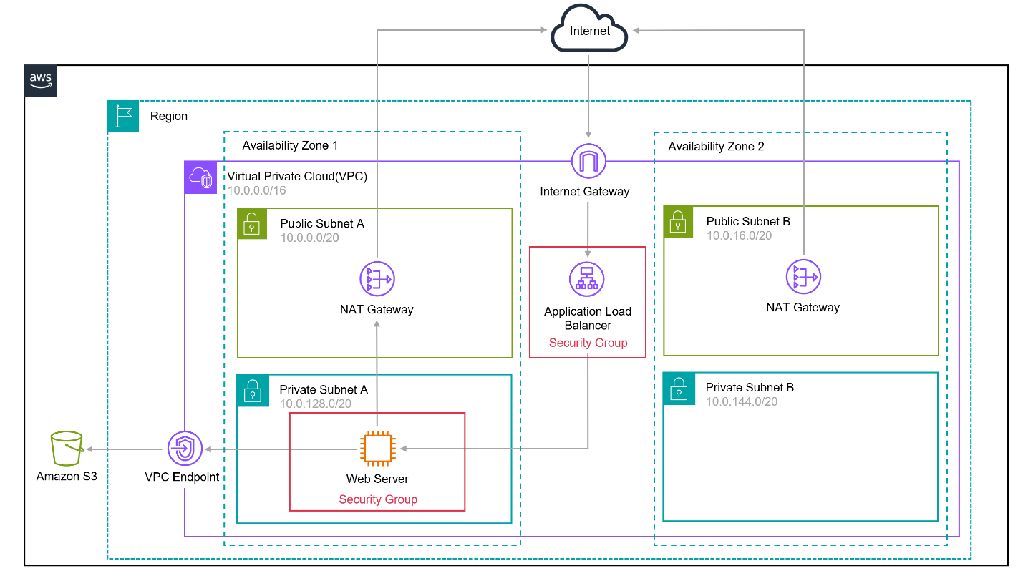

Figure 1 Architecture overview. Source [AWS](https://catalog.workshops.aws/aws101/en-US/1-getting-started/01-architecture).

### Key difference between ACL and Security Groups:

**🔑 Key Difference:**

* **Security Groups** are **stateful**, while **ACLs** are **stateless**.

**What that means:**

**🔒 Security Groups:**

* **Stateful**: If you allow an inbound rule (e.g., allow HTTP traffic in), the corresponding **outbound traffic is automatically allowed**.
* Operate at the **instance level** (attached to EC2 instances).
* Default behavior: **Deny all traffic**, then allow explicitly.
* Easier to manage for individual instances.

**🚧 Network ACLs (NACLs):**

* **Stateless**: If you allow inbound traffic, you must **explicitly allow outbound traffic** too (and vice versa).
* Operate at the **subnet level** (apply to all resources within the subnet).
* Default behavior: **Allow all**, until you specify deny rules.
* More granular control but requires more management.

**When to use:**

* Use **Security Groups** for most **EC2-based access control**.
* Use **NACLs** for **broader subnet-level filtering**, especially for blocking IPs or adding extra layers of security.

A quick **side-by-side comparison** of **Security Groups** vs **Network ACLs (NACLs)**:

| **Feature** | **Security Groups** | **Network ACLs (NACLs)** |
| --- | --- | --- |
| **Level** | Instance level (attached to EC2) | Subnet level (applies to all in subnet) |
| **Statefulness** | ✅ **Stateful** | ❌ **Stateless** |
| **Inbound/Outbound Rules** | Inbound implies outbound is allowed (and vice versa) | Must define both separately |
| **Rule Evaluation** | All rules are **allow** (no explicit deny) | Rules evaluated in order; can **allow/deny** |
| **Default Behavior** | Deny all, allow what’s specified | Allow all, until rules are added |
| **Rule Limit** | Fewer rules (limited to 60 by default) | More flexible with ordering and multiple rules |
| **Use Case** | Fine-grained access to EC2 | Broad traffic control at the subnet level |
| **Logging** | No built-in logging | Can be logged using VPC Flow Logs |

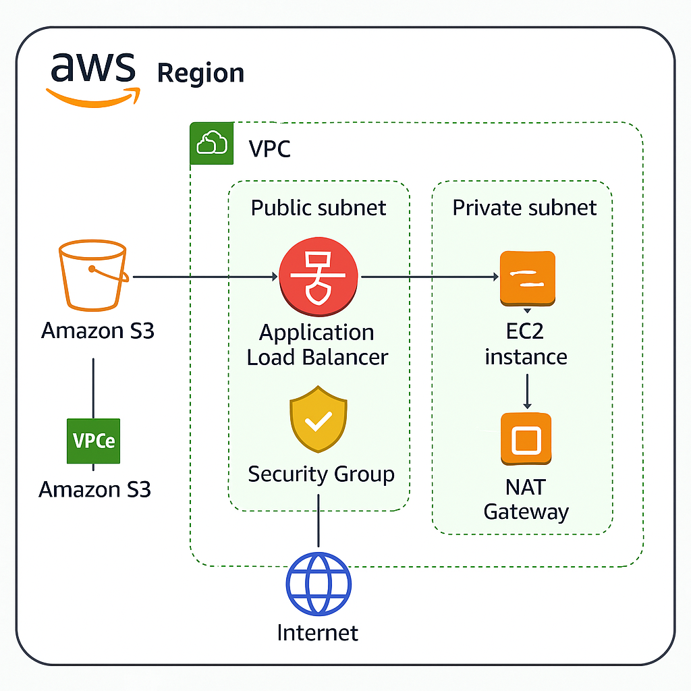

Figure 2 Simplified for a single AZ.

This architecture outlines the foundational setup we are implementing in **AWS** ☁️ to support our infrastructure needs.

We begin by creating a **Virtual Private Cloud (VPC)** 🛡️ within a specific AWS region 🌎. This acts as a logically isolated network to launch and manage our resources securely. Within this VPC, we define multiple **subnets**—both public 🌐 and private 🔒—to organize and control traffic flow between resources.

To securely connect to **Amazon S3** 🪣 without traversing the public internet, we configure an **S3 VPC Endpoint (VPCe)** 🔗. This enables **private connectivity** between our VPC and S3, enhancing security 🔐 and reducing latency 🚀 by keeping traffic within the AWS network.

An **Application Load Balancer (ALB)** ⚖️ is deployed in the public subnets to manage incoming traffic 🌍. It intelligently distributes requests to our **EC2 instances** 🖥️ running in the private subnets, ensuring **high availability** and **scalability** 📈.

Since private subnet instances do not have direct internet access ❌🌐, we provision a **NAT Gateway** 🔄 in the public subnet. This allows **outbound traffic** from EC2 instances (e.g., for software updates 📦), while still **blocking inbound connections** from the internet for enhanced security 🧱.

To enforce fine-grained traffic control, we attach **Security Groups** 🧯 to both the ALB and EC2 instances. These act as **virtual firewalls**, allowing only defined traffic based on our rules ✅⛔.

This design ensures a **secure**, **scalable**, and **well-structured** environment built with core AWS services and **cloud best practices** 🏗️✅.

Now that we have enough knowledge let’s begin our project.

### Create and configure a VPC

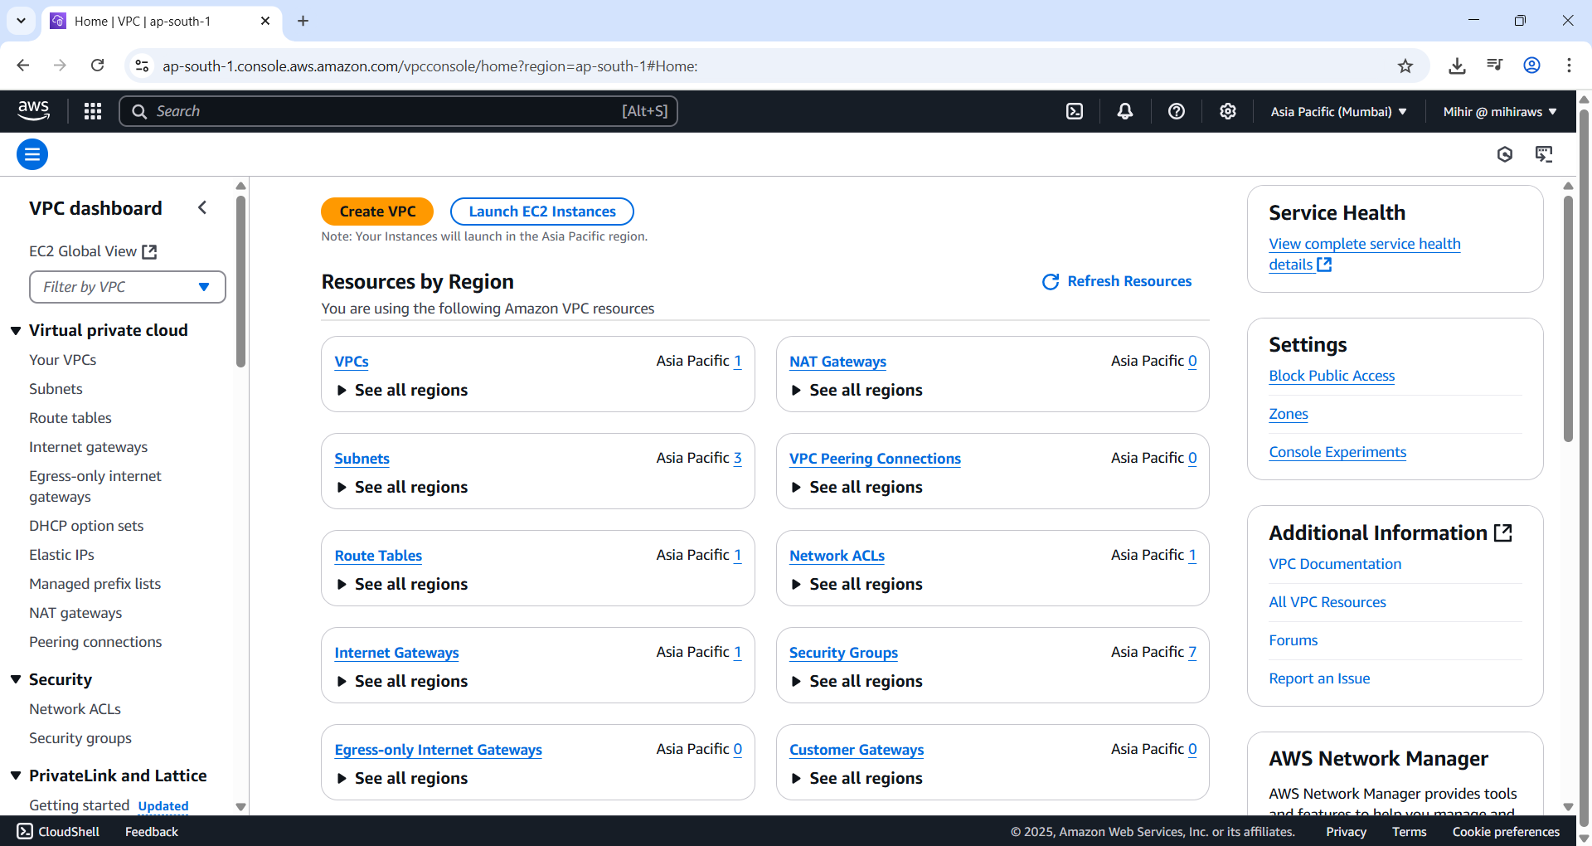

Figure 3. Go to VPC Page and hit 'Create VPC' button.

An **Amazon VPC (Virtual Private Cloud)** is a logically isolated network environment that you configure, enabling you to launch and manage AWS resources securely and privately.

Within a VPC, AWS distinguishes between **public and private subnets**:

* **Public subnets** have internet access and can communicate with external networks.
* **Private subnets** are isolated from the internet for enhanced security.

In this setup, subnets are distributed across **two Availability Zones**—**ap-south-1a** and **ap-south-1b**—to improve fault tolerance and availability. An **Availability Zone** consists of one or more physically distinct data centers within a given AWS Region. Each subnet is confined to a **single Availability Zone** and cannot span across multiple zones.

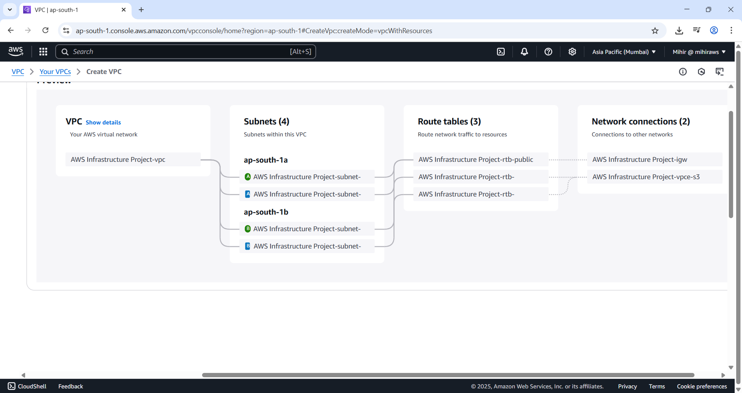

Figure 4. Our VPC has two AZ's and 2 Private and 2 Public Subnets.

Each **subnet** in the VPC is associated with a **route table**, which defines how network traffic is directed.

* **Public subnets** are connected to an **Internet Gateway (IGW)** 🌐. The IGW is a **horizontally scaled**, **redundant**, and **highly available** VPC component that enables communication between your VPC and the **internet**.
* **Private subnets** are connected to a **VPC Endpoint (VPCe)** 🔗. This gateway allows **private connectivity** to AWS services—such as **Amazon S3**—without routing traffic through the public internet. In this architecture, the VPC Endpoint enables the **web server** hosted in the private subnet to securely access **AWS storage services** without exposing the data to the outside world.



Figure 5 As you can see VPC is connected to 'ap-south-1a' and 'ap-south-1b' which are connected to Route tables.



Figure 6 In this figure public subnet is routed to internet and Private subnet is routed to VPC endpoint. VPCe gives access to other AWS Services without going through public internet.

We also require NAT gateways to securely allow private web servers to connect to internet.

Why do we need this? Let’s say we are using a software in our web application that needs to update. Since it is under a VPC and VPC is under private subnet it cannot access internet directly and hence we require some method for it to allow communication to internet. Think of it as a one-way transaction, our web server can make request to internet but not the other way round thus increasing security.

**🔄 NAT Gateway vs 🌐 Internet Gateway**

| **Feature** | **NAT Gateway (NAT GW) 🔄** | **Internet Gateway (IGW) 🌐** |
| --- | --- | --- |
| **Purpose** | Allows **private subnets** to access the internet for **outbound traffic only** (e.g., updates, APIs) | Enables **public subnets** to send and receive **both inbound and outbound** internet traffic |
| **Direction of Traffic** | **Outbound only** (from private subnet to internet) | **Inbound and outbound** |
| **Who uses it** | **EC2 instances in private subnets** | **Resources in public subnets** (e.g., ALBs, EC2) |
| **Public IP Needed?** | ✅ NAT Gateway has a public IP; private EC2s do **not** need public IPs | ✅ Resources need **public IP or Elastic IP** to use IGW |
| **Security Use Case** | Keeps instances **hidden from the internet**, but allows them to **initiate requests** | Opens up internet access **to and from** public-facing resources |
| **Attached To** | Public Subnet (but used by Private Subnet traffic) | VPC |
| **Common Use** | Patch/download updates, API calls from private EC2s | Web servers, ALBs, or anything that needs public access |

**🧠 In Short:**

* Use a **NAT Gateway** when you want your **private resources to access the internet** without being accessible **from** the internet.
* Use an **Internet Gateway** when you want your **resources to be publicly accessible** (like a web server or load balancer).

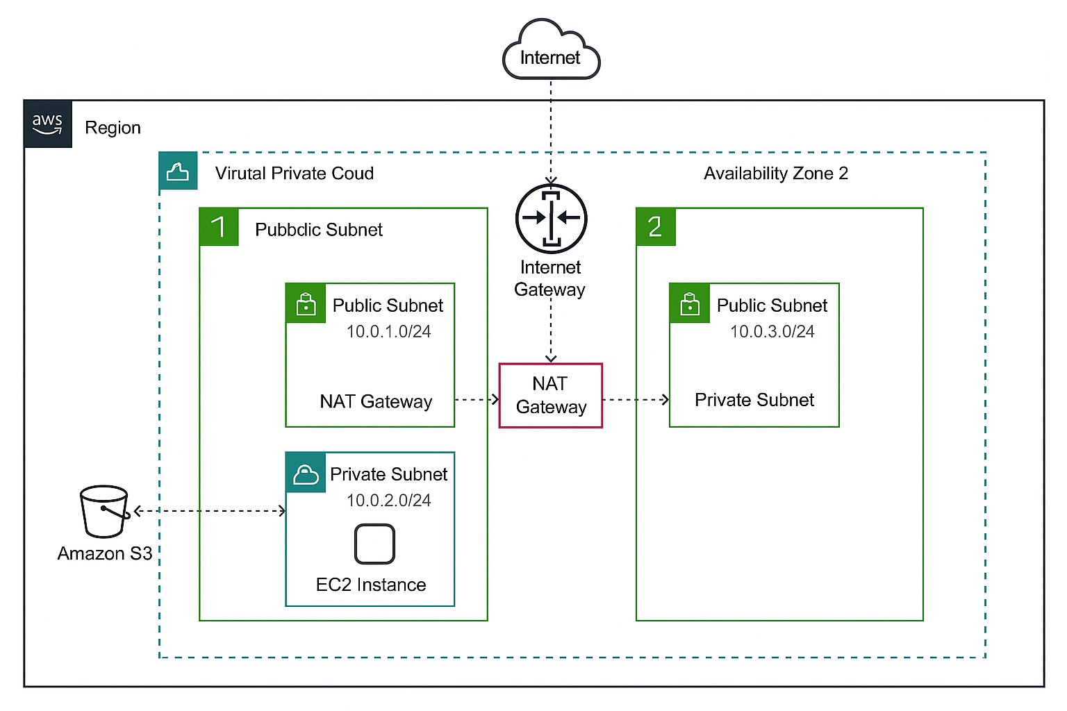

Figure 7 Diagram to simplify understanding.

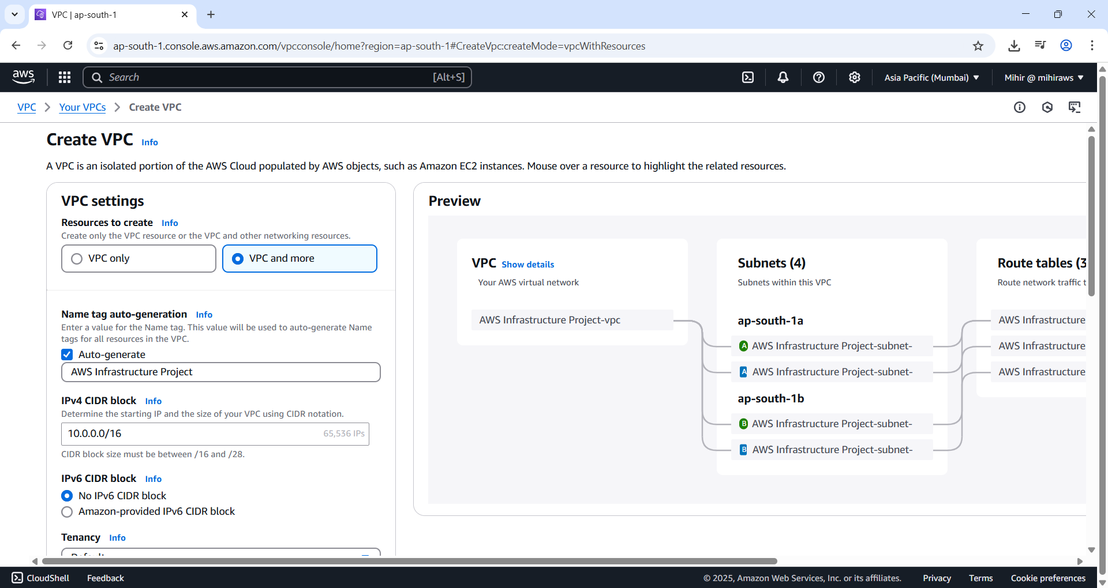

Figure 8 Give a name to your VPC or leave blank to auto generate.

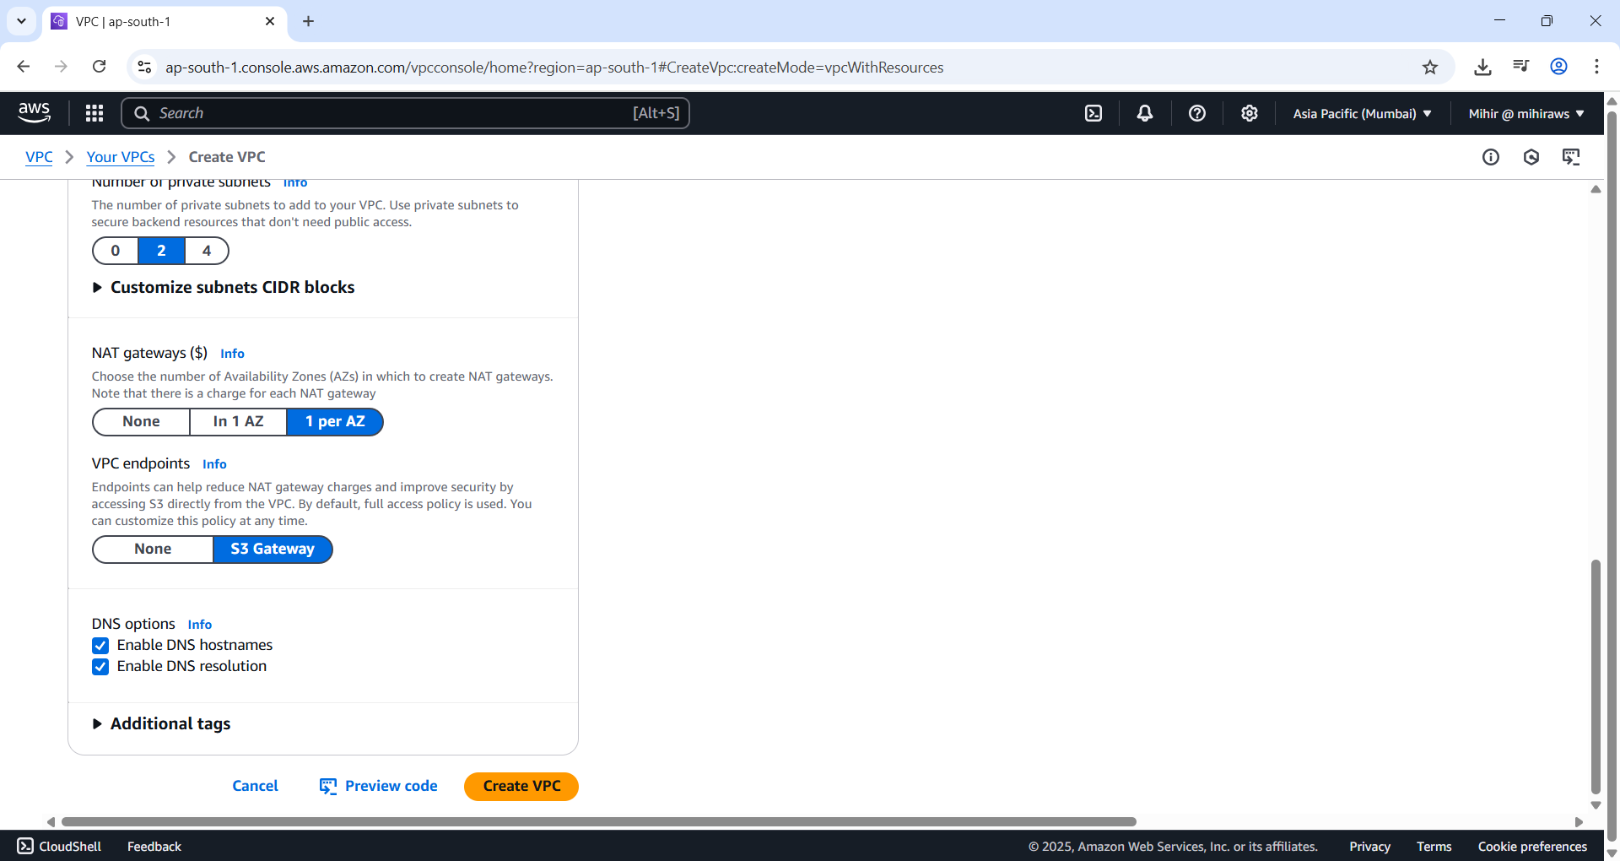

Figure 9 Scroll down and select under NAT Gateway '1 per AZ'.

This allows you to set NAT Gateway per private subnet.

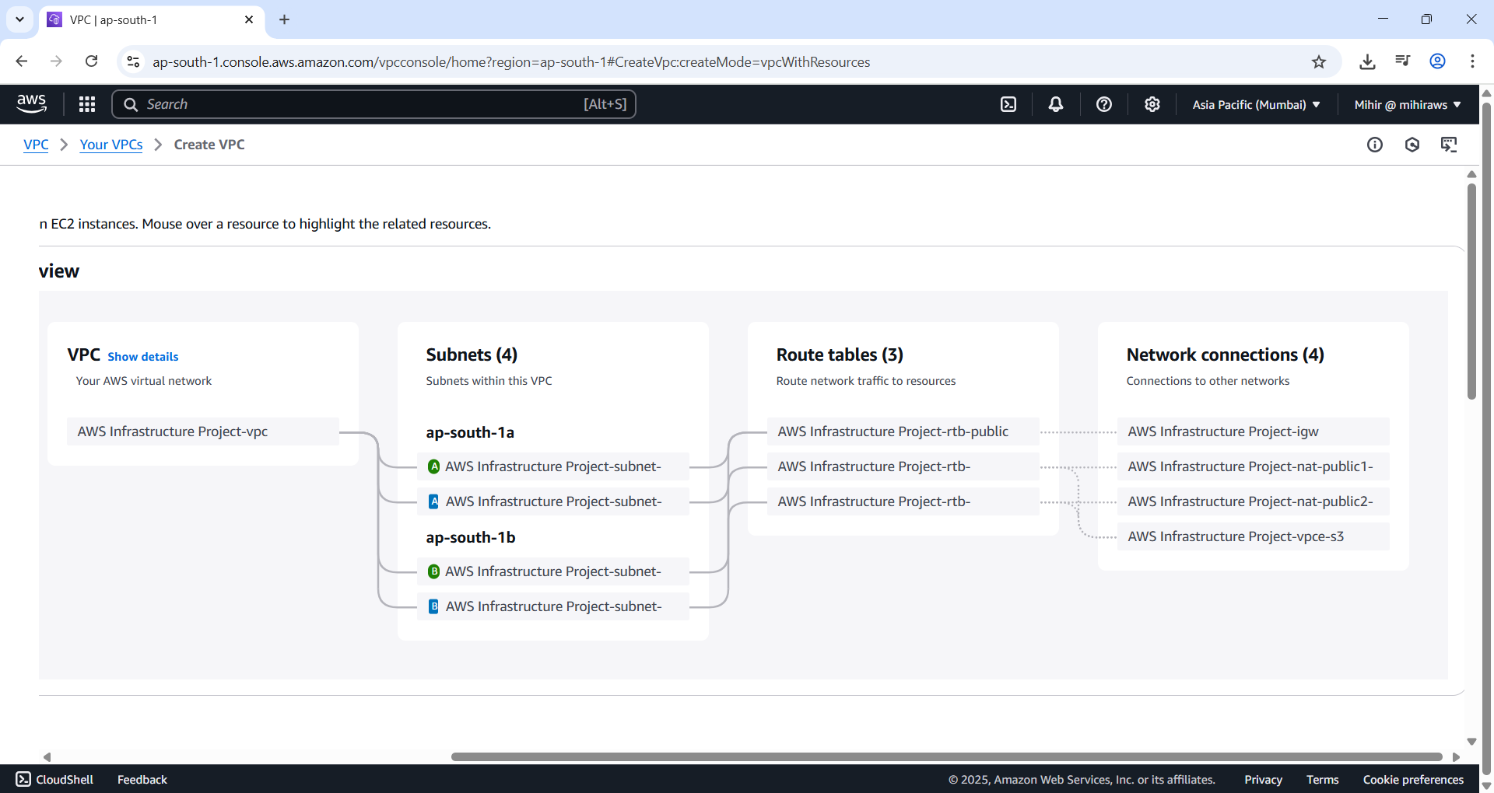

Figure 10 As you can see from route table each private subnet has it's own NAT Gate way per AZ. Now hit Create VPC.

**What is an Availability Zone, and why use more than one?**  
An **Availability Zone (AZ)** consists of one or more physically separate data centers within a single AWS Region. Leveraging multiple AZs enhances **redundancy and fault tolerance**, ensuring your resources remain available even if one zone experiences an outage.

**Why deploy two NAT Gateways?**  
By deploying a **NAT Gateway in each Availability Zone**, you ensure **high availability** and **resilience**. If one zone or NAT Gateway becomes unavailable, instances in the other zone can still access the internet without disruption.

**What’s the maximum number of subnets you can create in a VPC?**  
While the VPC creation wizard has certain default limits, AWS allows you to create **up to 200 subnets per VPC**, giving you flexibility in structuring your network.

**What should you consider when selecting subnet CIDR blocks during a migration from on-premises?**  
When defining **CIDR blocks** for your VPC and subnets, make sure they **do not overlap with your on-premises IP ranges**. This prevents routing conflicts and ensures seamless **hybrid connectivity** during and after migration.

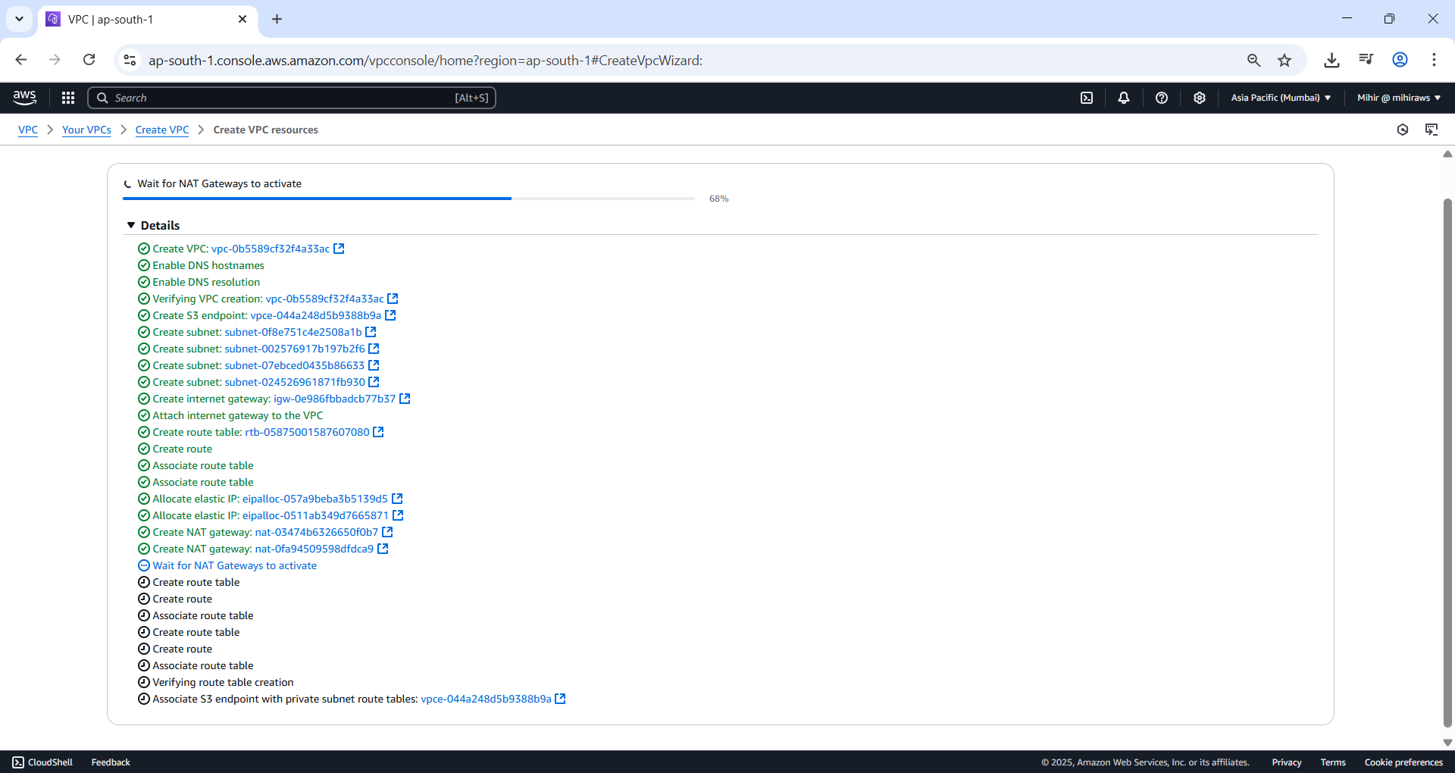

Figure 11 After you hit 'Create VPC' it AWS configures the network and subnets.

Subnets are basically sub parts of a network. Why do we need to do it?

Let’s say there are resources like EC2 that needs access to Database and you don’t want Database have internet access for obvious security reasons it might contain users personal information.

**Think of a VPC as a city** 🏙️, and **subnets as neighborhoods** 🏡 within that city. Each neighborhood (subnet) has its own type of infrastructure:

* **Public subnet** is like a commercial area with open access (e.g., shops with roads connecting to highways — the internet).
* **Private subnet** is like a gated residential community 🏠 — secure, no direct public road access, but residents can go out via a security-controlled exit (like a NAT Gateway).

Each has its own purpose, but they all exist within the boundaries of the same city (VPC), connected and managed together

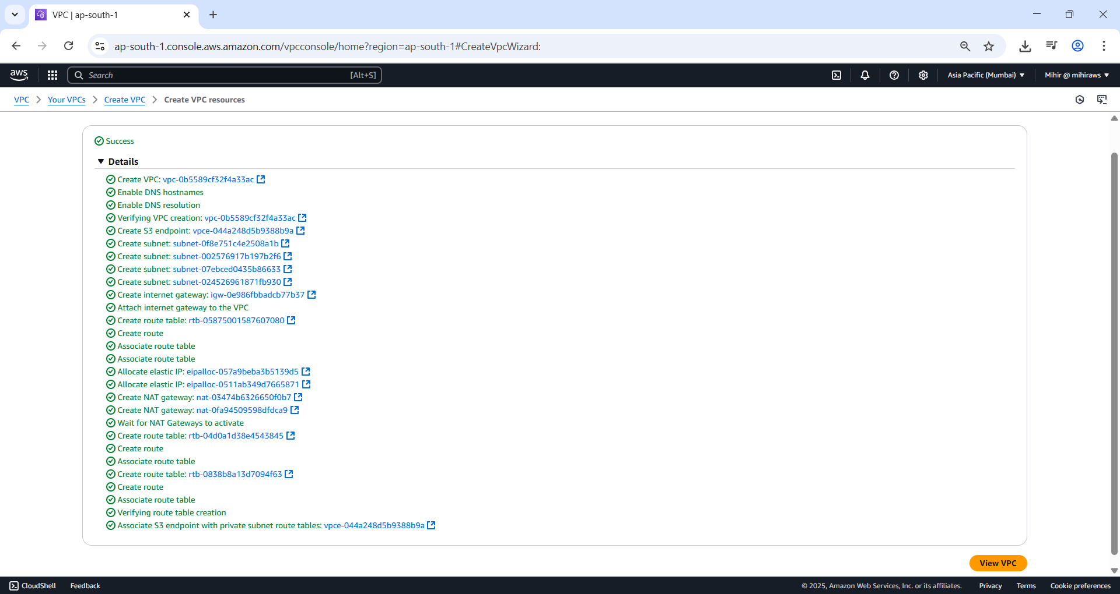

Figure 12 VPC Created Successfully now hit 'View VPC' button.

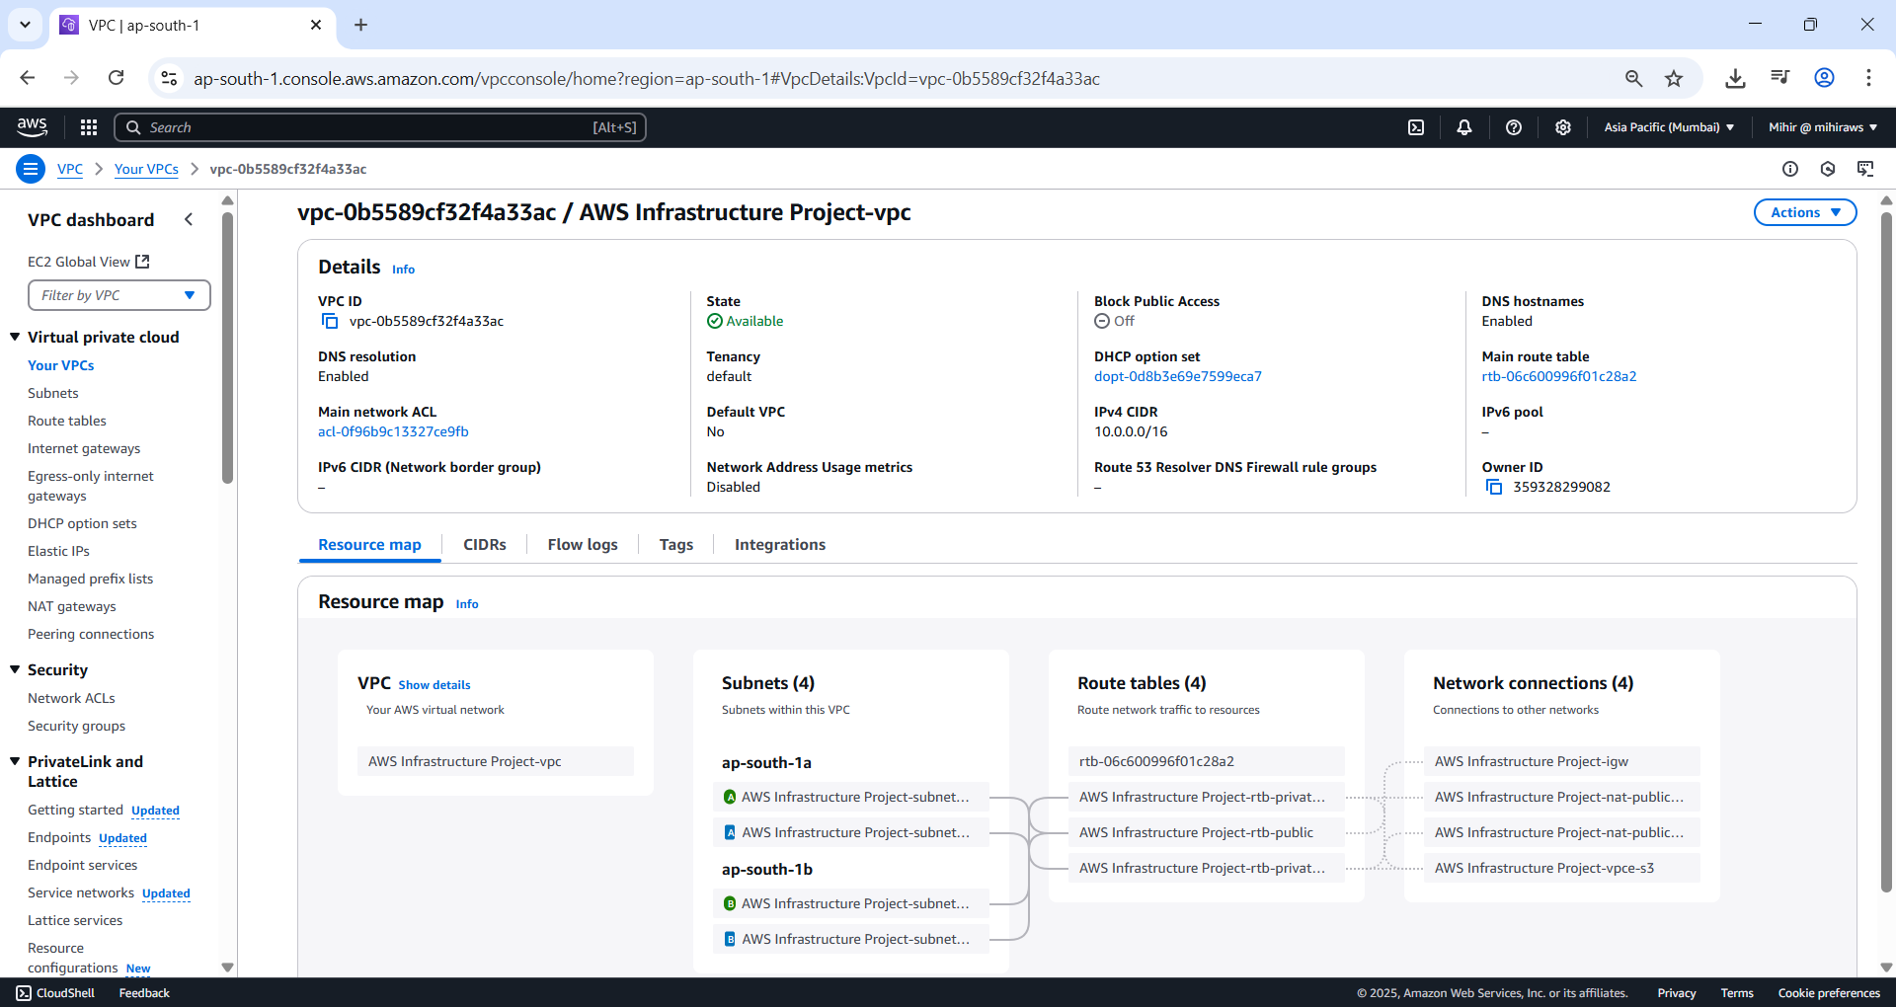

Figure 13 As you can see all the information of your VPC is available.

### Create Security Groups

**Security Groups** in AWS act as virtual firewalls, controlling **inbound and outbound traffic** for associated resources such as EC2 instances and load balancers. Every VPC includes a default security group, but custom groups can be created to enforce more granular access control.

In this setup, two security groups are created to secure a web application:

1. **Load Balancer Security Group**
   * **Purpose:** Controls external access to the application.
   * **Inbound Rule:** Allows **HTTP (TCP port 80)** traffic from **any IPv4 source**, enabling public internet access.
   * **Outbound Rules:** Left as default, allowing all outbound traffic.
   * **Tag:** Name = LoadBalancerSecurityGroup
2. **Web Server Security Group**
   * **Purpose:** Secures the web server instance by restricting traffic to only what's necessary.
   * **Inbound Rule:** Allows **HTTP (TCP port 80)** traffic, but **only from the Load Balancer Security Group**. This ensures that the web server can only be accessed through the load balancer.
   * **Outbound Rules:** Default settings, permitting all outbound traffic.
   * **Tag:** Name = WebServerSecurityGroup

**Key Note:**  
Ensure that both security groups are associated with the correct VPC (project-vpc). The setup enhances security by **limiting direct access** to the web server and **filtering incoming traffic** at both the load balancer and instance levels.

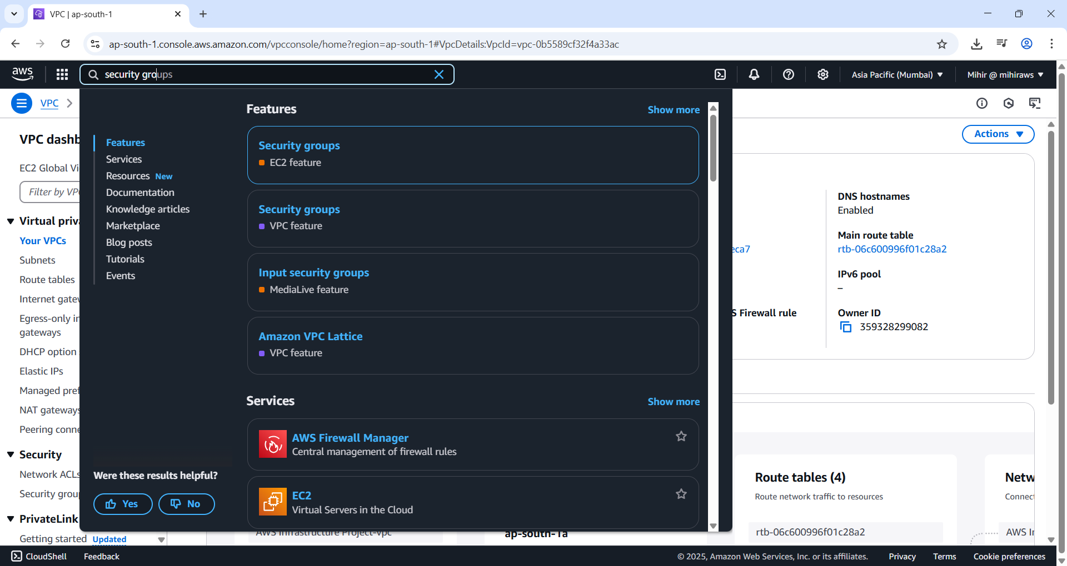

Figure 14 Search Security Group and select the first option in this image.

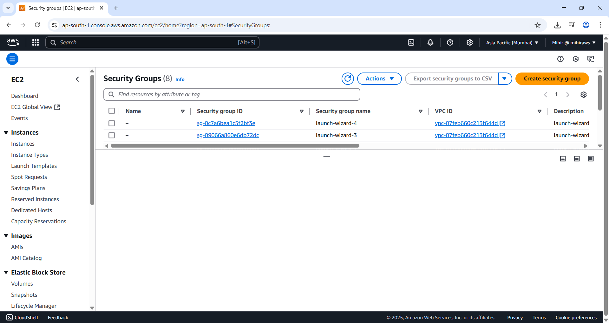

Figure 15 Security Group page is loaded now hit 'Create security group' button to create a new security group.

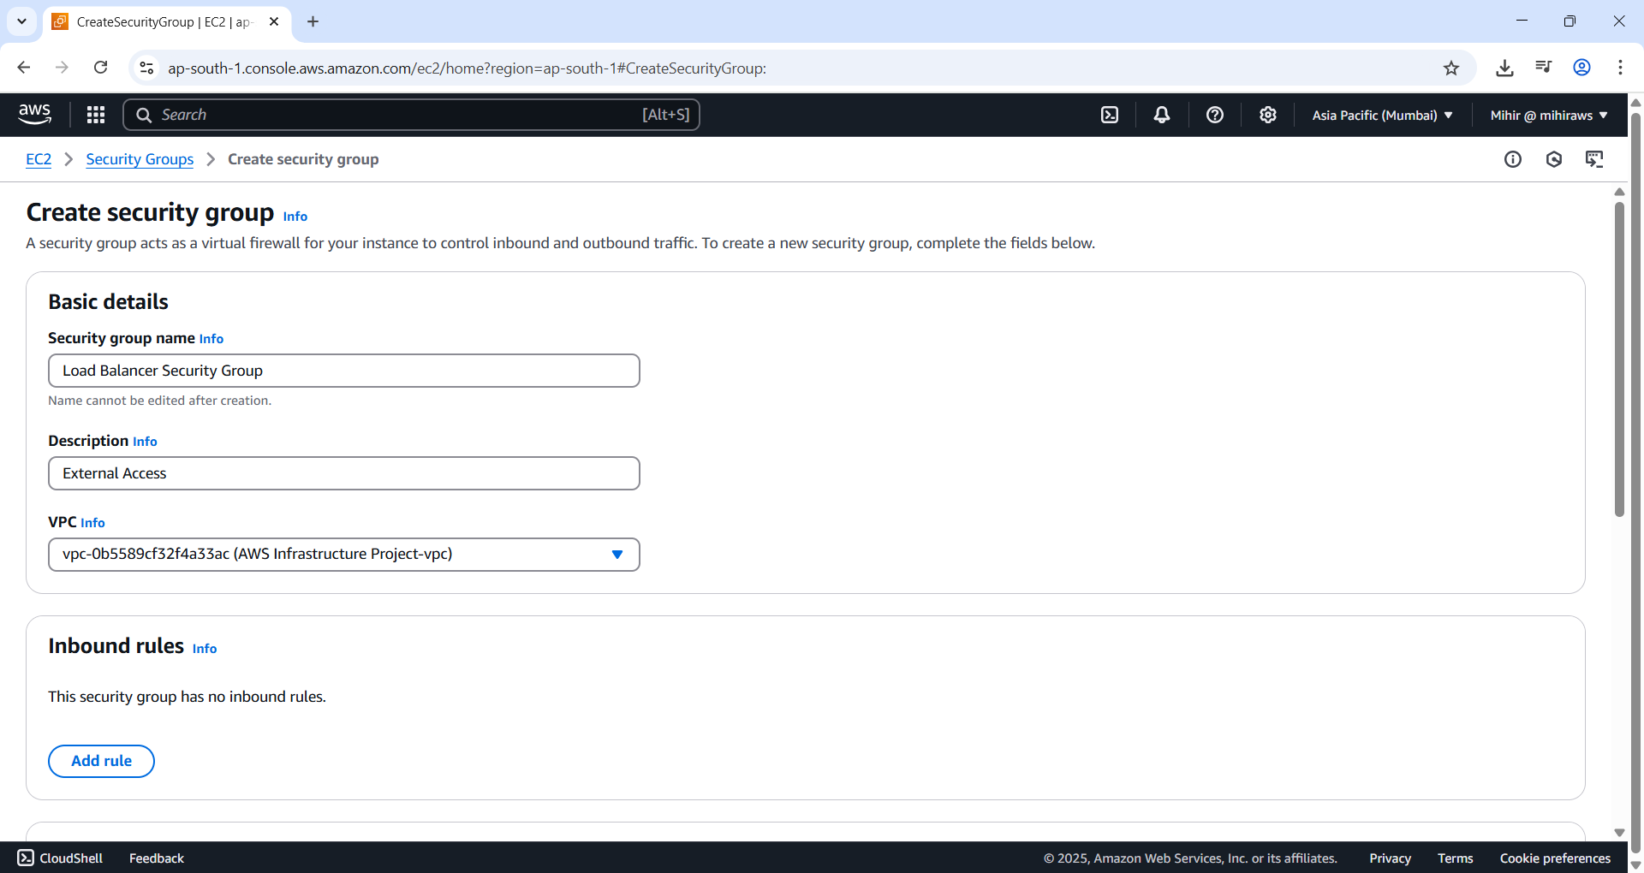

Figure 16 Give name and description. Select your VPC.

Make sure you select your correct VPC you want to attach these rules to.

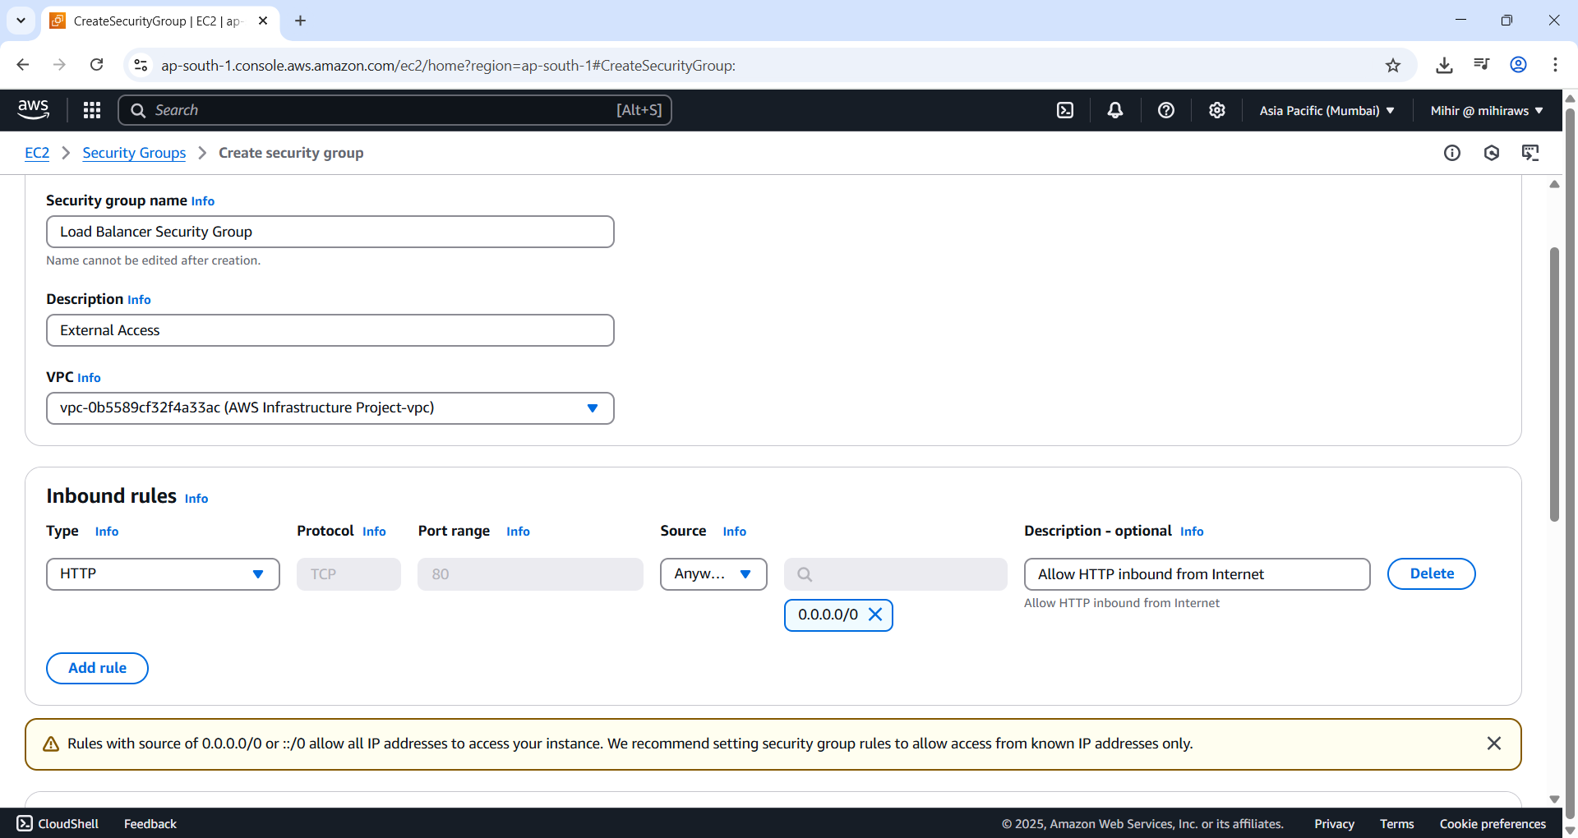

Figure 17 Add inbound rule to allow HTTP traffic from internet.

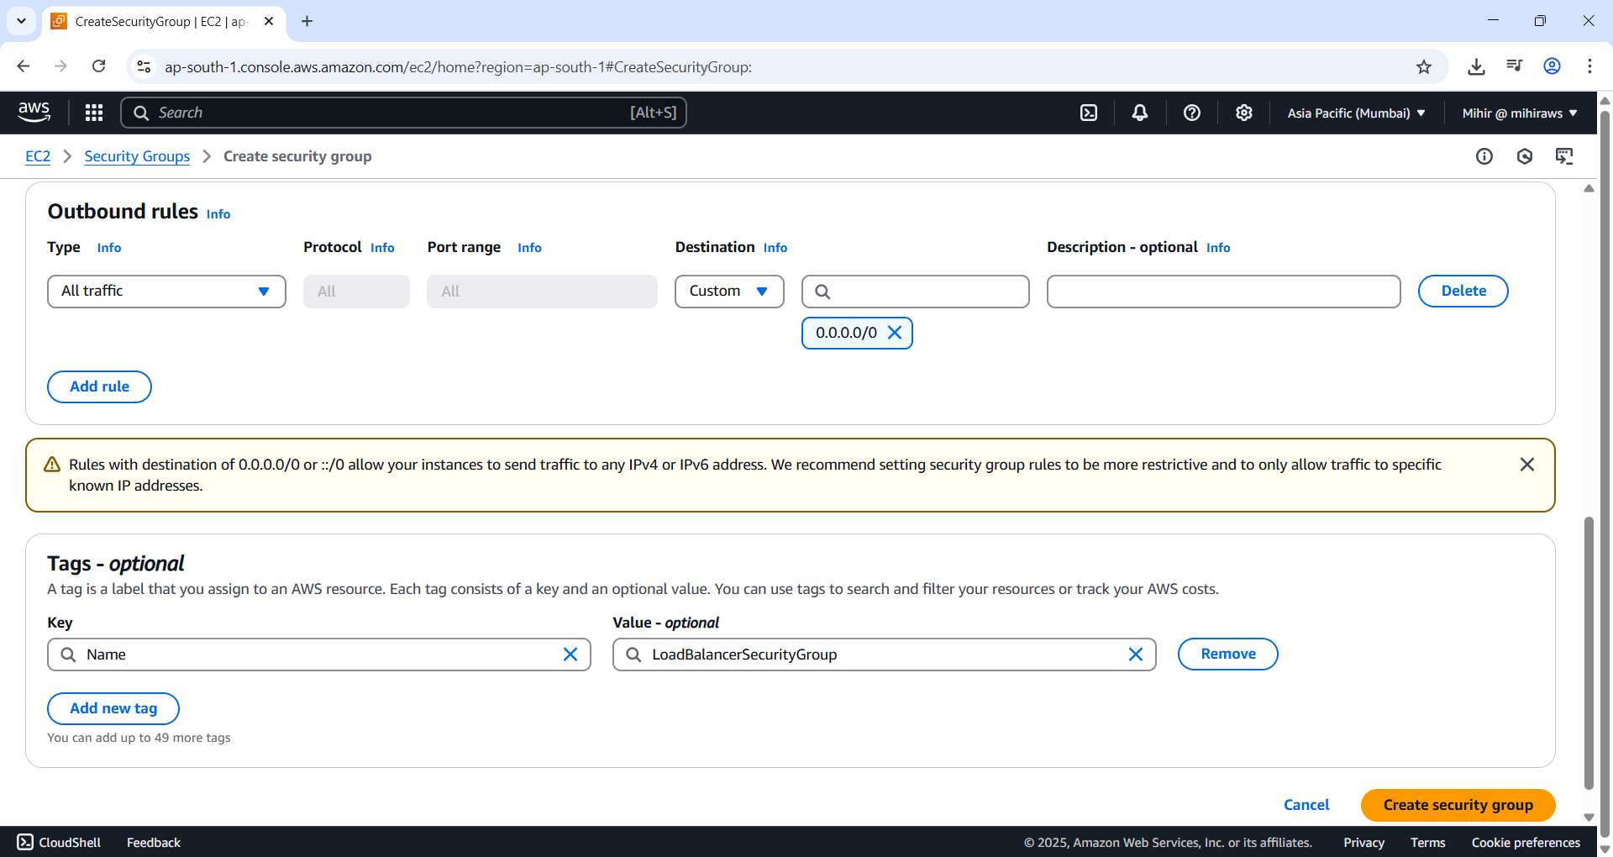

Figure 18 Add a tag. Key as ‘Name’ and value as ‘LoadBalancerSecurityGroup’.

Leave rest to default and don’t make any changes.

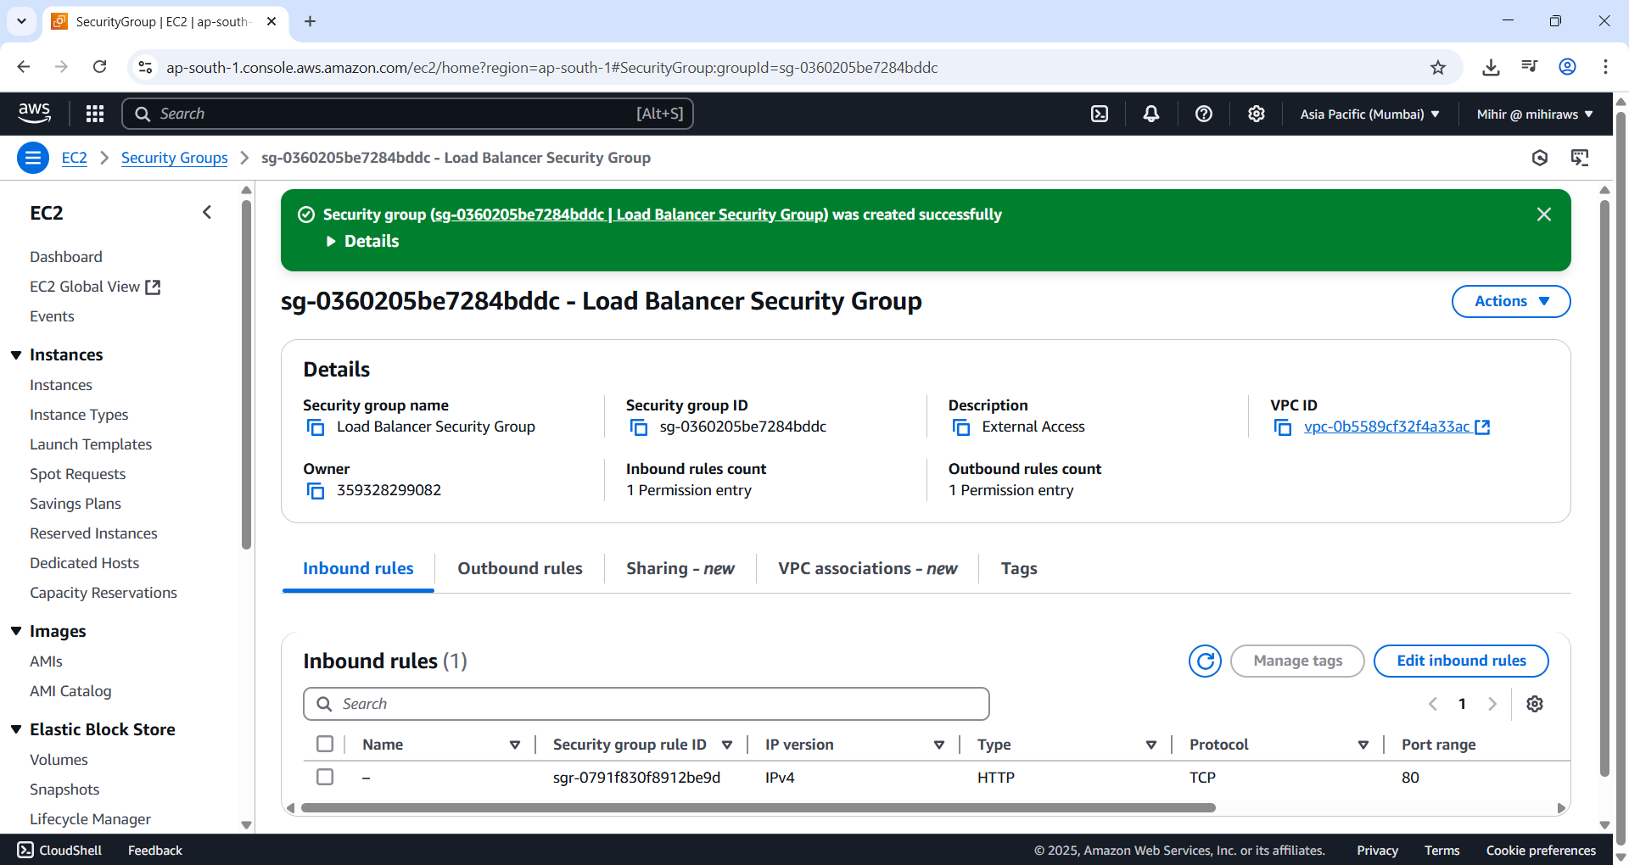

Figure 19 Hit 'Create security group' button to create these rules.

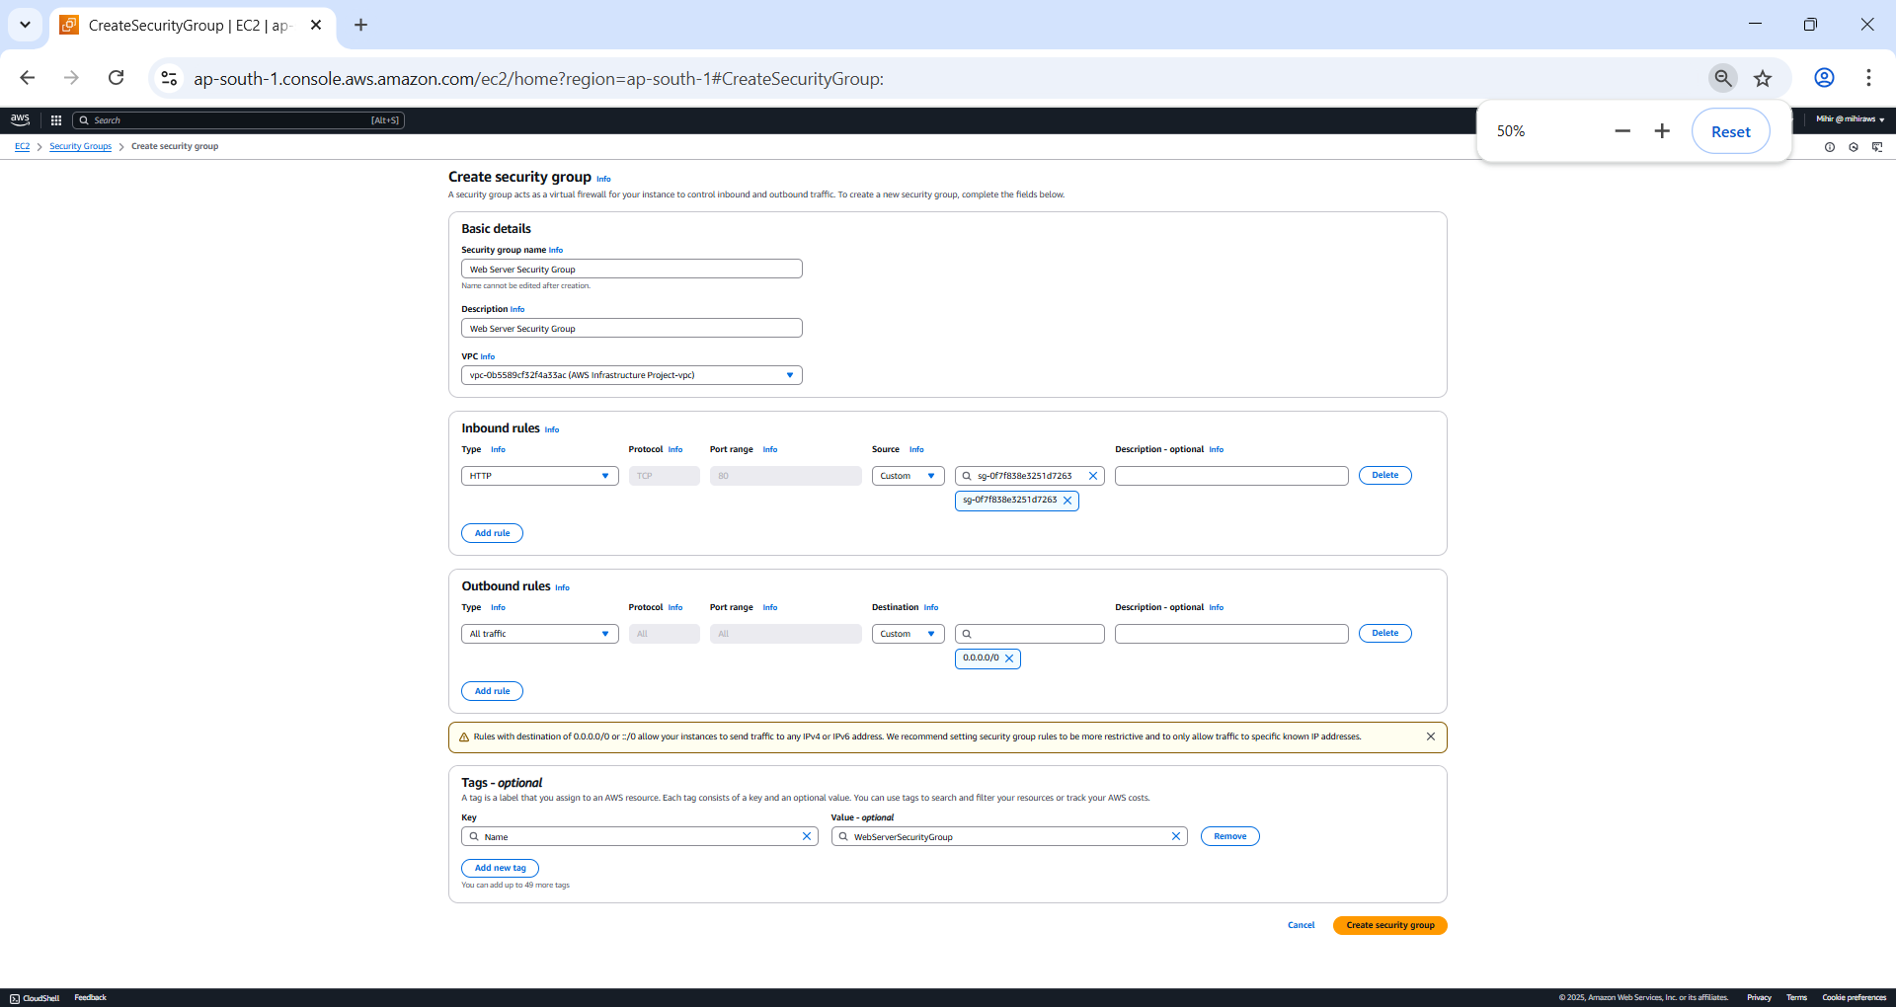

Figure 20 Repeat same for Web Server. In source for inbound rule search for sg and select load balancer.. security group.

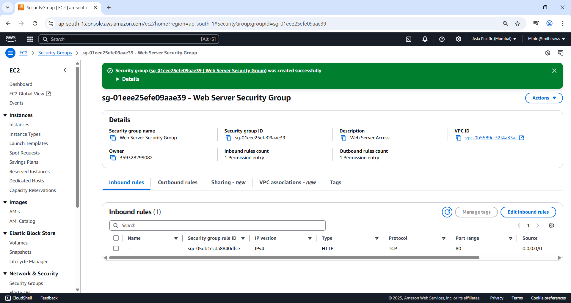

Figure 21 Web Server security Group created.

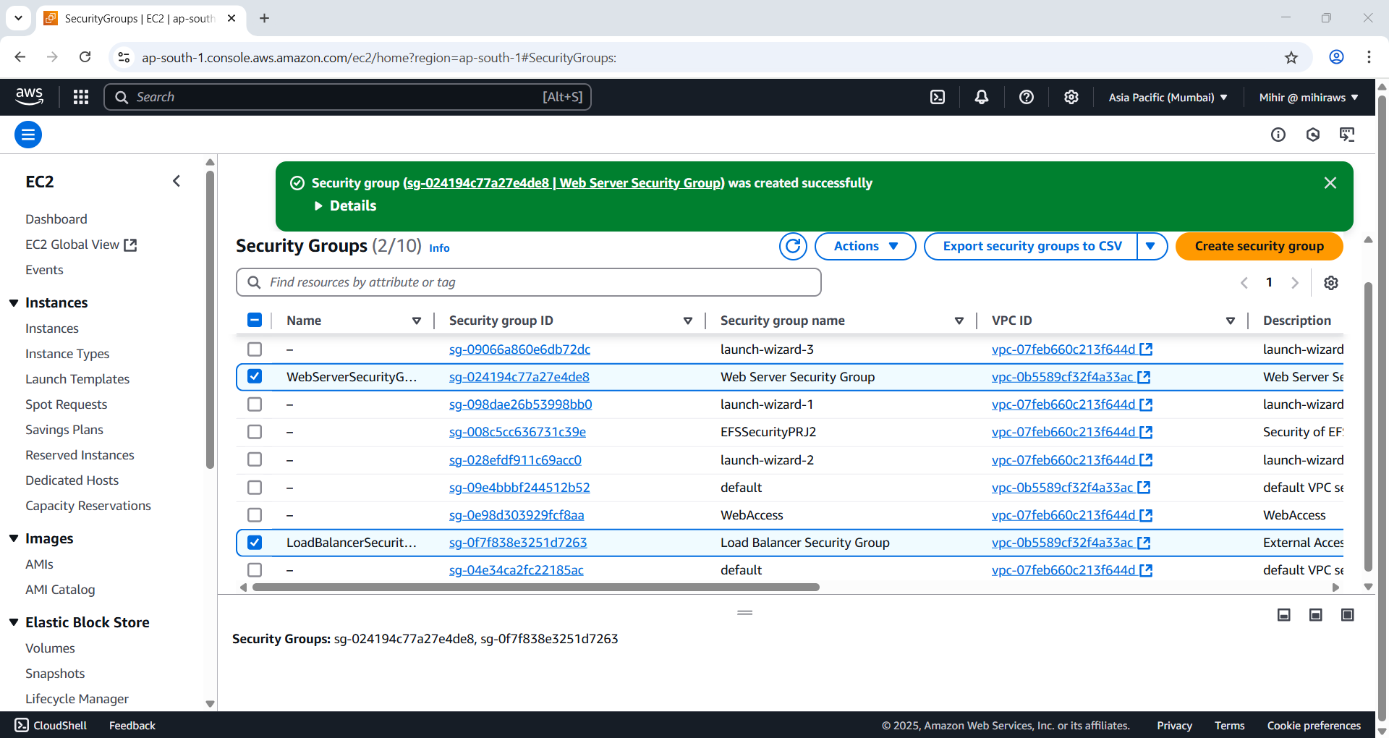

Figure 22 Check both security groups are created.

* **Default Behavior of Security Groups:**  
  Newly created security groups **deny all inbound traffic by default** while **allowing all outbound traffic**.
* **Use of HTTP vs. HTTPS in Production:**  
  HTTP is not secure for production environments because it lacks encryption. **HTTPS** is recommended to protect data in transit. **AWS Certificate Manager (ACM)** can be used to provision and manage **SSL/TLS certificates** for enabling secure communication.
* **Number of Rules per Security Group:**  
  A single security group can have **multiple inbound and outbound rules**, with a default limit of **60 rules per group**.
* **Resources Protected by Security Groups:**  
  Security groups can be attached to various AWS resources including **EC2 instances, load balancers, RDS databases**, and other components within a **VPC** to control their network access.

### IAM Role

**🔐 IAM Overview (Identity and Access Management)**

**AWS Identity and Access Management (IAM)** is a service that allows centralized control over who can access specific AWS services and resources. It enables you to manage **users**, **permissions**, and **security credentials** like access keys.

In this setup, IAM is configured to ensure that the **web server EC2 instance** has only the necessary permissions to interact with required AWS resources, following the principle of **least privilege**.

**🧰 IAM Roles and Policies**

* **IAM Policies** define what actions are allowed or denied on which resources.
* **IAM Roles** are assumed by trusted entities (like an EC2 instance) and use policies to determine access rights.
* An **Instance Profile** acts as a container to attach an IAM Role to an EC2 instance.

In this case, a role named **WebServerInstanceProfile** is created and attached to the EC2 instance. It includes the **AWS managed policy** AmazonSSMManagedInstanceCore, which allows:

* Secure access and control of EC2 instances via **AWS Systems Manager (SSM)**.
* Management of the instance **without exposing it to the public internet**.

**✅ Best Practices Highlighted**

* Using **AWS managed policies** like AmazonSSMManagedInstanceCore is convenient but may not always offer the best granularity.
* The setup follows the **Principle of Least Privilege**, ensuring that the EC2 instance receives only the permissions it needs — no more, no less.



Figure 23 Source [AWS](https://static.us-east-1.prod.workshops.aws/public/1d2acbf4-ef06-4573-bb95-c6ae9d6de043/static/img/build_web_server/009.png).

IAM Policies will grant permissions to AWS resources and services. Policies can be applied to IAM Roles. IAM Roles are assumed by trusted entities like EC2 instance allowing to access permitted AWS resources.

***EC2 instance profile*** is a container that holds all the IAM Roles.

On the left side Select ‘Roles’.

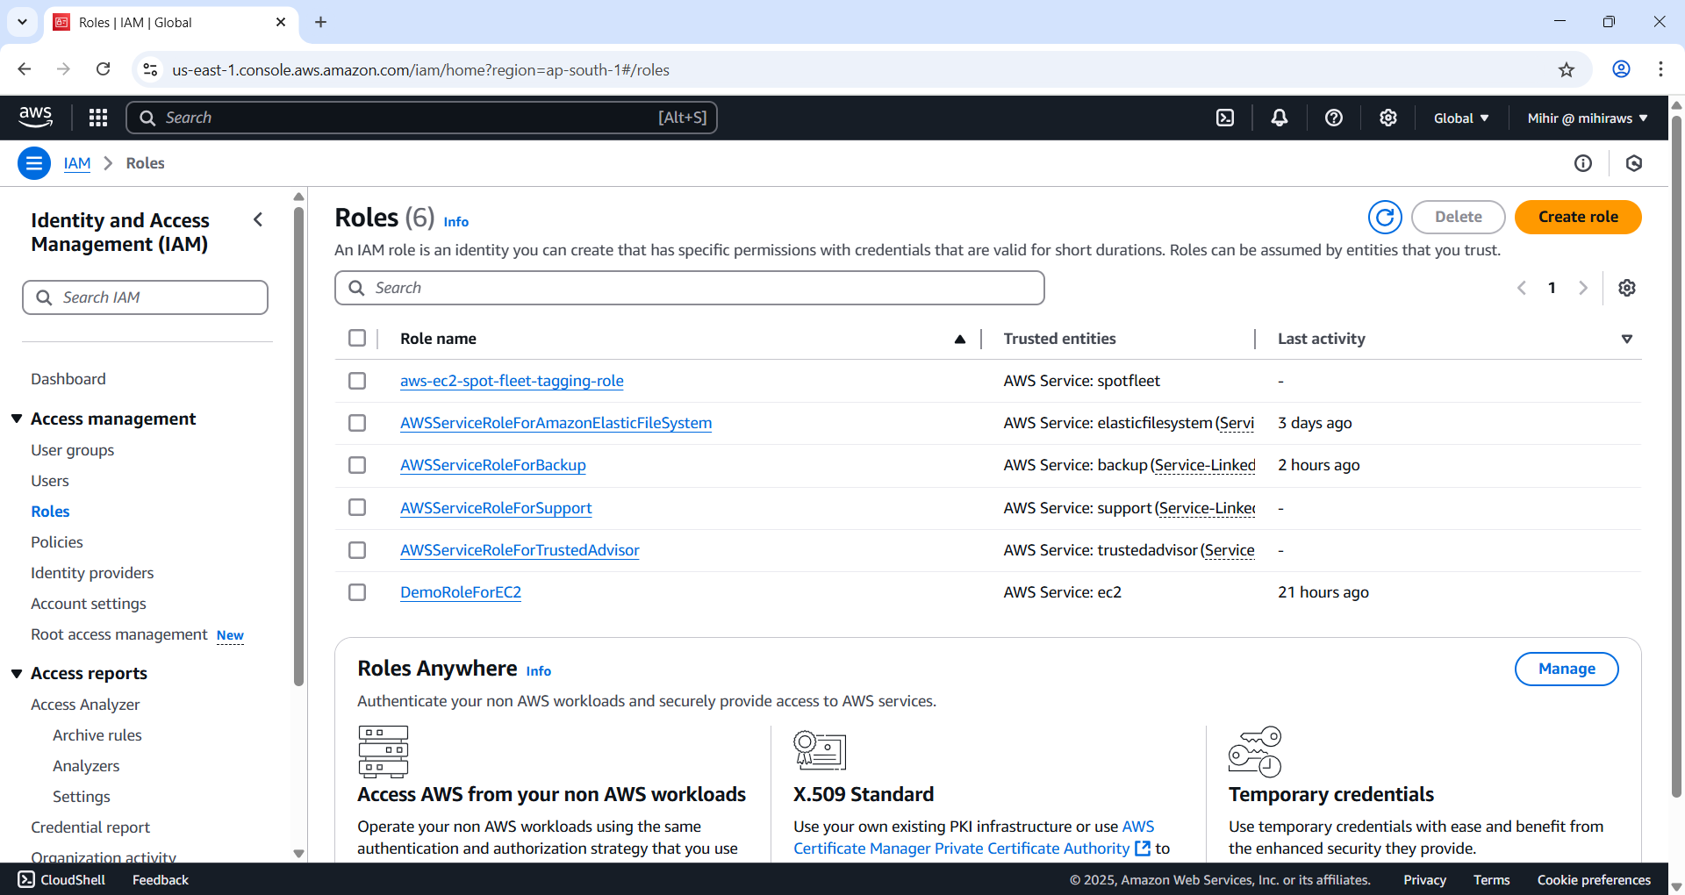

Figure 24 Roles page appears. Click ‘Create role’ button to create a new role.

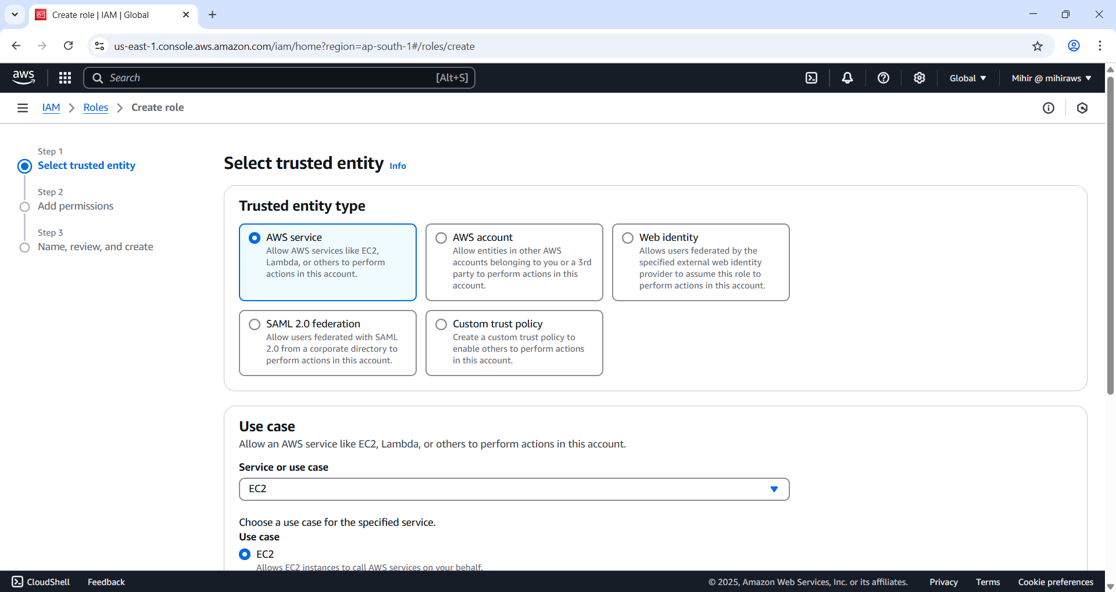

Figure 25 Select Trusted Entity as 'AWS service' and Use case as ‘EC2’.

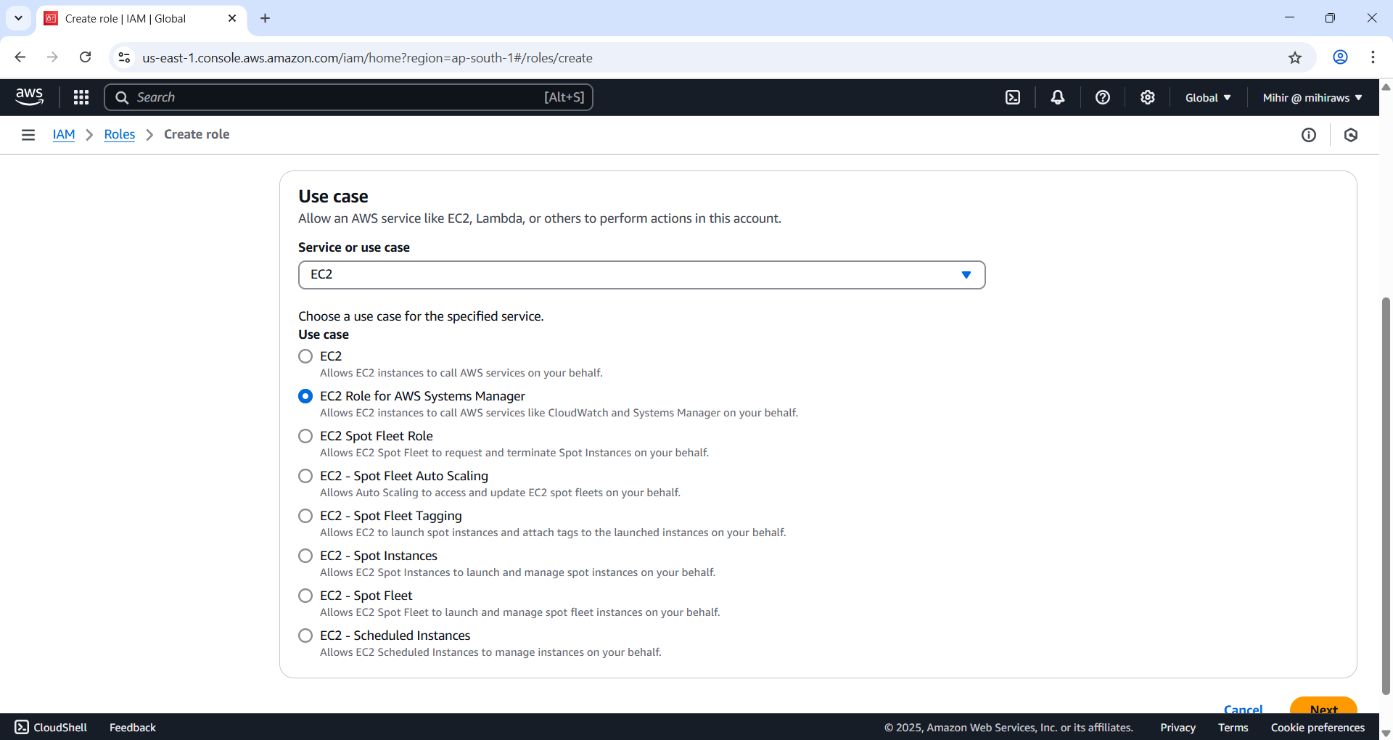

Figure 26 Select EC2 Role for AWS System Manager. Hit ‘Next’ button.

**AWS Systems Manager** is a management service that enables secure administration of **EC2 instances** **without requiring direct access over the public internet**. By assigning the appropriate IAM role, Systems Manager can remotely manage and interact with the web server instance, enhancing security and operational efficiency.

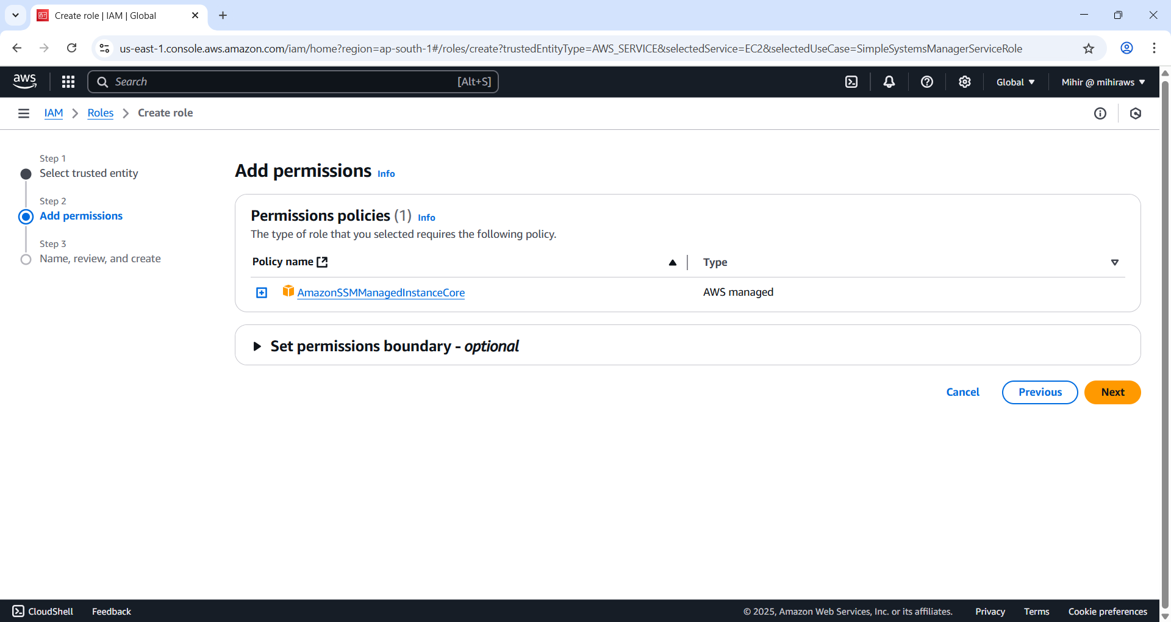

Figure 27 Policy automatically added.

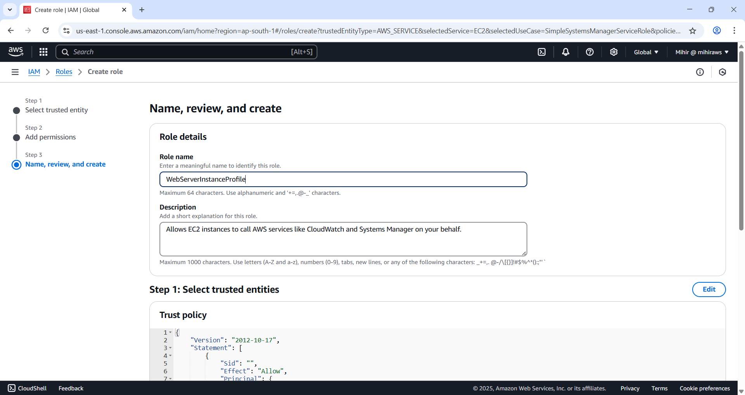

Figure 28 Give a name to the role. Hit ‘Create role’.

### Deploy EC2

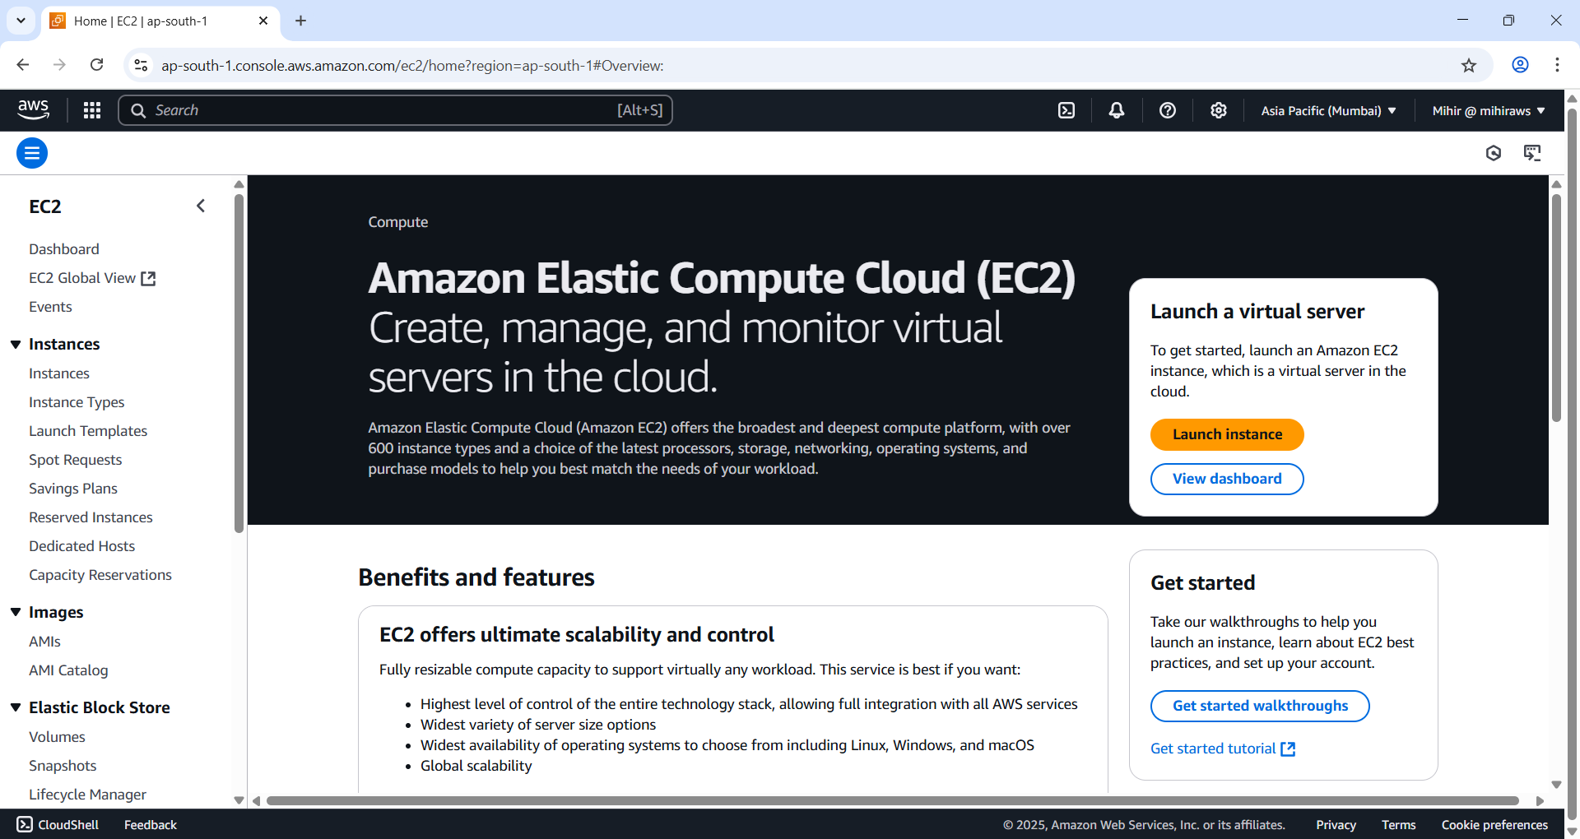

Figure 29 Create EC2 instance.

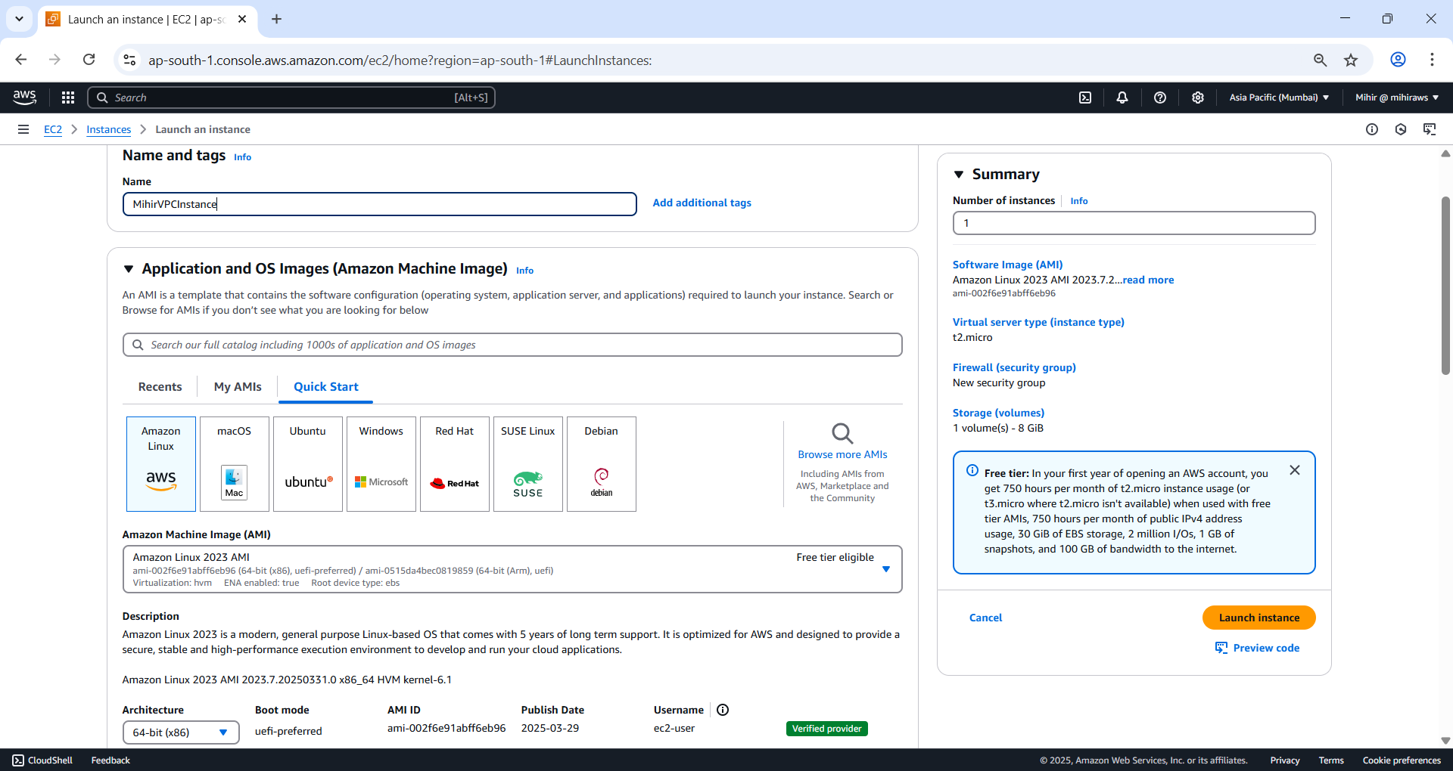

Figure 30 Give your instance a name and select an AMI.

Here I have selected Amazon Linux 2023 AMI with t2.micro Free tier eligible instance.

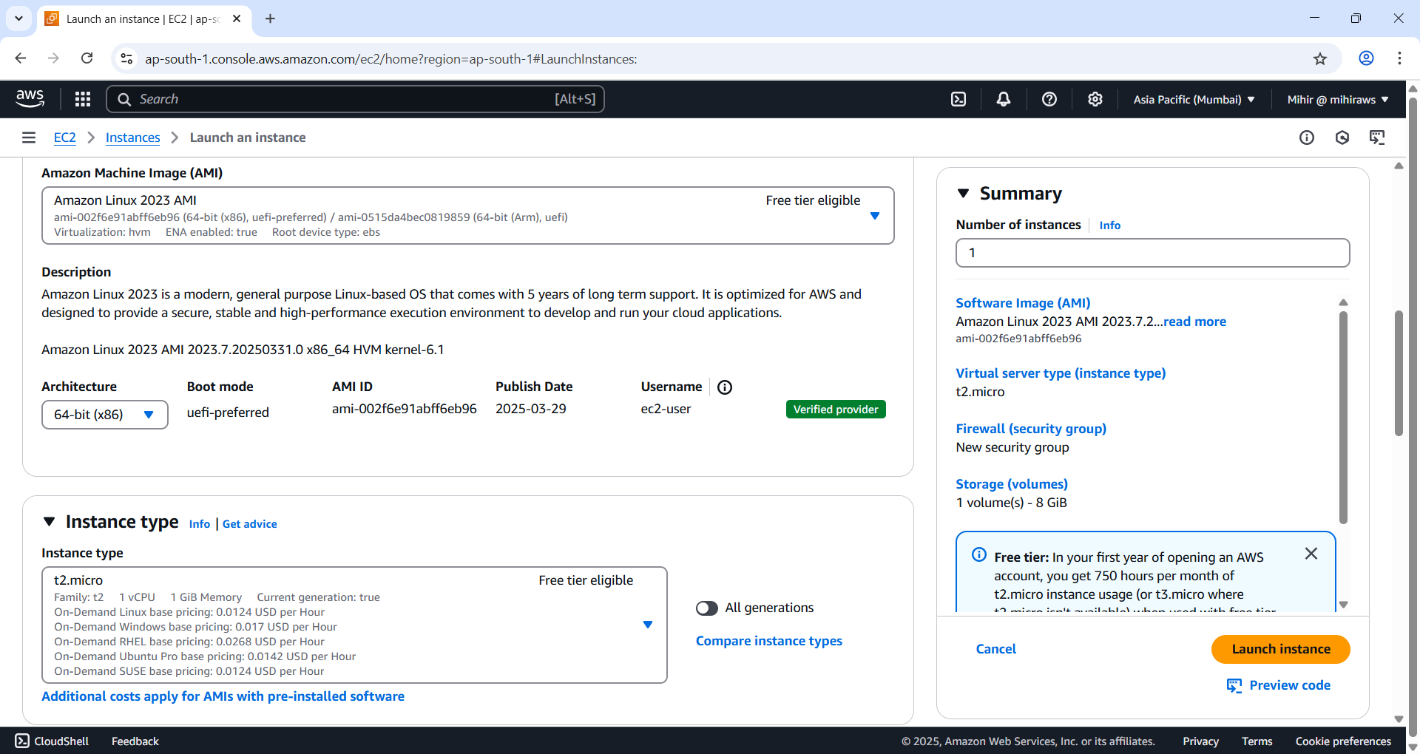

Figure 31 t2.micro and 64-bit arch selected.

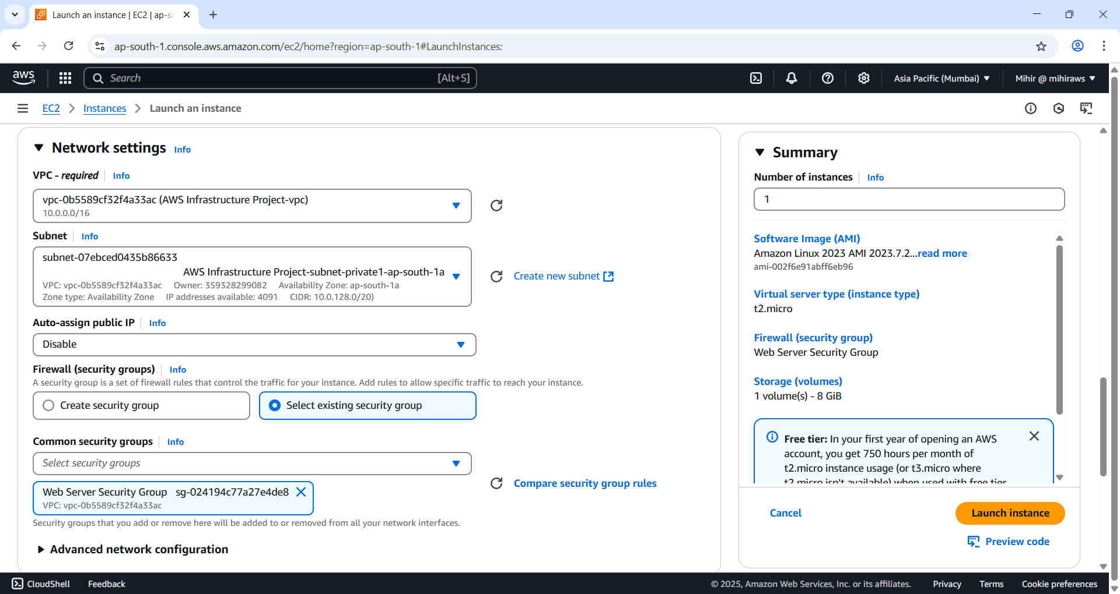

Figure 32 Edit Network settings and select the VPC we created and select 'private' subnet.

In this Network Settings section we select existing security group and select from drop down ‘Web Server Security Group’. This will allow traffic from port 80 from public subnets.

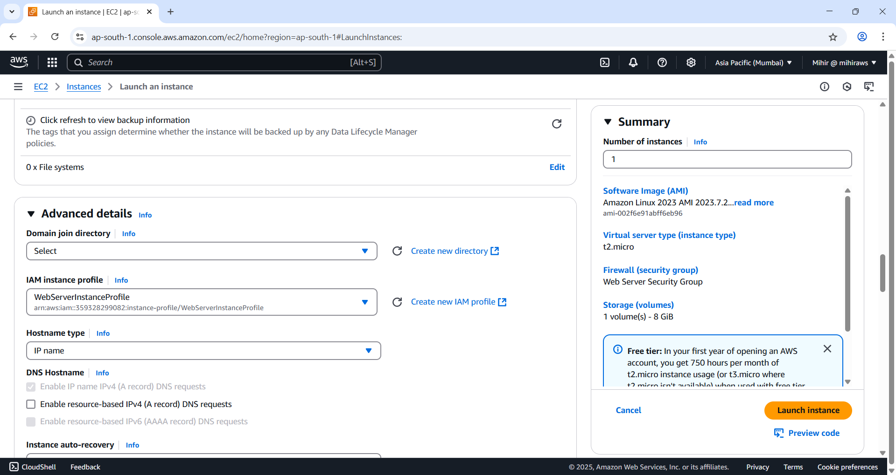

Figure 33 Under IAM instance profile select 'WebServerInstanceProfile'.Scroll down and copy paste text in user data field.

#!/bin/bash

yum update -y

# Install Session Manager agent

yum install -y https://s3.amazonaws.com/ec2-downloads-windows/SSMAgent/latest/linux_amd64/amazon-ssm-agent.rpm

systemctl enable amazon-ssm-agent

# Install and start the php web server

dnf install -y httpd wget php-json php

chkconfig httpd on

systemctl start httpd

systemctl enable httpd

# Install AWS SDK for PHP

wget https://docs.aws.amazon.com/aws-sdk-php/v3/download/aws.zip

unzip aws.zip -d /var/www/html/sdk

rm aws.zip

#Install the web pages for our lab

if [ ! -f /var/www/html/index.html ]; then

rm index.html

fi

cd /var/www/html

wget https://ws-assets-prod-iad-r-iad-ed304a55c2ca1aee.s3.us-east-1.amazonaws.com/2aa53d6e-6814-4705-ba90-04dfa93fc4a3/index.php

# Update existing packages

dnf update -y

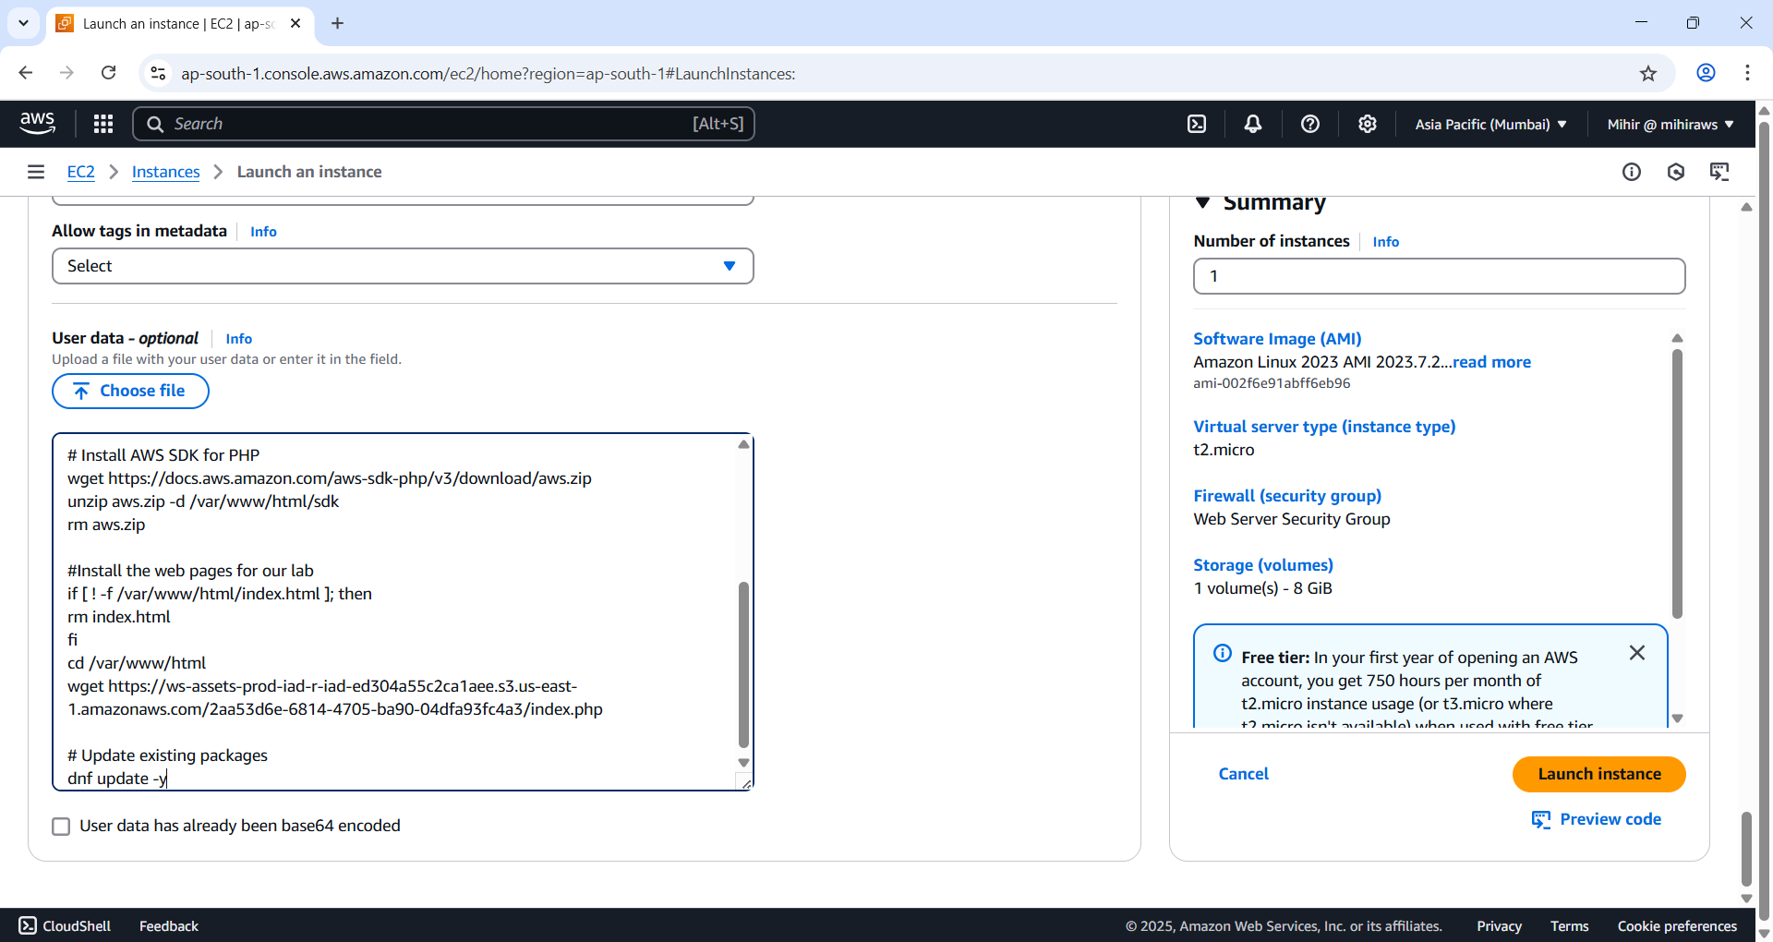

Figure 34 Launch Instance.

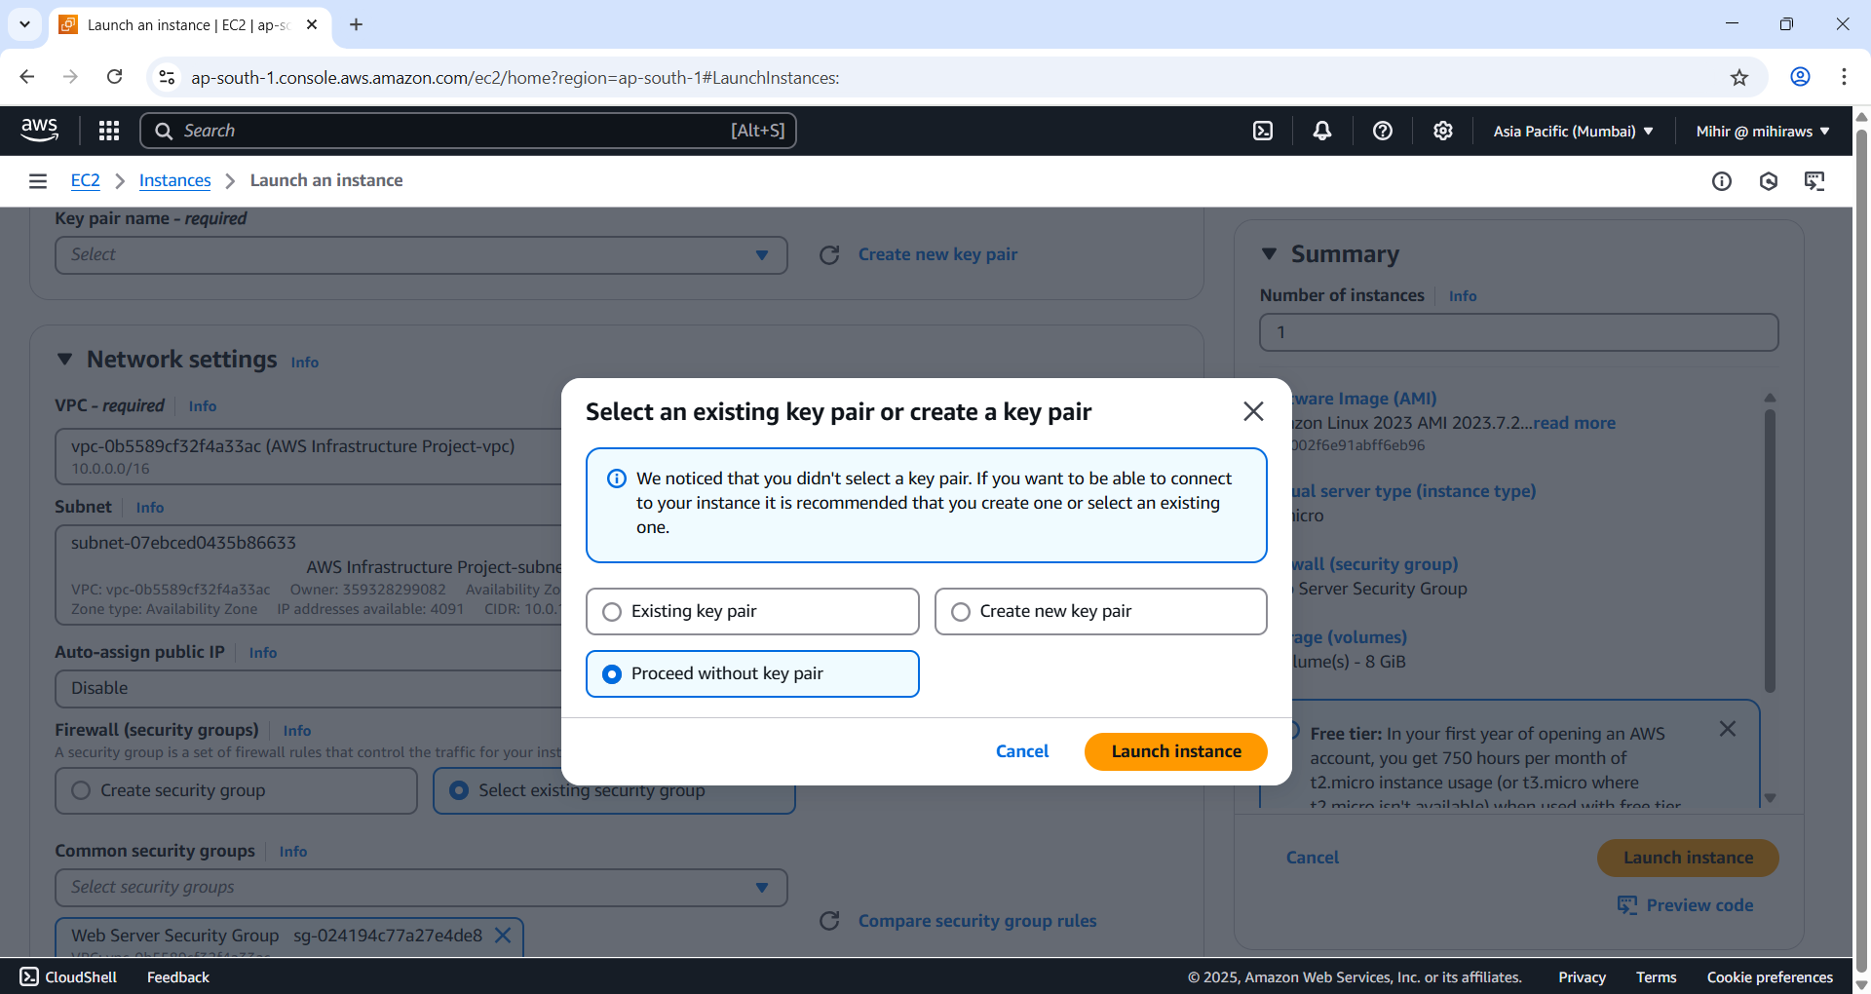

Figure 35 Proceed without key pair.

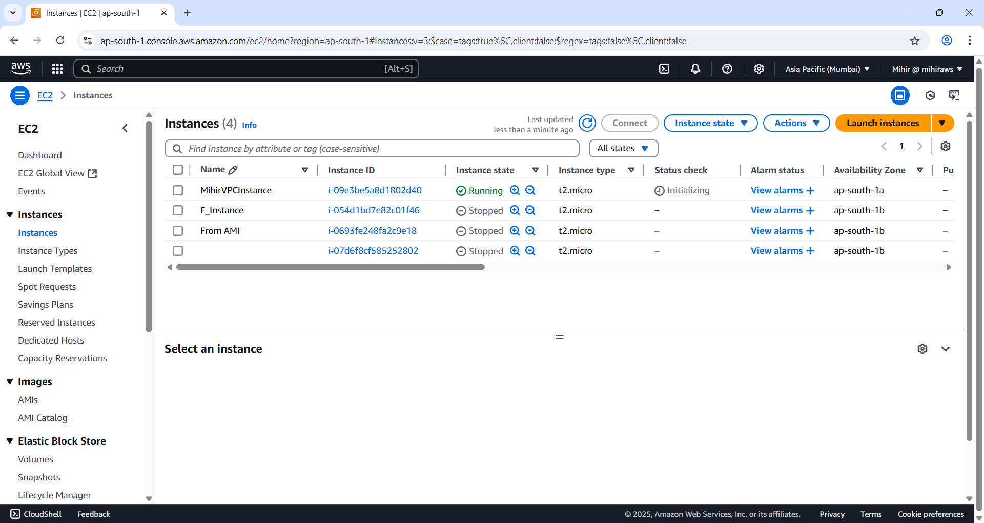

Figure 36 Instance Created.

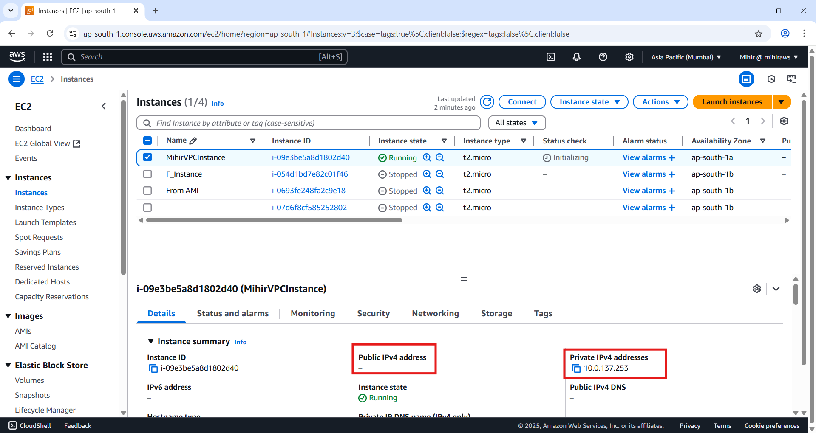

Figure 37 Notice it doesn’t have public IP iit only has private IP.

Do not close the EC2 Page.

### AWS Session Manager

**Session Manager** is a fully managed capability within **AWS Systems Manager**. It enables secure and seamless access to manage Amazon EC2 instances, edge devices, on-premises servers, and virtual machines (VMs) without needing to open inbound ports or maintain bastion hosts.

In this setup, Session Manager is used to securely administer the web server instance, which resides in a private subnet and only has a private IP address. Despite not having a public IP or requiring SSH access, the instance can still be managed through Session Manager. This enhances security by avoiding direct exposure to the internet.

Upon connection via Session Manager, administrators can run shell commands to inspect the instance. For example, a command may reveal both the private IPv4 address (assigned directly to the instance) and the public IPv4 address. The public IP shown in this context is typically the **Elastic IP attached to the NAT Gateway**, which enables internet access for resources within the private subnet—like the web server.

This confirms successful setup and management of the instance via Systems Manager without compromising security. Additionally, Session Manager supports secure port forwarding for advanced use cases, allowing local development environments to securely connect to EC2 instances without exposing SSH or RDP ports.

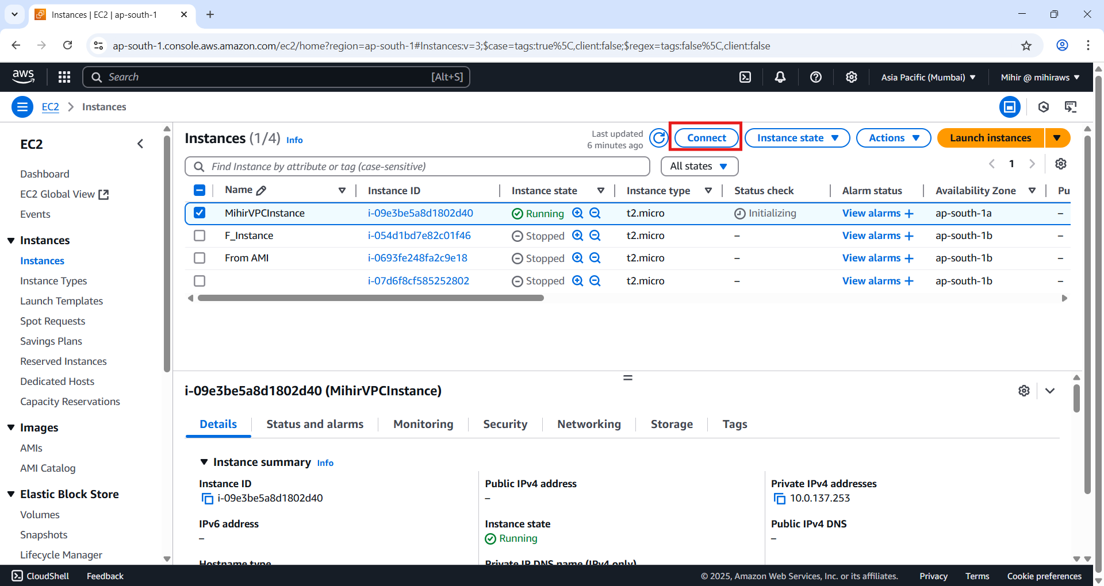

Figure 38 Click 'Connect' to launch session manager.

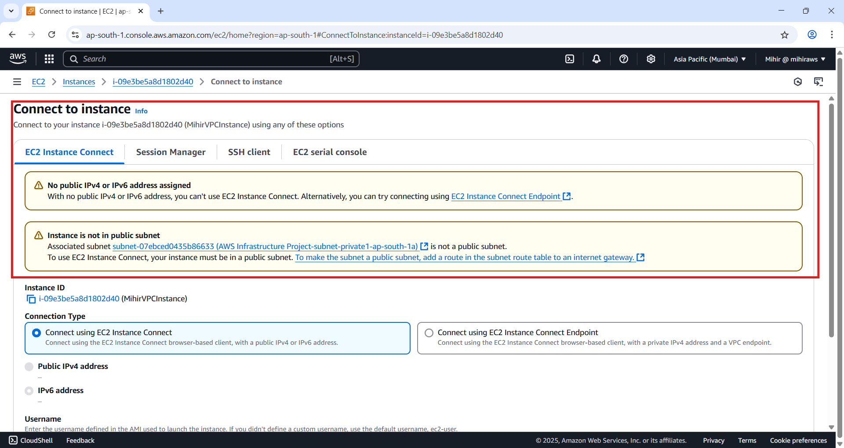

Figure 39 Observe since EC2 doesn't have access to pubic IP it has displayed a message saying cannot connect to instance. So we will use session manager tab to connect.

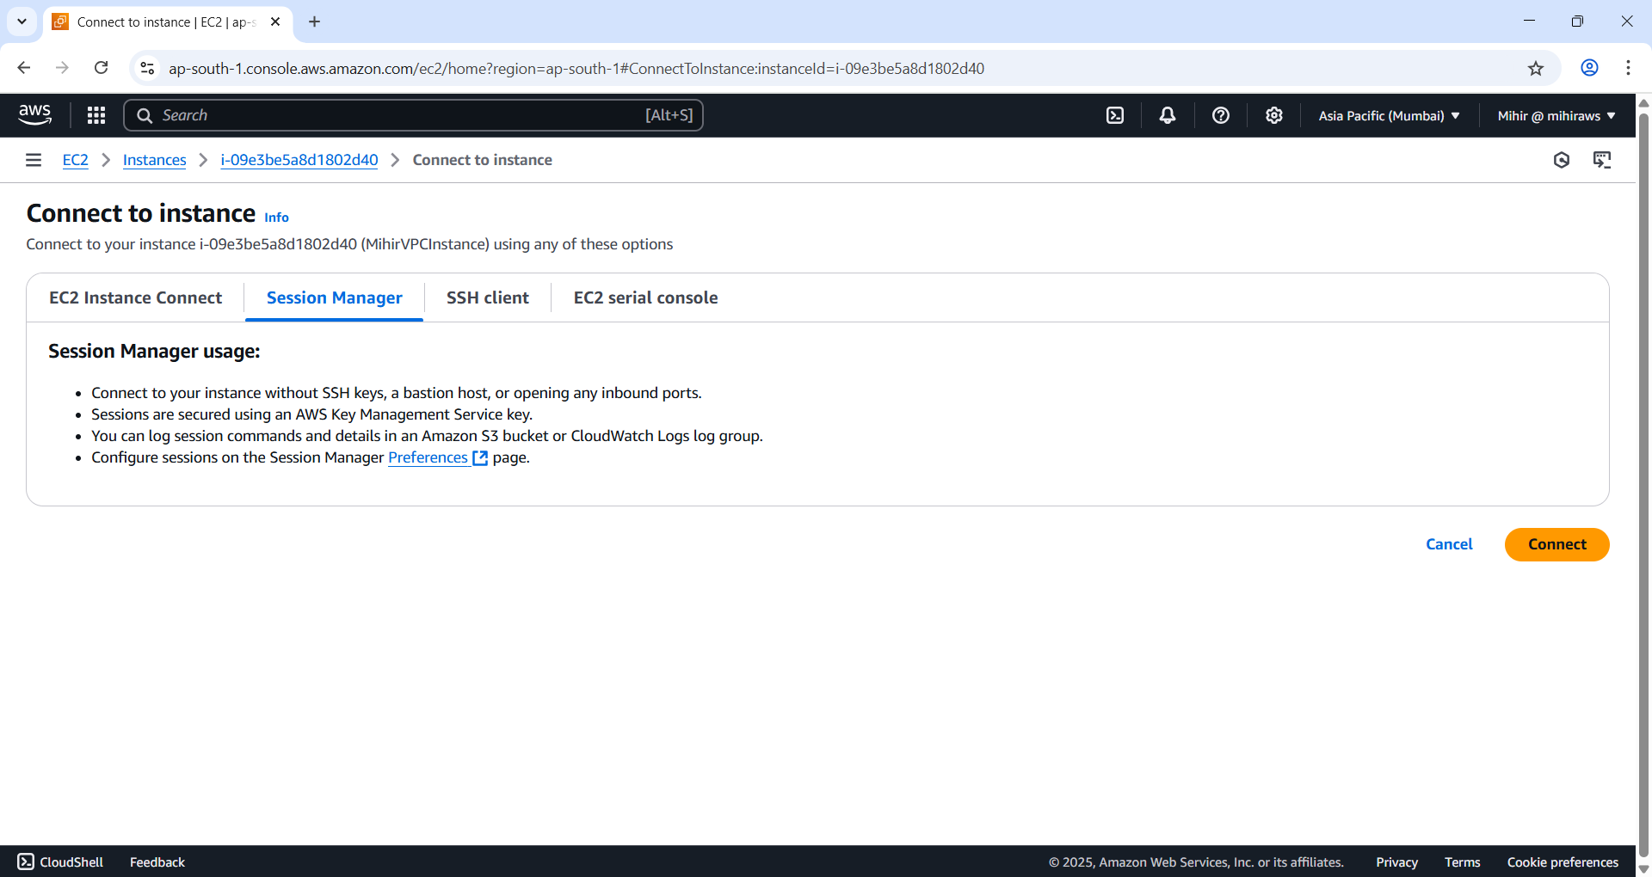

Figure 40 Click 'Connect'.

Copy and paste the following command:

echo -n 'Private IPv4 Address: ' && ifconfig enX0 | grep -i mask | awk '{print $2}'| cut -f2 -d: && \

echo -n 'Public IPv4 Address: ' && curl checkip.amazonaws.com

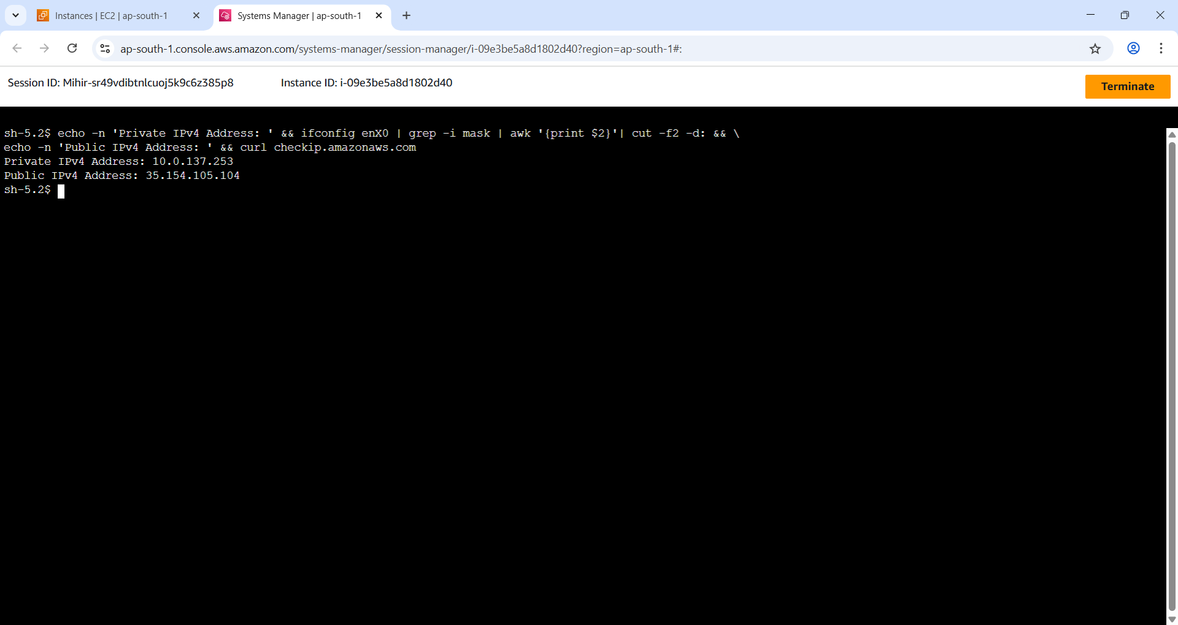

Figure 41 As you can see we have access to our instance without SSHing into it.

Note: The Public IP displayed here is IP for NAT Gateway.

### Application Load Balancer

**AWS Load Balancers** distribute traffic across infrastructure for better availability and performance. In this context, an **Application Load Balancer (ALB)** is used to route HTTP web traffic to a single EC2 instance hosting a web server. The ALB manages network configuration and enforces security policies to ensure secure client-server communication.

Unlike other types such as the **Network Load Balancer (NLB)**, the **ALB operates at the application layer (OSI layer 7)**, offering advanced routing based on content-level details like path or headers.

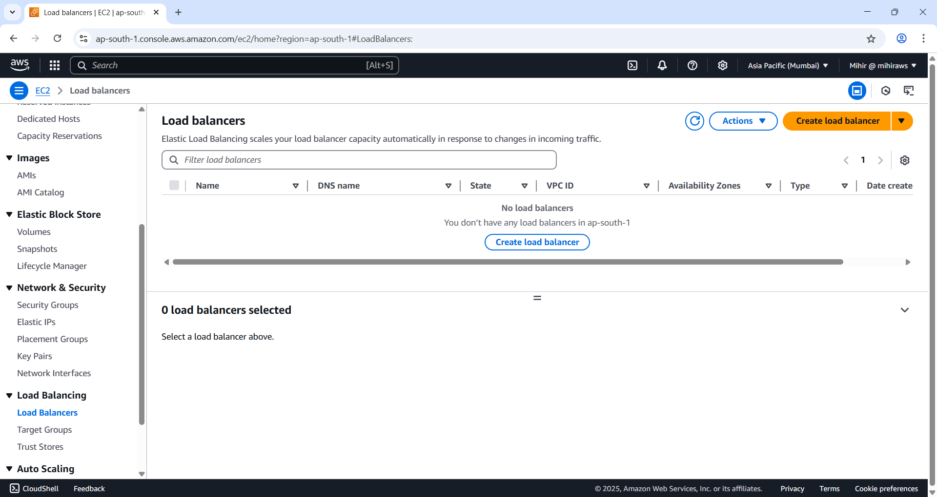

Figure 42 Go to load balancers on the left. Hit ‘Create load balancer’.

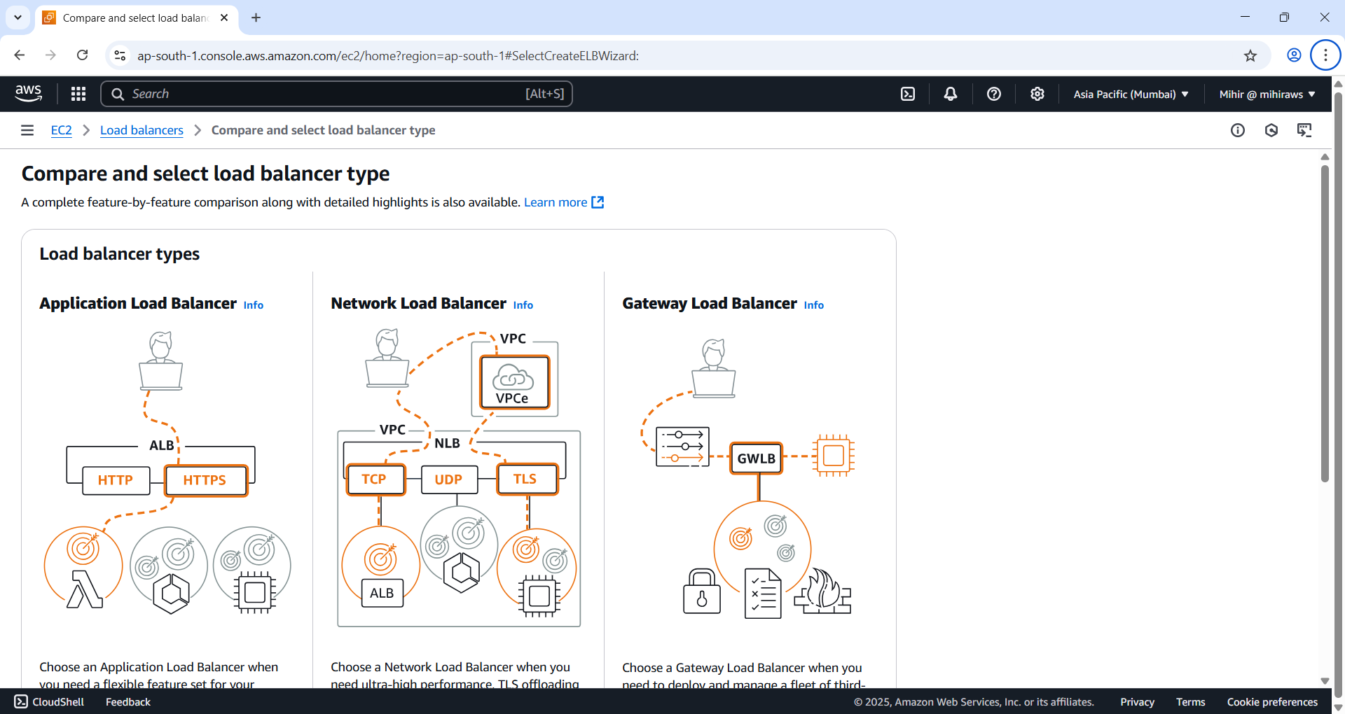

Figure 43 Select 'Application Load Balancer'.

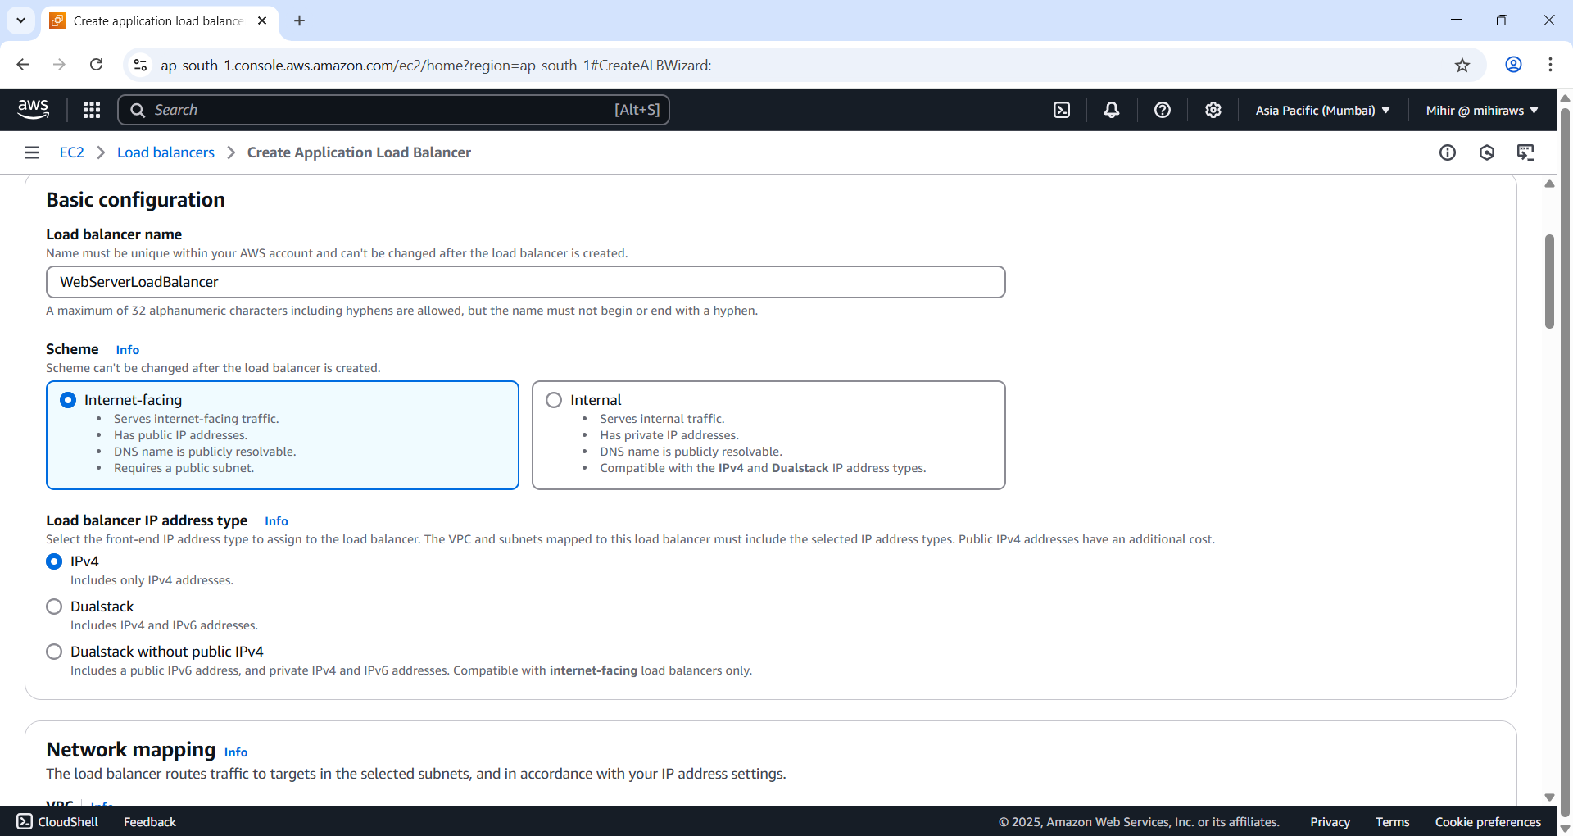

Figure 44 Name your public load balancer. Set 'Scheme' to 'Internet facing'. and Set 'Load balancer IP address type' as 'IPv4'.

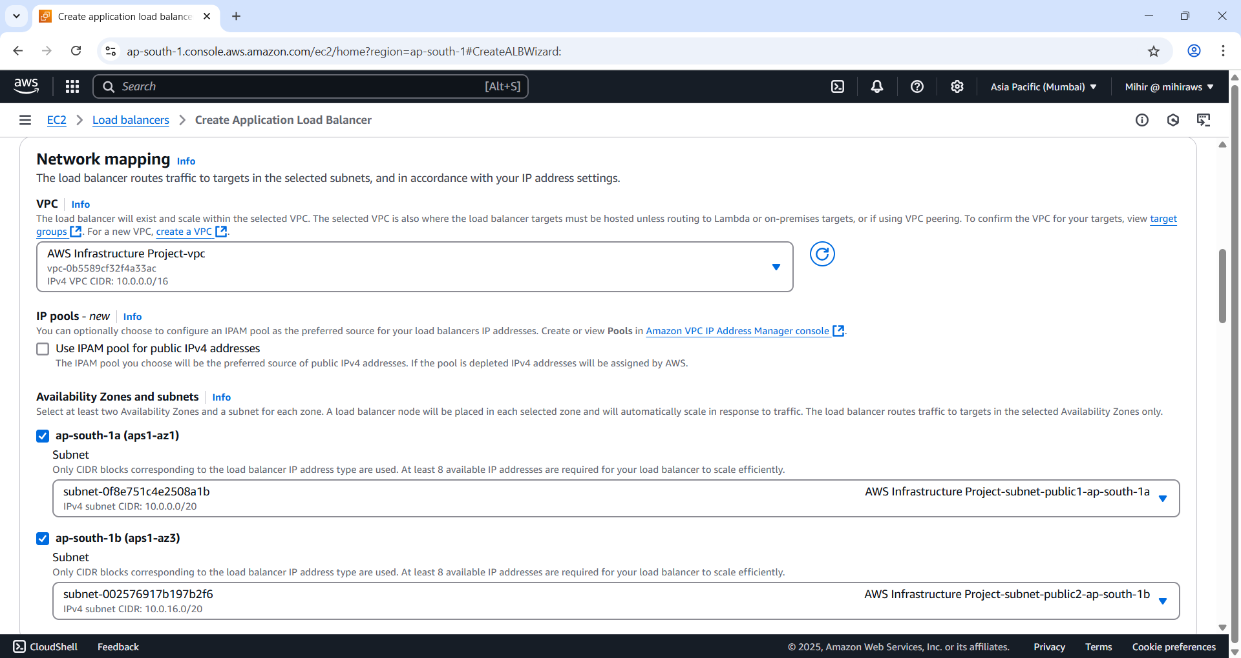

Figure 45 Under network mapping section select 'VPC' the one we created and set 'Availability Zones and subnets' as the one we selected and select corresponding public subnet.

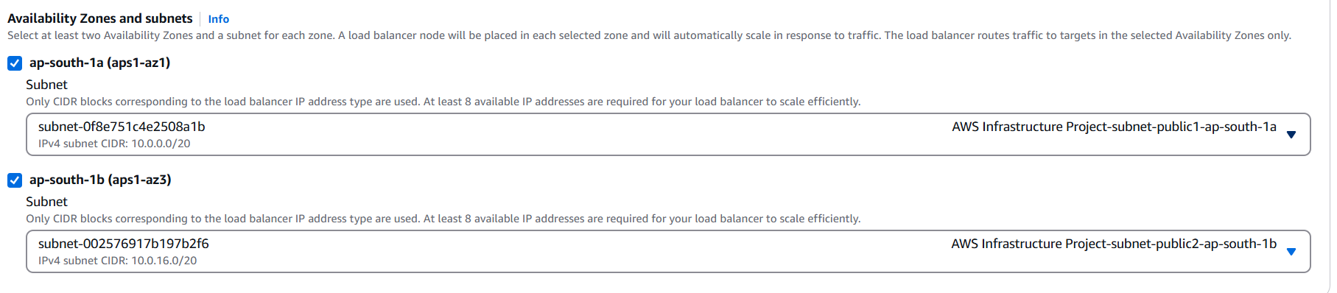

Figure 46 Have a close look.

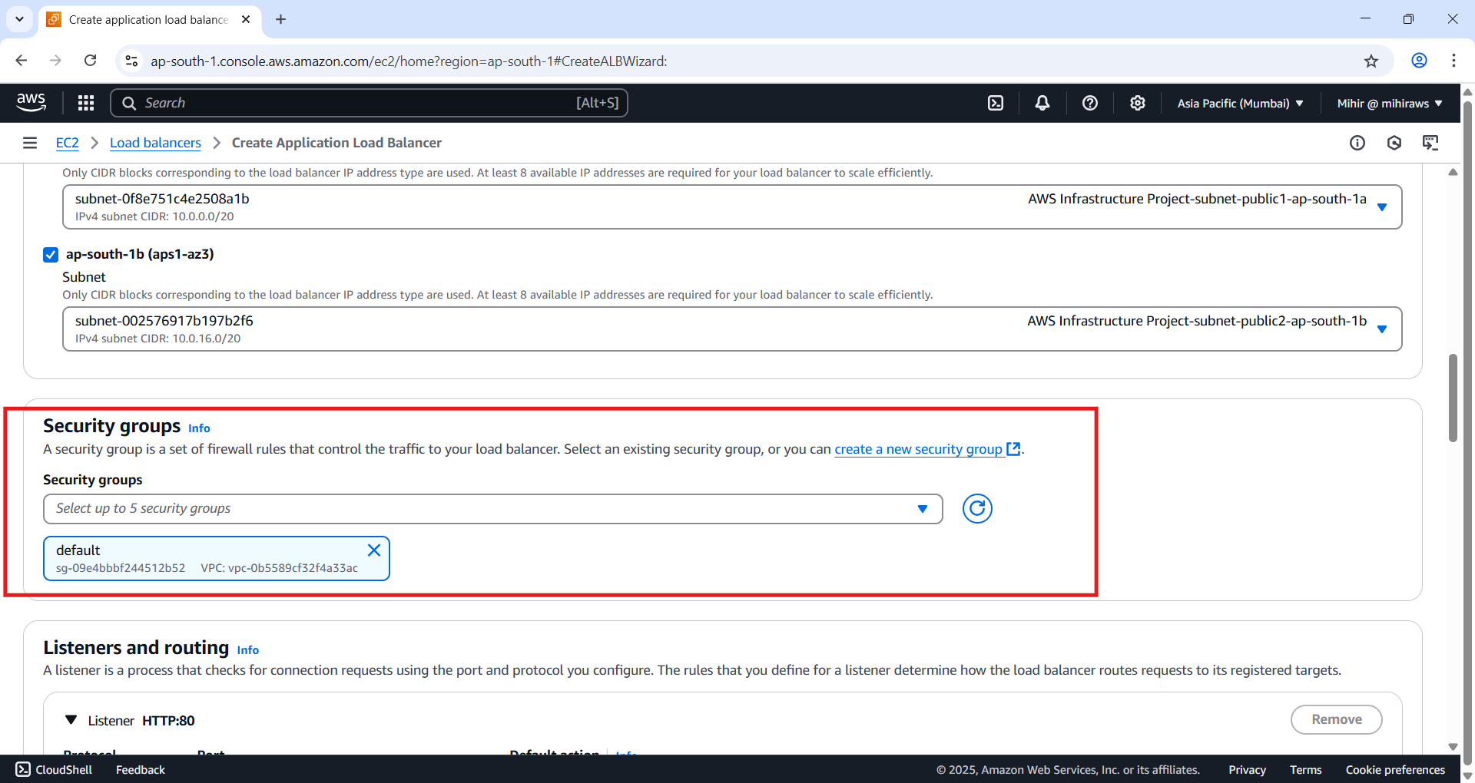

Figure 47 Delete the default Security group and add the one we created for laod balancer from drop down.

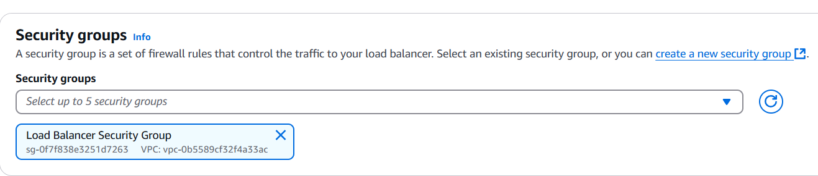

Figure 48 Load Balancer Security Group selected.

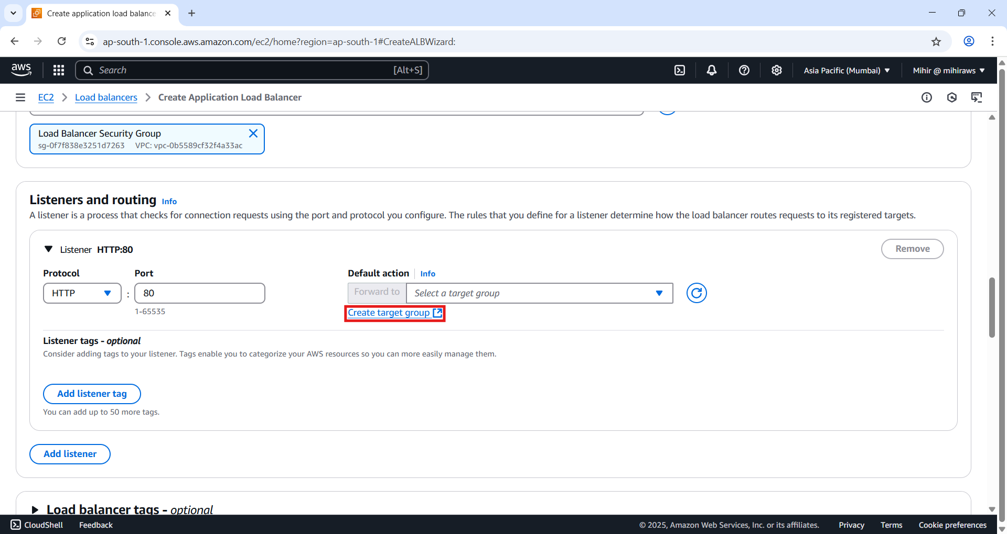

Figure 49 Click 'Create target group’. Do not close anything.

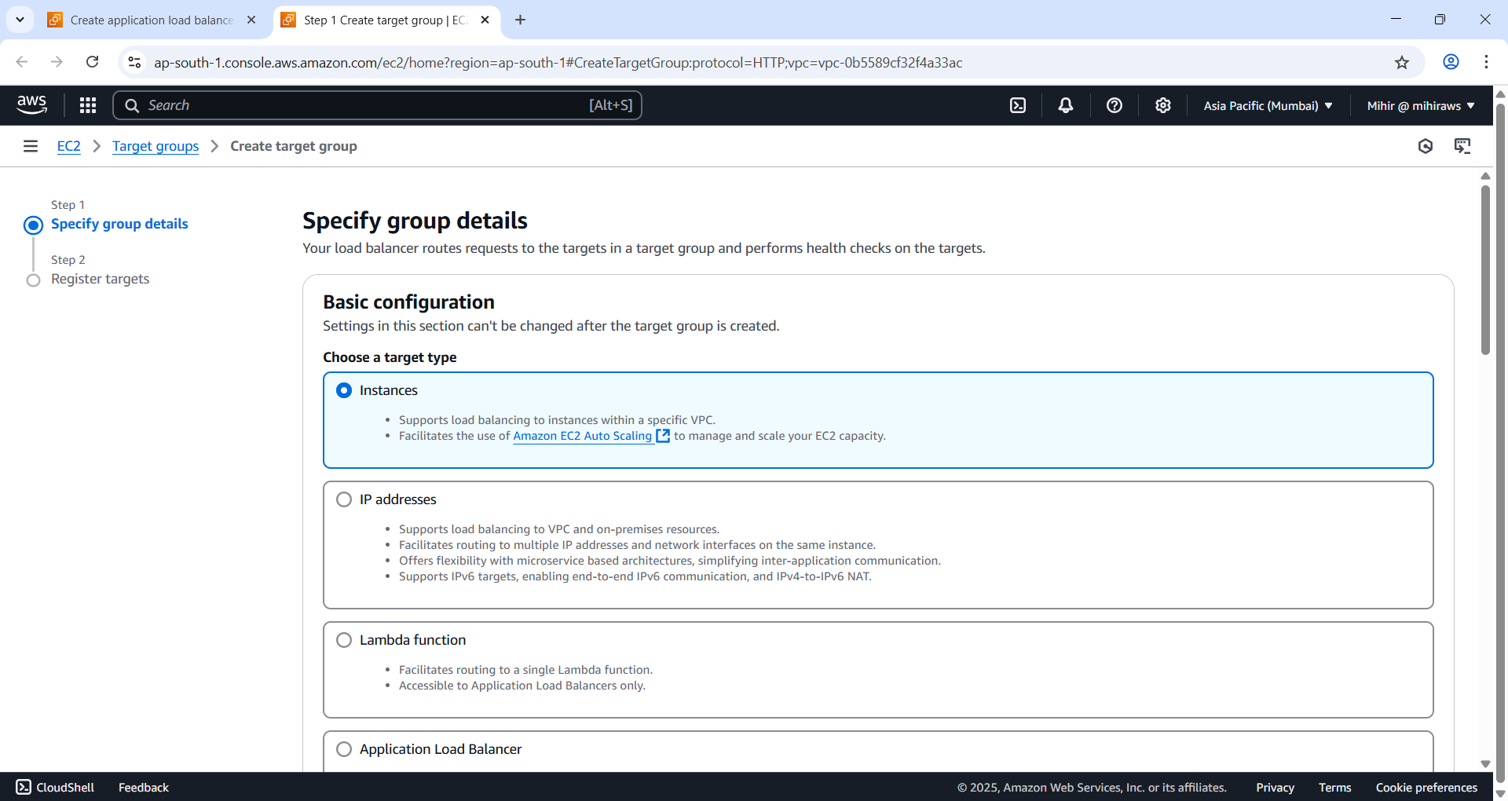

Figure 50 Target type 'Instances'.

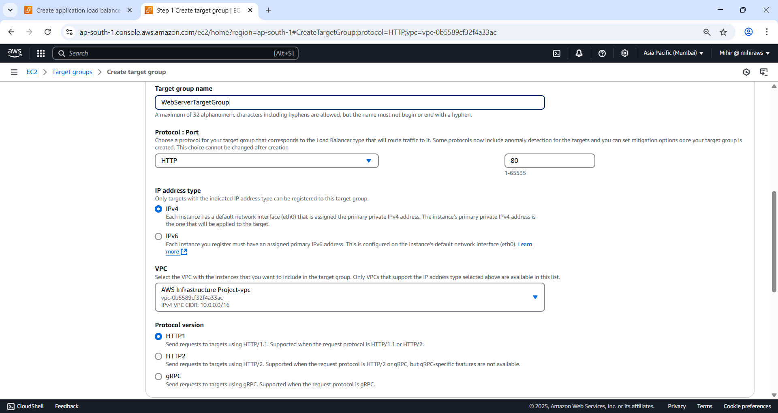

Figure 51 Set Protocol: HTTP, Port : 80, IP address type:IPv4 and Protocol version HTTP1.

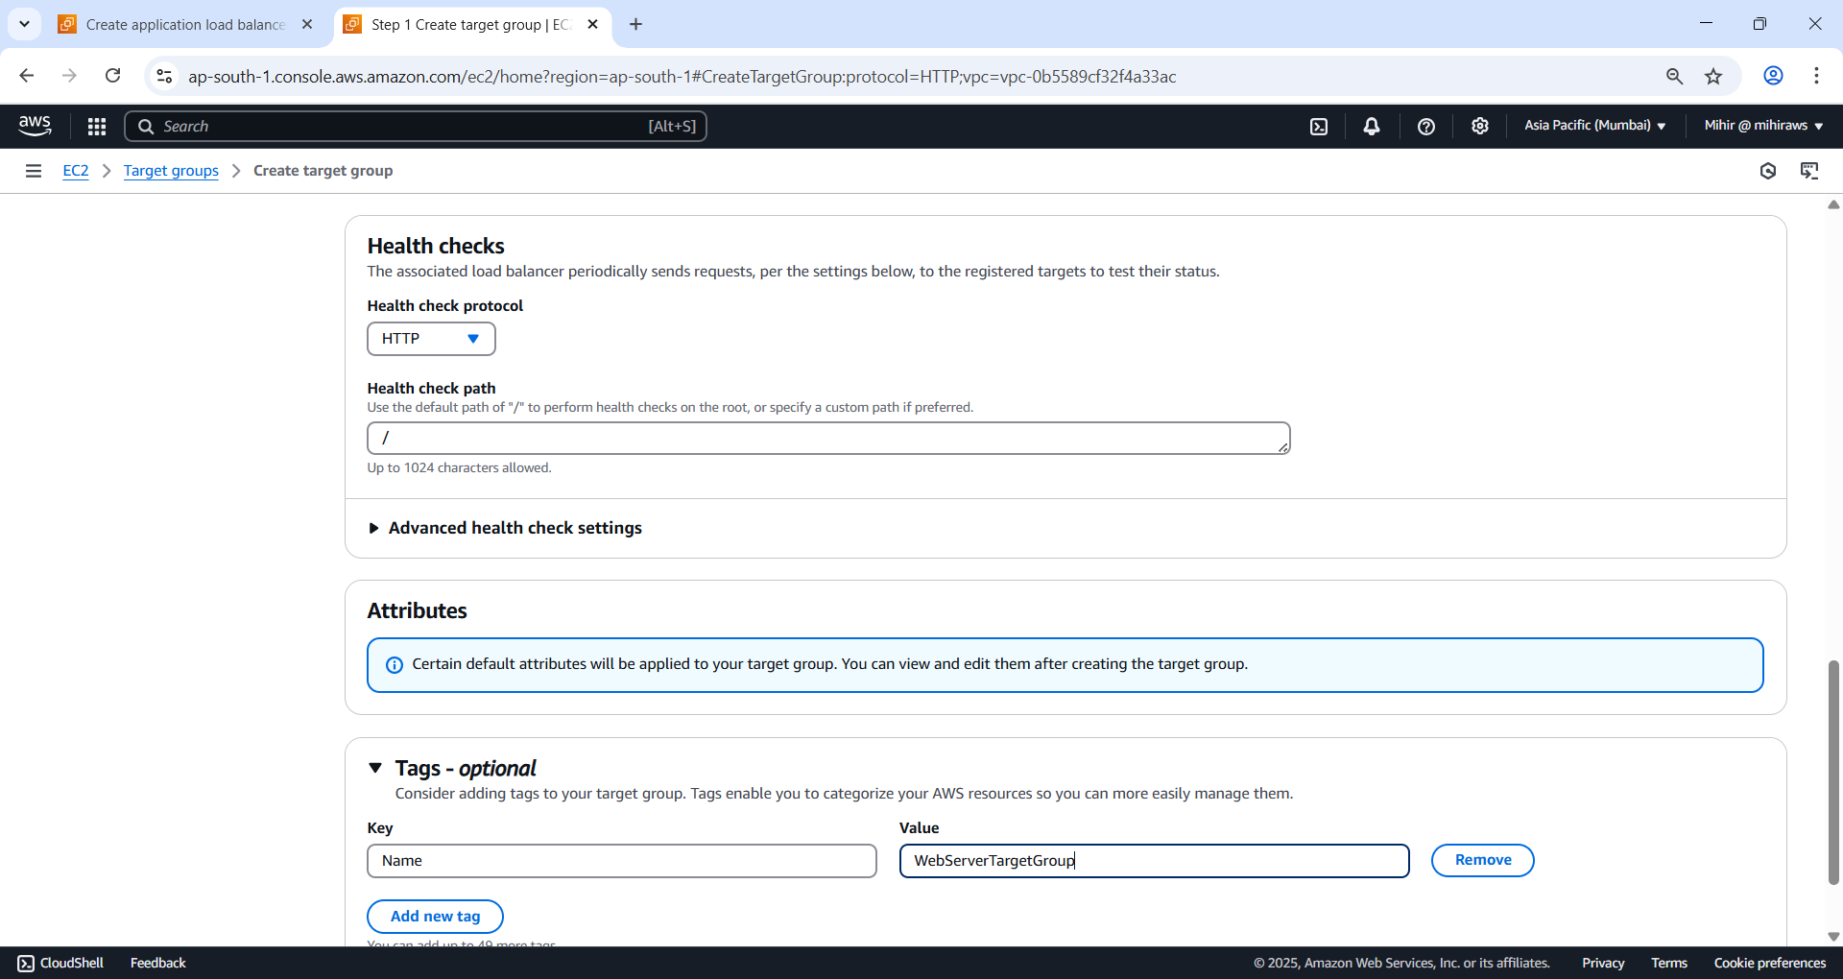

Figure 52 Set Health check protocol to HTTP, Network check path as ‘/’, Create a tag. Key as Name and Value as WebServerTargetGroup. Click ‘Next’ to proceed to target settings.

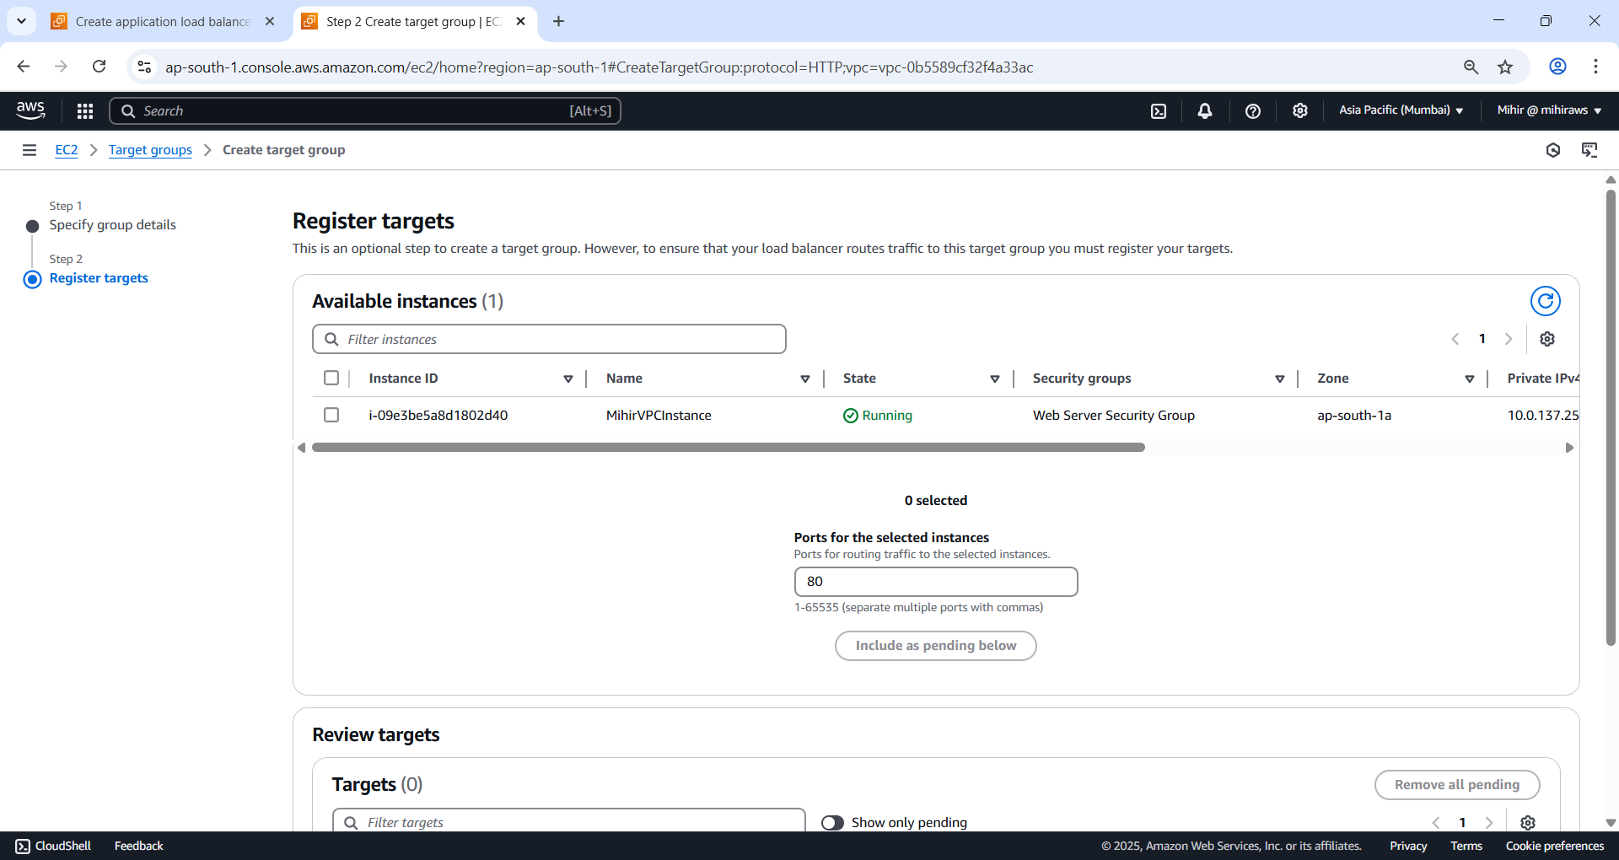

Figure 53 Register targets.

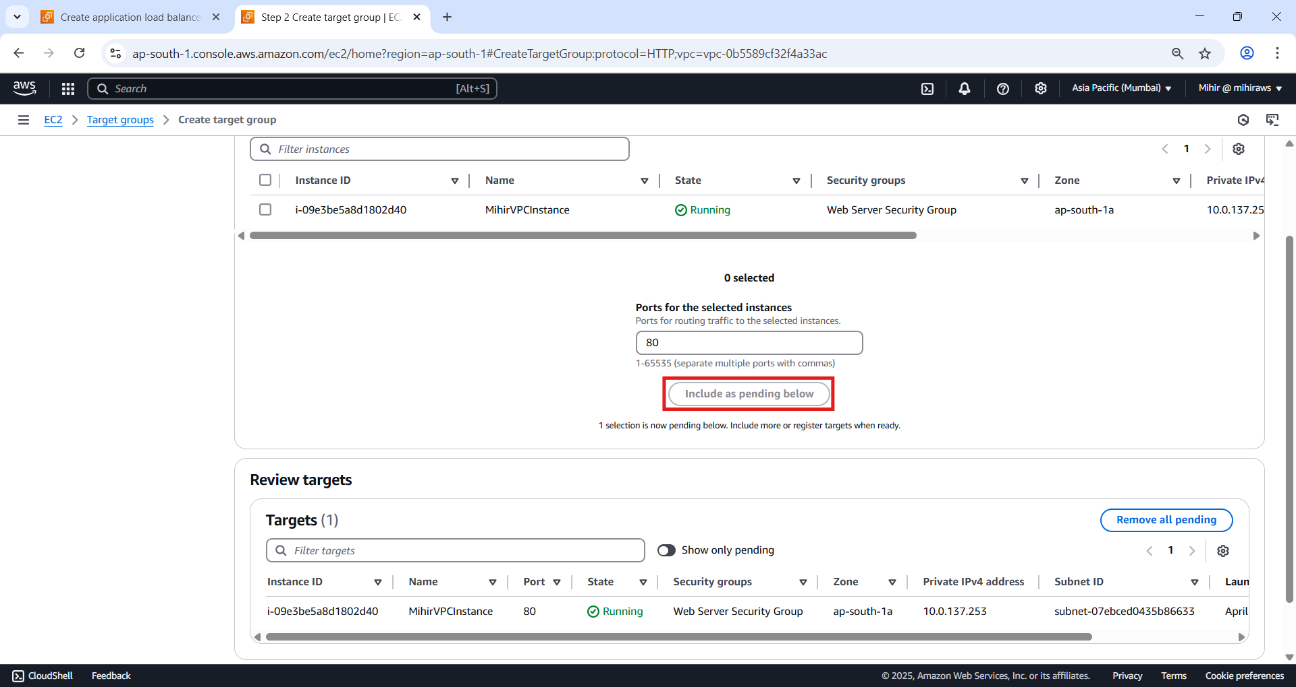

Figure 54 Select your option from list and then clicl 'Include as pending below'.

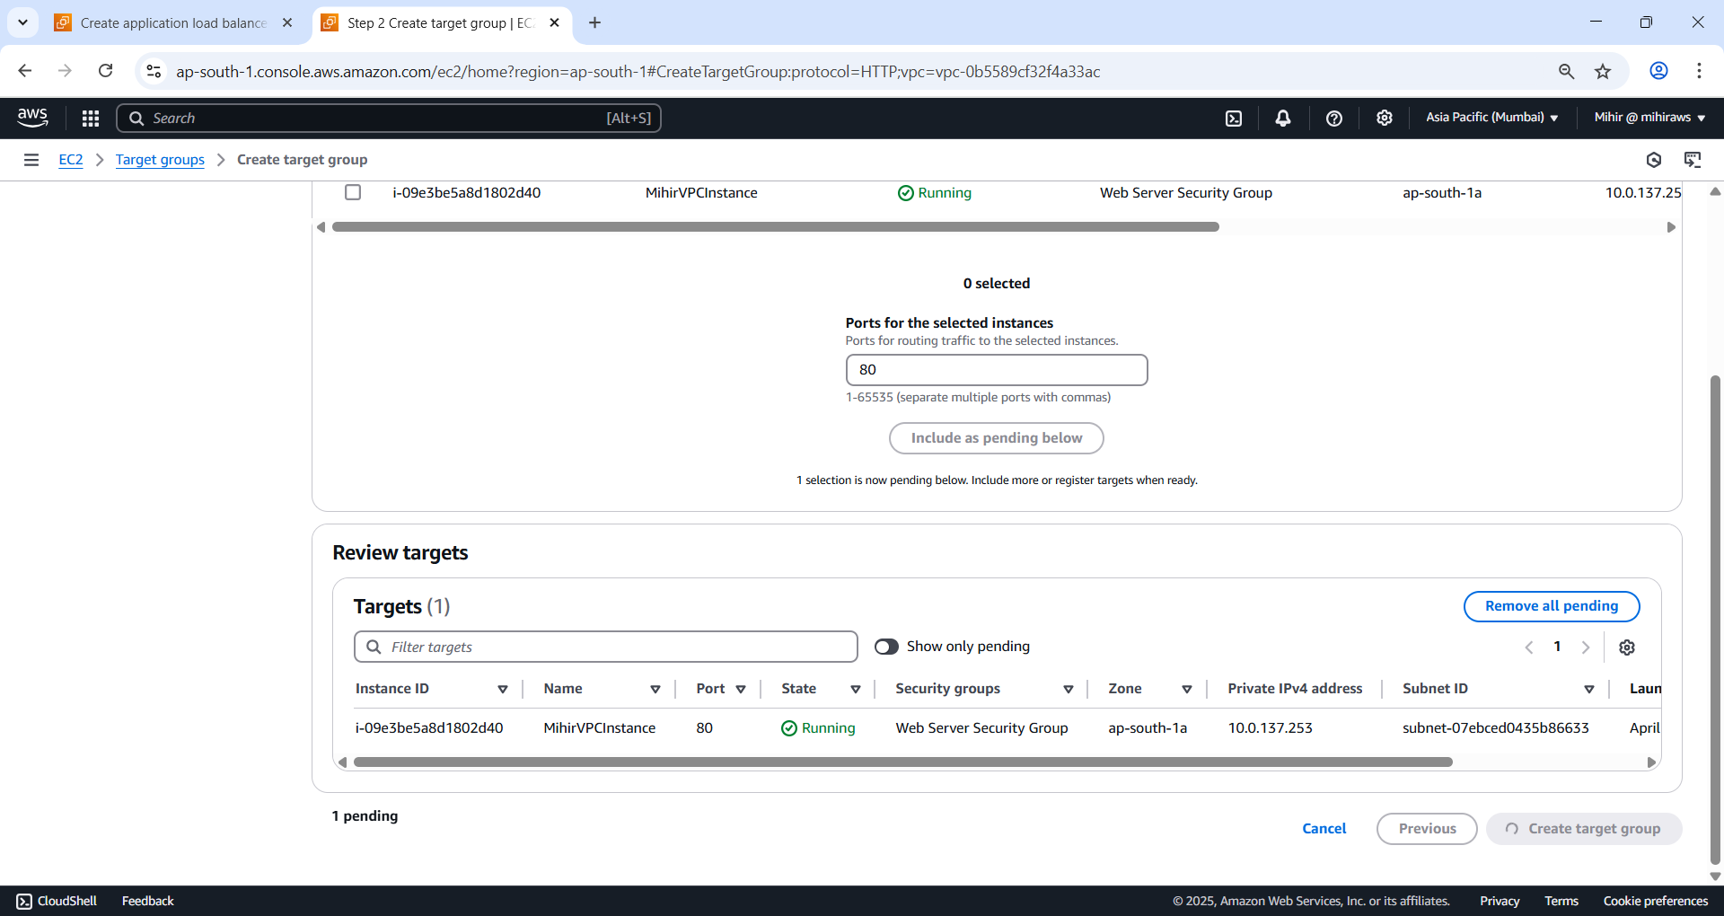

Figure 55 Click 'Create target group'.

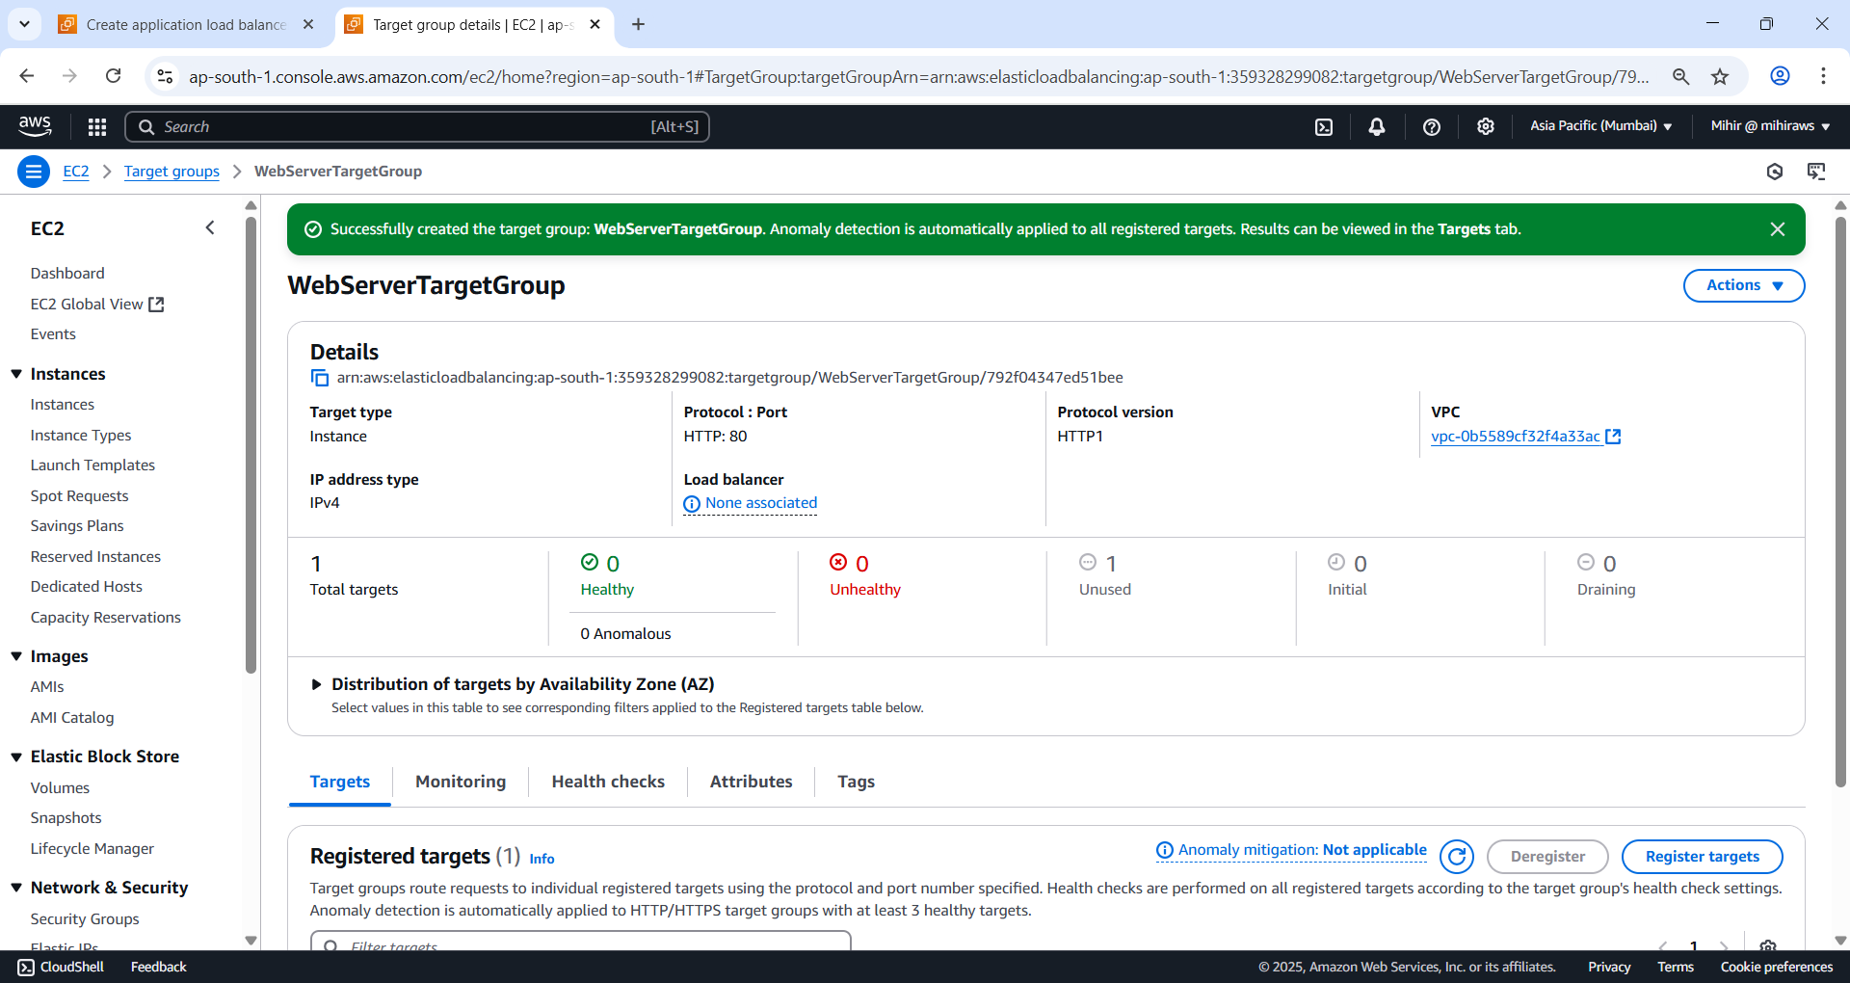

Figure 56 Close this tab.

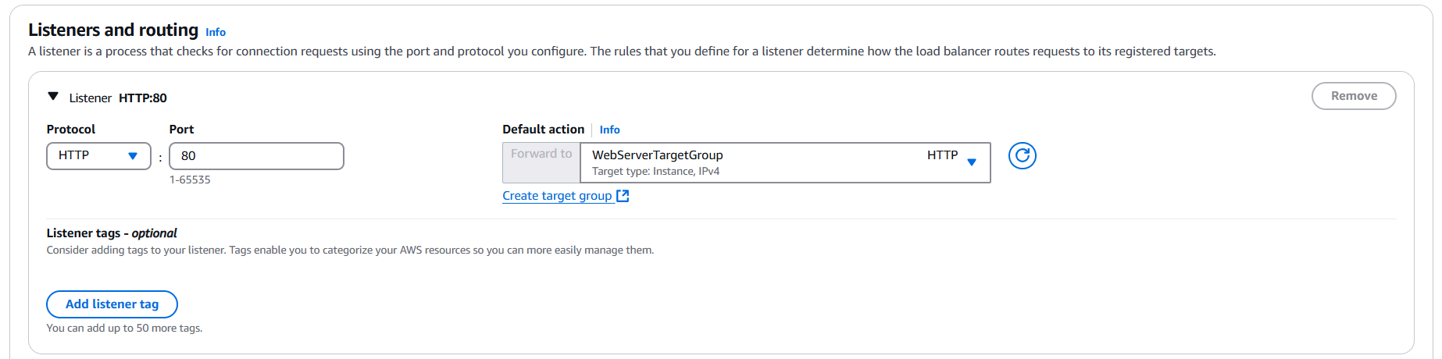

Figure 57 click blue 'Refresh' button at Default location and select WebServerTargetGroup.

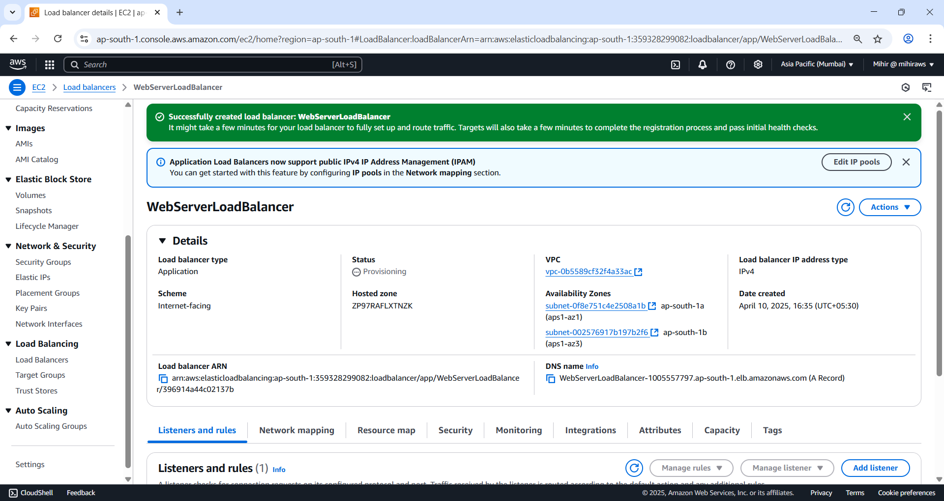

Figure 58 Select 'Create load balancer' button.

**Summary of Key Concepts**

* **Security Groups**: Assigning one to the ALB ensures you control inbound access to the load balancer itself—adding another layer of security on top of the EC2 security group.
* **Target Groups**: These define the destination resources (e.g., EC2 instances) for the ALB to route traffic to.
* **HTTPS Consideration**: Although HTTP is used in this setup, **HTTPS is recommended in production** for encrypted communication.
* **ALB vs. NLB**:
  + ALB: Application layer (L7), content-based routing
  + NLB: Network layer (L4), connection-based routing

**Security Integration**

For enhanced protection, **AWS WAF** (Web Application Firewall) can be integrated with ALB to defend against common web threats like SQL injection or cross-site scripting (XSS).

### Test Site

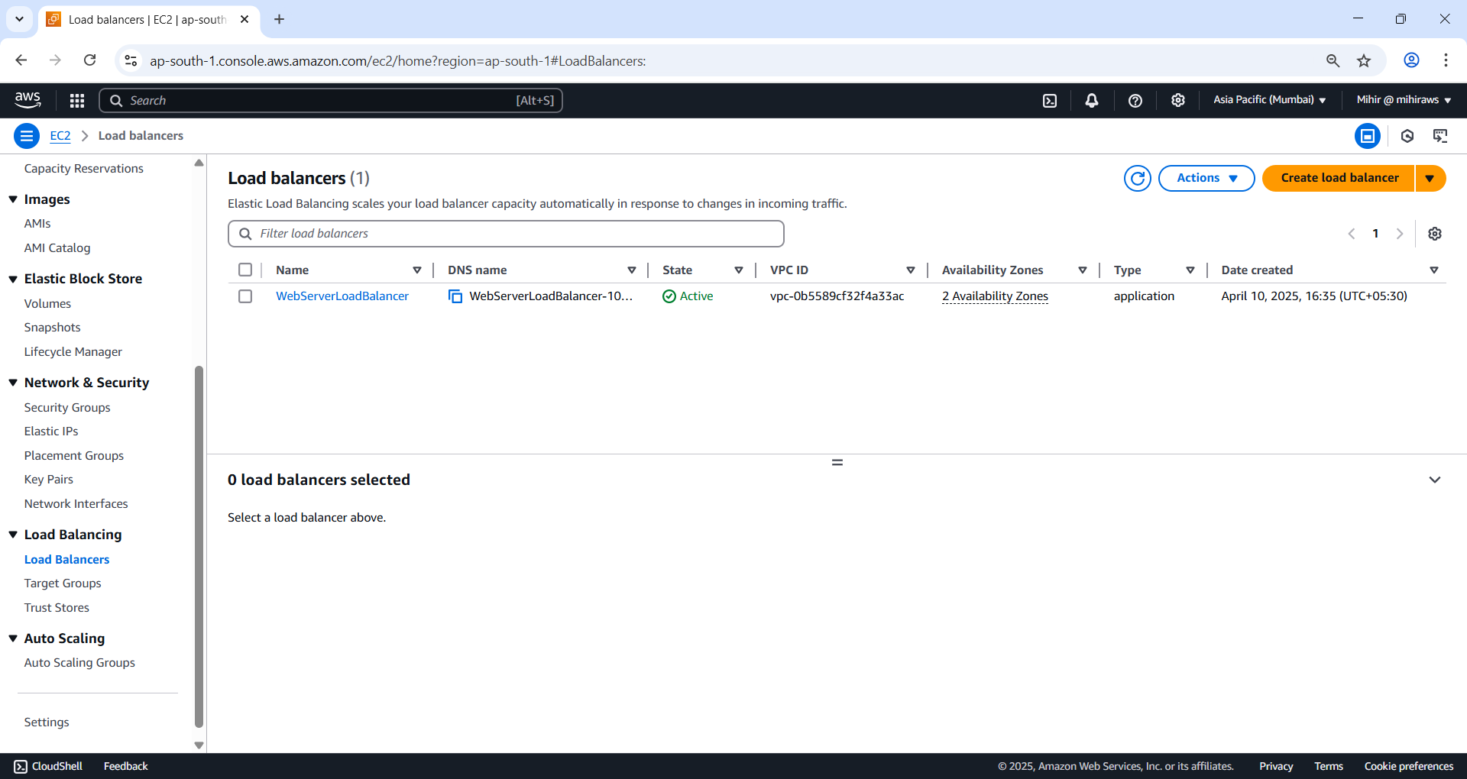

Figure 59 Go to load balancers and check that it's 'Status' is 'Active'.

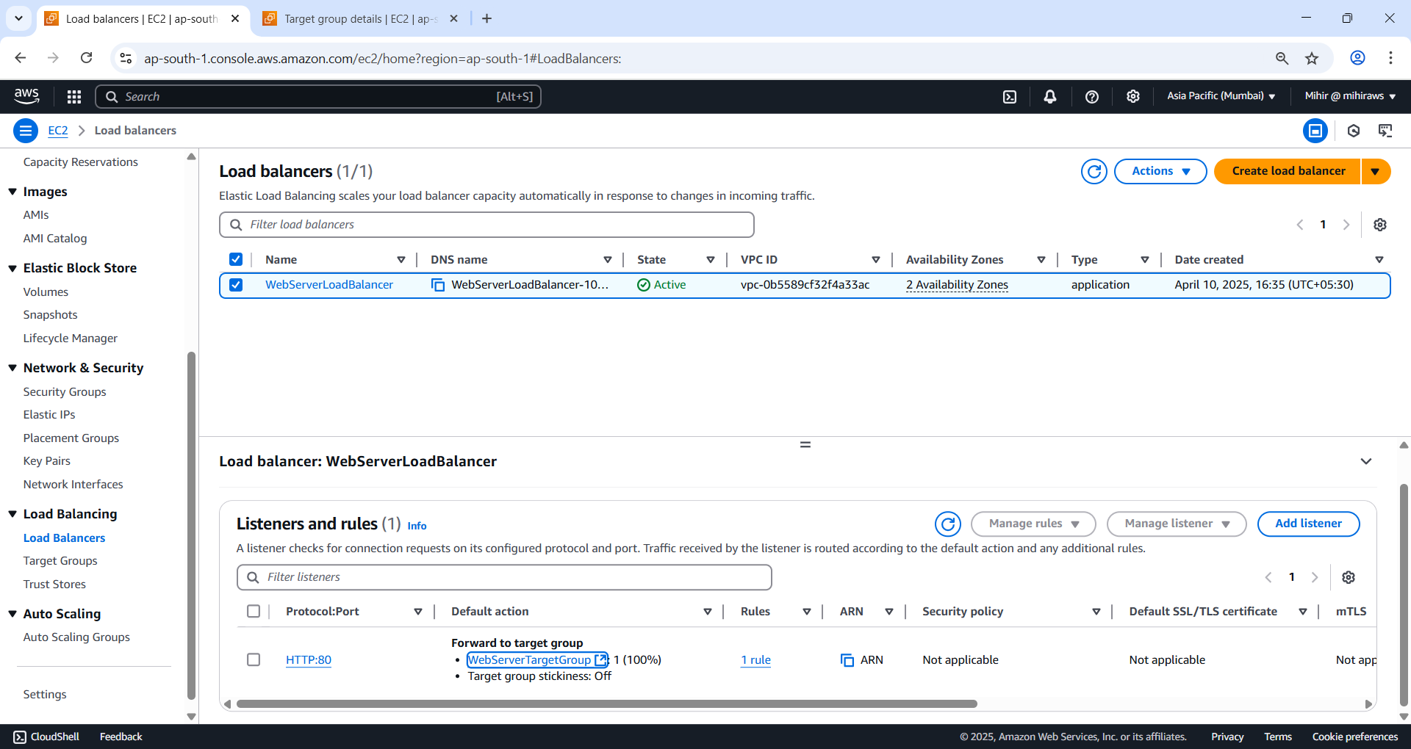

Figure 60. Go to 'Listeners and rules' tab and click on 'WebServerTargetGroup'.

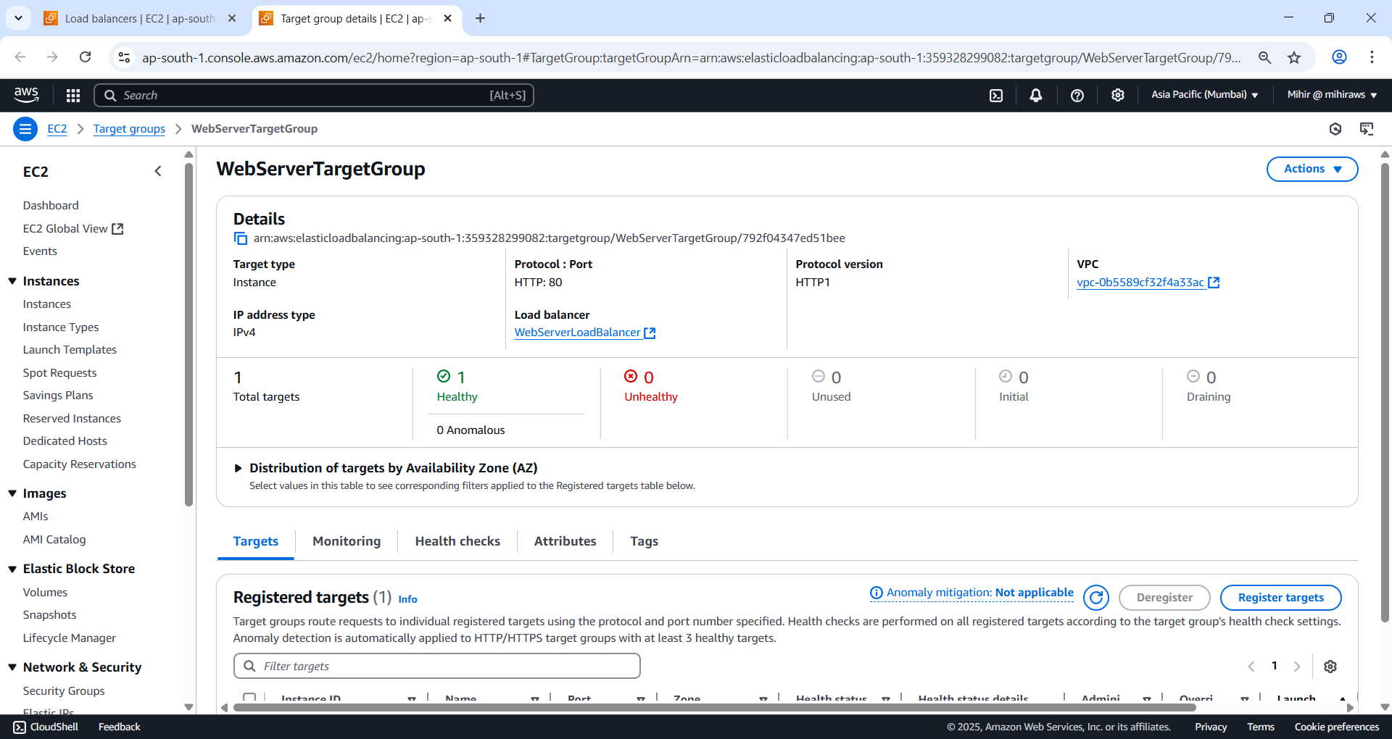

Figure 61 Check it is healthy.

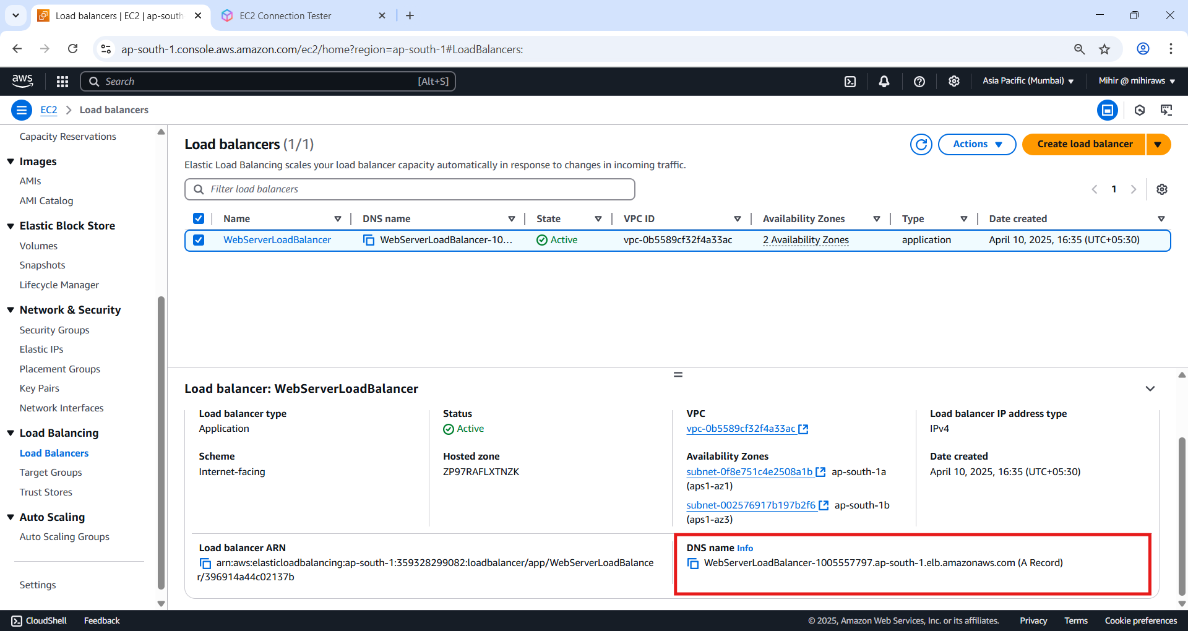

Figure 62 Open it in new tab.

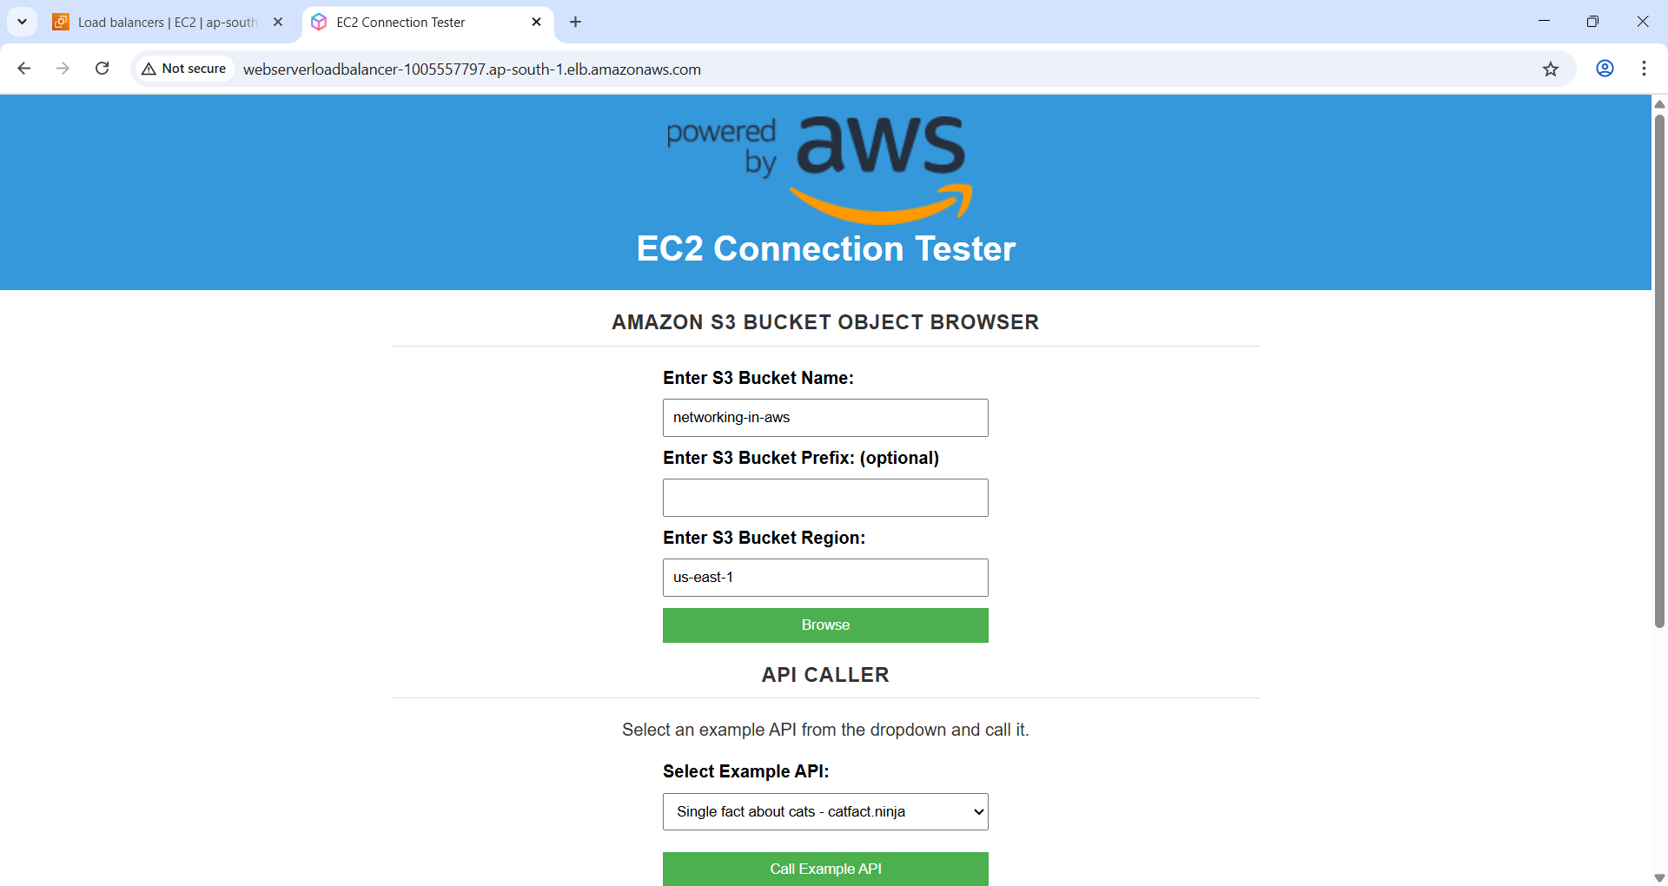

Figure 63 It is working.

Once the **Application Load Balancer (ALB)** is fully provisioned and the associated **target group** reports a healthy instance, the web server can be accessed via its **public DNS name**.

**Verification Steps**

* Ensure the **ALB state** shows as **Active** in the EC2 dashboard.
* Under the **Listeners and rules** tab, click the **WebServerTargetGroup** and verify that **one healthy target** is listed.
* This setup process typically takes **3–5 minutes** to complete.

**Accessing the Web Server**

* The **Load Balancer's DNS name** serves as the public URL for the website.
* Since only **port 80 (HTTP)** is open, make sure to **manually enter http://** before the DNS name in your browser.
  + If the browser defaults to https://, the request will fail due to lack of SSL configuration.

**Expected Result**

* A functioning website appears when accessed through the ALB’s public URL.
* The website includes various features, such as actions related to **Amazon S3 storage**.
* You can test the site's API capabilities using the **EC2 Connection Tester App** to confirm that the EC2 instance in the **private subnet** can communicate with the internet (enabled via **NAT Gateway**).

**Architecture Note**

* While functional, this architecture has **single points of failure**:
  + One EC2 instance
  + One NAT Gateway
* For **higher availability and resilience**, it is recommended to explore **Amazon EC2 Auto Scaling** as a next step.

### S3

Amazon S3 (Simple Storage Service) is an industry-leading object storage service used for a wide range of purposes, including:

* Data lakes
* Cloud-native applications
* Mobile apps
* Secure data storage and retrieval at scale

In this section, the goal is to **store files in an S3 bucket** and **enable access via the website** you previously deployed.

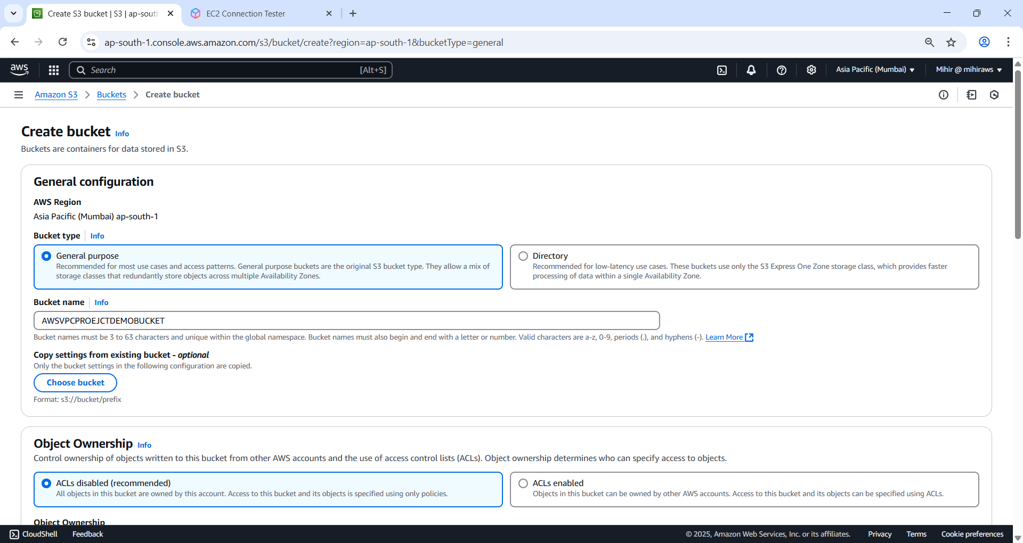

Figure 64 I skipped basic steps just go to create bucket and give it a globally unique name. Leave everything to default and hit 'Create bucket'.

Note: I changed name and remember no spaces and only lower-case letters. My bucket name is ‘awsbucketforvpc’.

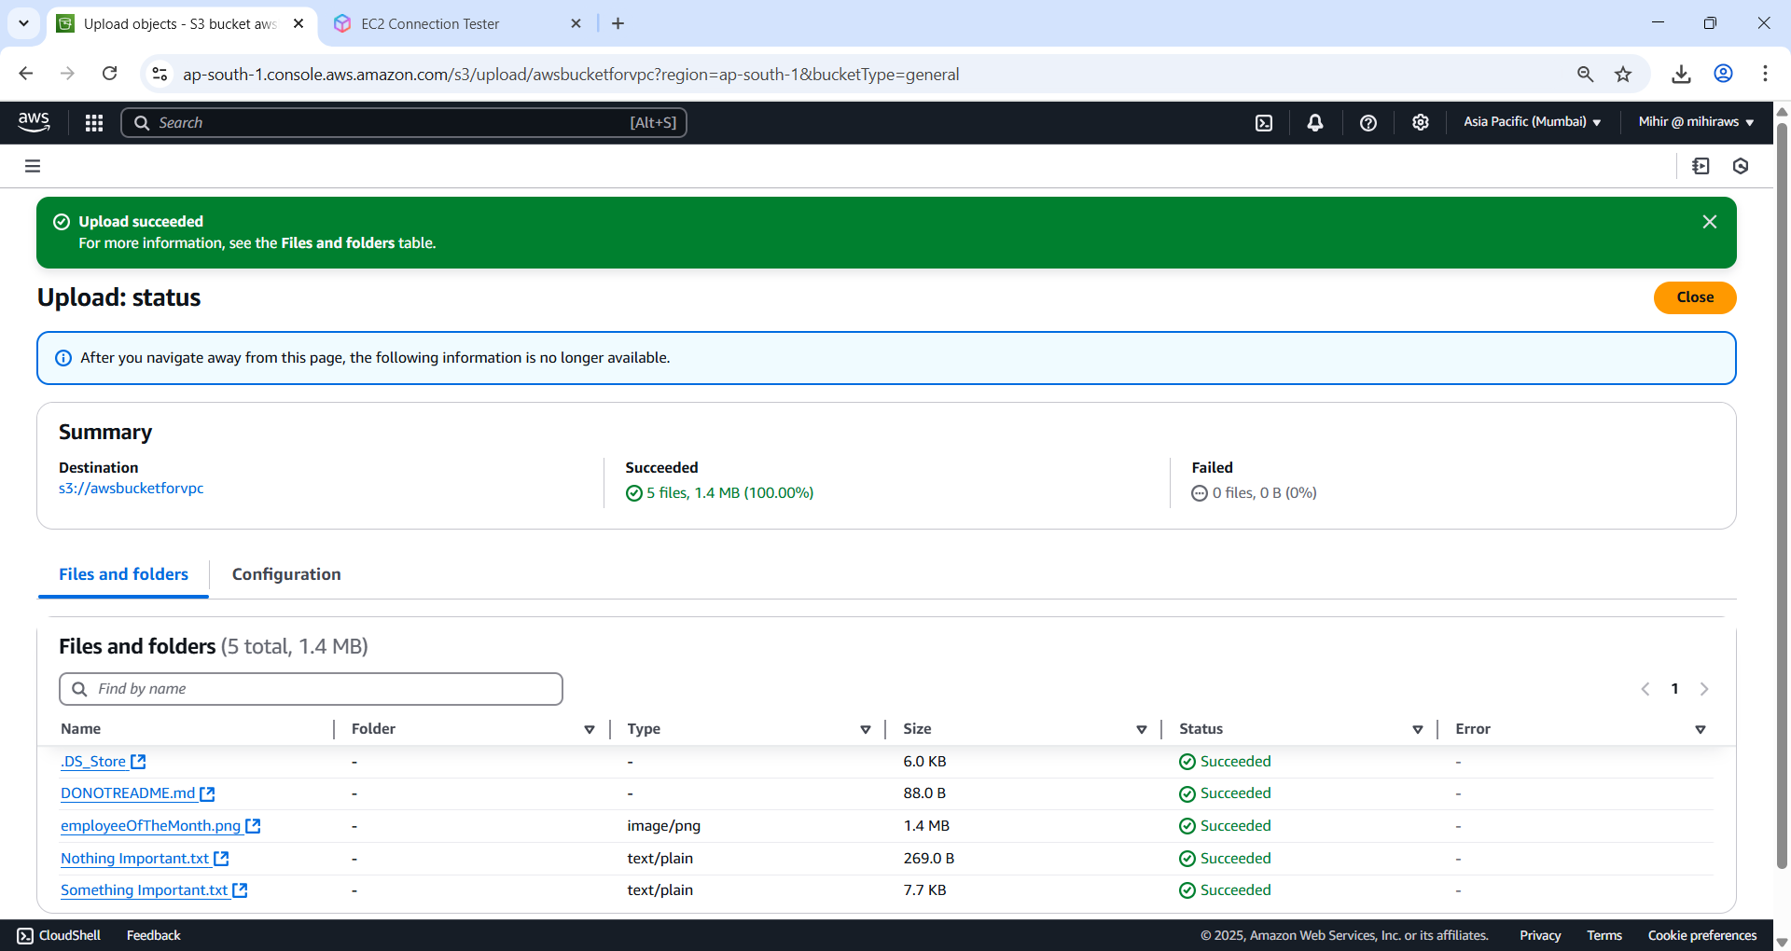

Figure 65 Uploaded the files to bucket now switch to the test server.

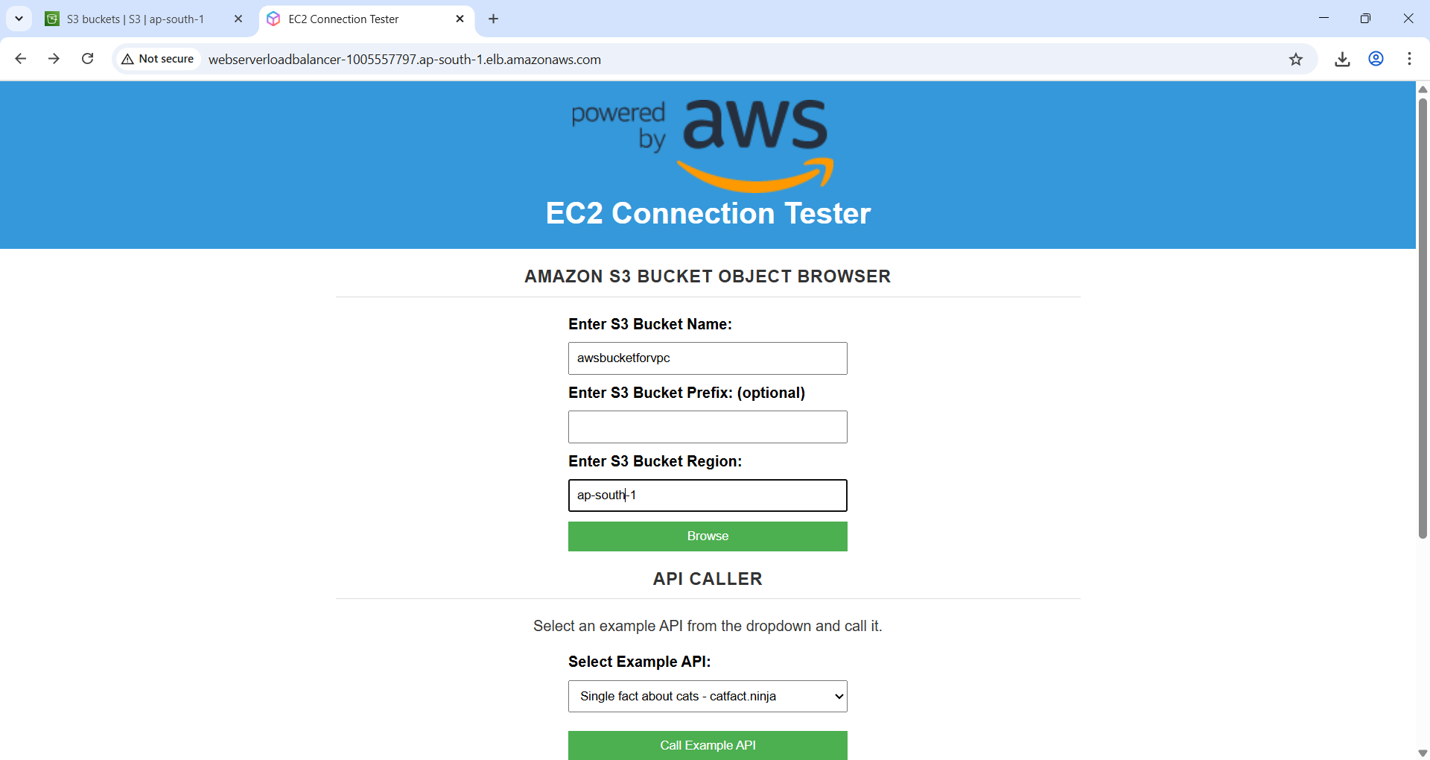

Figure 66 Enter your S3 bucket name and region. It will throw an error.

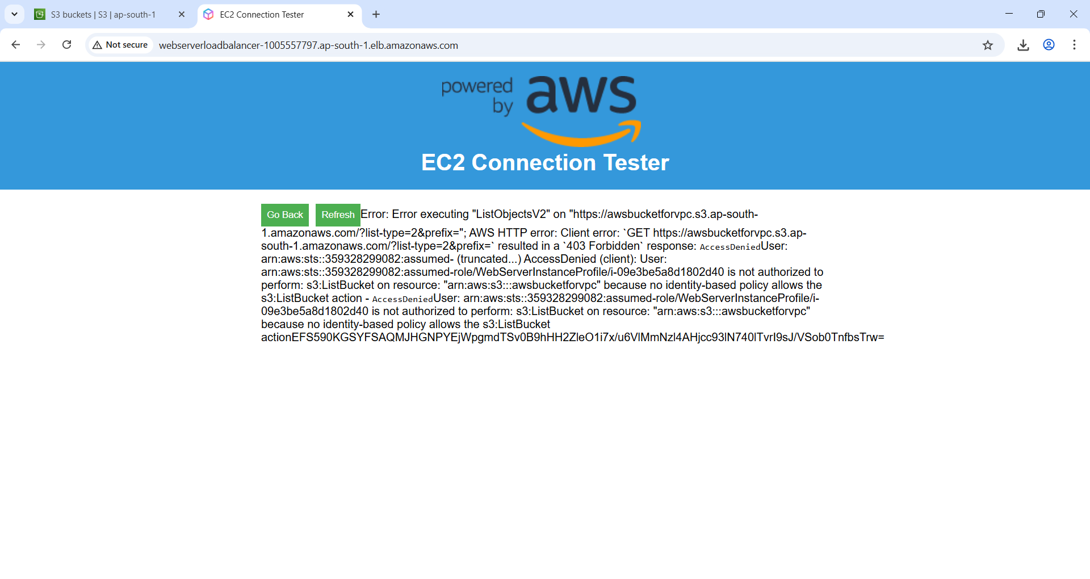

Figure 67 This is because we did not give access to S3 bucket.

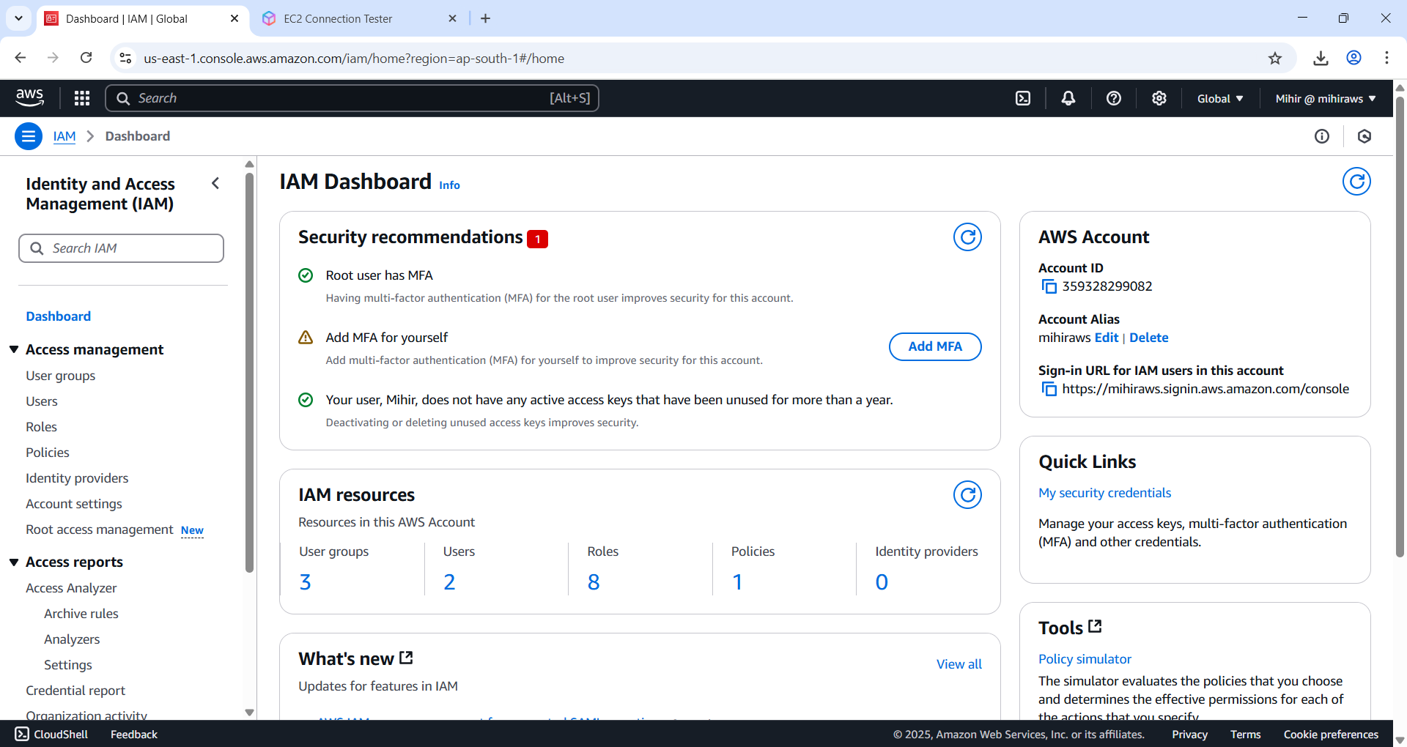

Figure 68 Browse to IAM page.

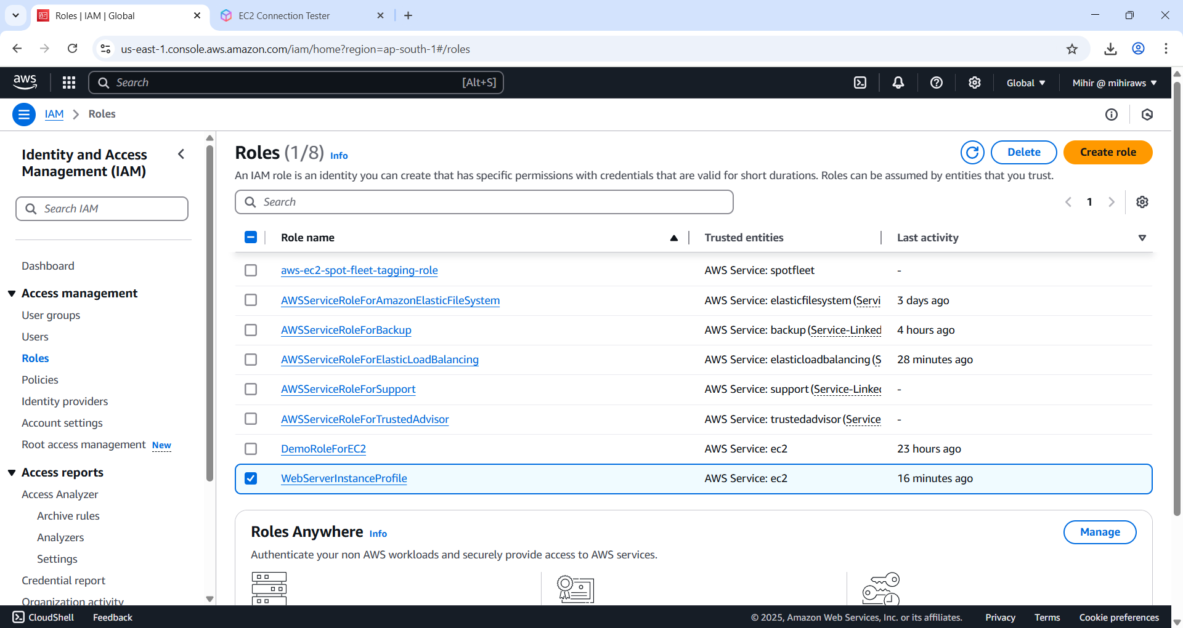

Figure 69 Select your Instance profile.

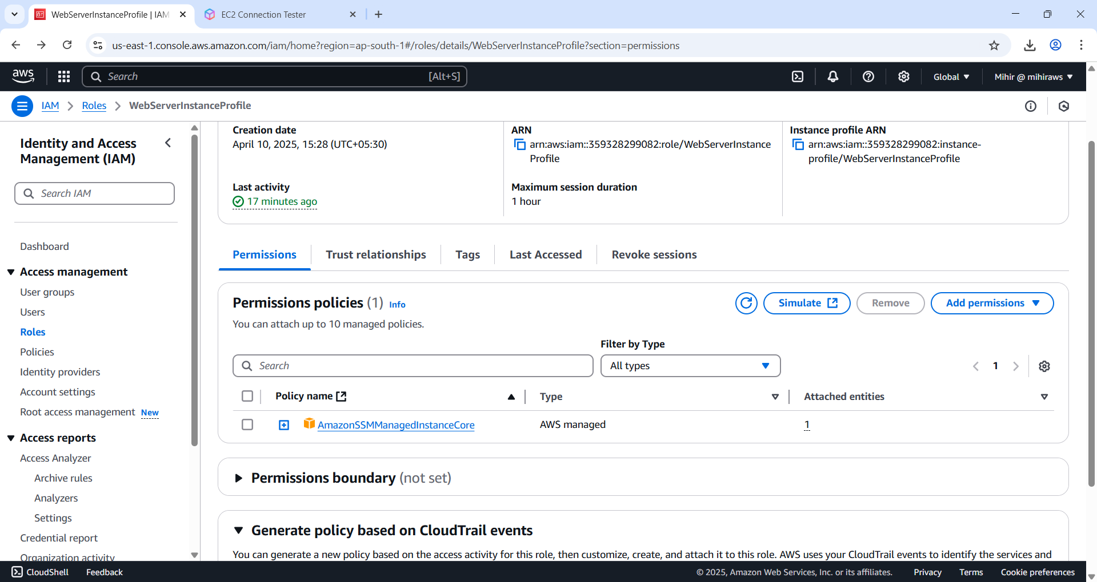

Figure 70 Click 'Add permissions' and from drop-down select 'Attach policies'.

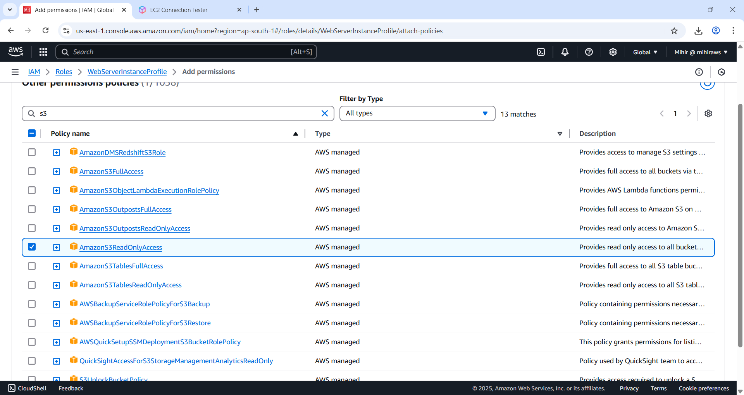

Figure 71 search for S3 and select 'AmazonS3 ReadOnlyAccess' policy and click 'Add permissions' button.

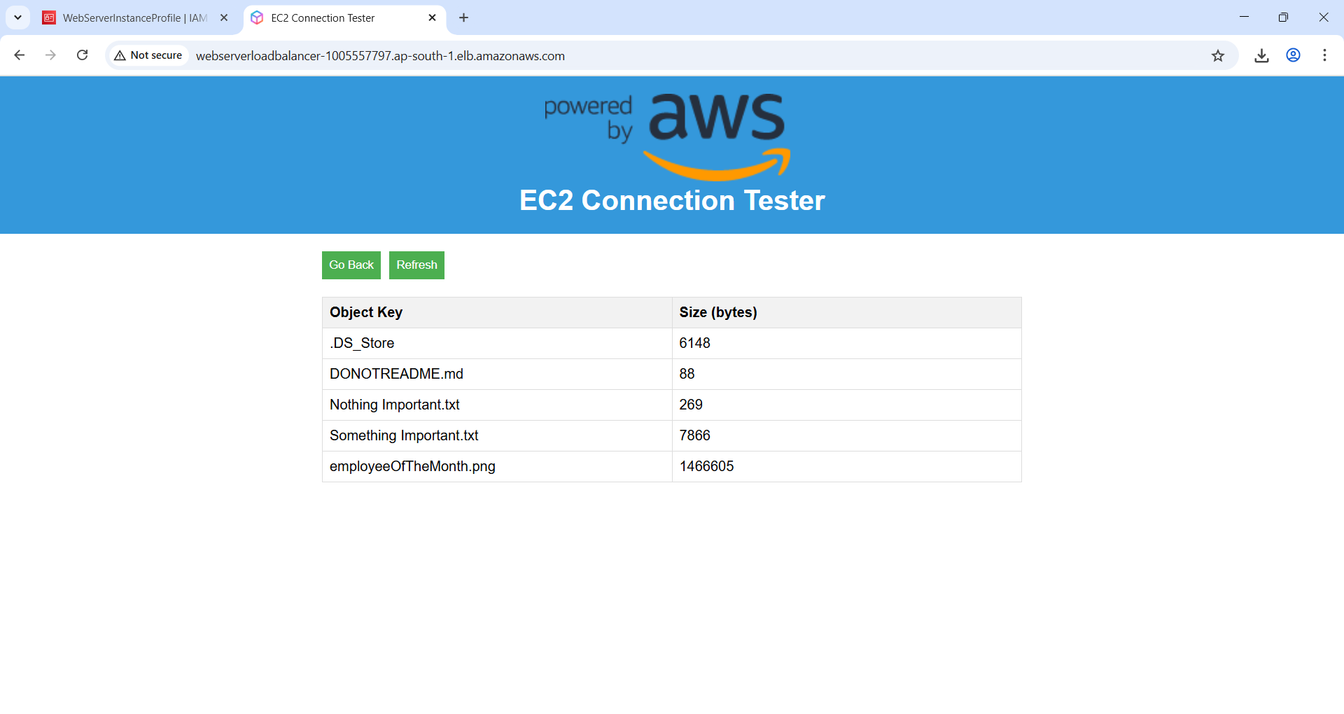

Figure 72 Switch back to the page and click 'Refresh' button you will be able to see the files listed in S3 bucket.

## Learnings

**📚 Learnings**

Throughout this project, I gained hands-on experience in designing and deploying a secure, scalable, and structured AWS cloud architecture. Here's a summary of the services I used and what I learned from each:

**✅ AWS Services Used and How They Were Applied:**

1. **Amazon VPC (Virtual Private Cloud)**
   * Created a logically isolated network environment.
   * Designed both **public and private subnets** across two Availability Zones (ap-south-1a, ap-south-1b) for high availability and fault tolerance.
   * Configured **route tables** to control traffic between the subnets, Internet Gateway, NAT Gateway, and VPC Endpoints.
2. **Subnetting & CIDR Planning**
   * Learned to calculate subnet sizes using CIDR notation (/24, /25, /26, etc.).
   * Subnetted a /23 block to support multiple departments with planned room for future growth.
   * Applied real-world logic for efficient IP allocation.
3. **Internet Gateway (IGW)**
   * Attached to the VPC to provide internet access to public subnets (e.g., for the Application Load Balancer).
4. **NAT Gateway**
   * Provisioned one NAT Gateway per Availability Zone to allow **outbound internet access** for instances in **private subnets**, while keeping them secure from inbound traffic.
5. **AWS Identity and Access Management (IAM)**
   * Created a custom **IAM Role** with the AmazonSSMManagedInstanceCore policy to allow EC2 to connect via Systems Manager.
   * Attached this role to an **EC2 instance profile** to control permissions securely.
   * Later attached the AmazonS3ReadOnlyAccess policy to allow EC2 instances to access S3 buckets.
6. **Amazon EC2 (Elastic Compute Cloud)**
   * Deployed a web server using Amazon Linux 2023 AMI in a **private subnet**.
   * Installed PHP, Apache, AWS SDK for PHP, and retrieved sample web content.
7. **AWS Systems Manager (Session Manager)**
   * Enabled **secure, browser-based shell access** to the EC2 instance in the private subnet, without using a public IP or SSH — enhancing security and management convenience.
8. **Security Groups**
   * Configured two security groups:
     + One for the **Application Load Balancer** to allow inbound HTTP (port 80) from anywhere.
     + One for the **Web Server** to allow inbound HTTP only from the ALB's security group.
   * Reinforced the **principle of least privilege**.
9. **Application Load Balancer (ALB)**
   * Deployed in public subnets to distribute incoming web traffic to the private EC2 instance.
   * Set up **target groups**, **health checks**, and configured HTTP listeners.
10. **Amazon S3 (Simple Storage Service)**
    * Created an S3 bucket (awsbucketforvpc) to store and serve web assets.
    * Configured the EC2 instance to access S3 securely using IAM permissions.

**🧠 Key Skills and Concepts Gained:**

* Understood the core components of AWS networking: VPC, subnets, route tables, NAT Gateway, and IGW.
* Mastered **CIDR notation** and **subnetting** strategies for efficient IP planning.
* Learned how to securely manage EC2 instances in private subnets using **Session Manager**.
* Applied **least privilege principles** using IAM roles and scoped permissions.
* Understood the distinction between **Security Groups** (stateful) and **Network ACLs** (stateless), and when to use each.
* Learned how to deploy and configure an **Application Load Balancer** to ensure scalable and highly available web architecture.
* Integrated Amazon S3 for web storage and confirmed access from EC2 using IAM-based permissions.
* Understood the significance of **Availability Zones** for high availability.
* Gained exposure to **user data scripting** for EC2 instance automation during boot time.

**💡 Final Thoughts**

This project helped me build a real-world AWS infrastructure from the ground up, using best practices for **security**, **scalability**, and **modularity**. It also showed the power of automation, IAM, and AWS-managed services to create a robust cloud-native environment. This setup forms a strong foundation for more advanced concepts like Auto Scaling, CloudFront, SSL (via ACM), and containerization with ECS or EKS in future projects.

A kind thank you to the AWS team to making such tutorials.  
Reference: <https://aws.amazon.com/tutorials/>